

State of Alabama

Impaired Driving Strategic Plan
2019-2021

March 25, 2018

Table of Contents Page
Executive Summary 3
Alabama’s Impaired Driving (ID) Challenge 3
Program Management 4
Prevention 4
Criminal Justice Approaches 5
Communication Program 8
Alcohol and other Drugs Misuse: Screen, Assessment, Treatment and Rehabilitation 9
Program Evaluation and Data Collection 9
Appendixes 10
1.0 Alabama’s Impaired Driving (ID) Challenge 11
1.1 Magnitude and Classifications of the Impaired Driving Problem 11
1.2 Strategic Plan Mission and Goal Statements 21
1.3 Guiding Principles in the ID Strategic Plan (IDSP) Development 23
1.4 Relationship to the State Strategic Highway Safety Plan (SHSP) Efforts 24
1.5 Organization of the ID Strategic Plan 25
2.0 Program Management 26
2.1 Alabama Impaired Driving Prevention Council (AIDPC) 26
2.2 Strategic Planning Organization 27
2.3 Management Control 28
2.4 Resources 29
2.5 Data and Records 29
2.6 Communication Program Management 30
3.0 Prevention 31
3.1 Responsible Alcohol Service 31
3.2 Community Based Programs 32
3.3 Transportation Alternatives Program 34
4.0 Criminal Justice Approaches 36
4.1 Laws 36
4.2 Enforcement 39
4.3 Publicizing High Visibility Enforcement 43
4.4 Prosecution 44
4.5 Adjudication 45
4.6 Administrative Sanctions and Driver License Programs 49
4.7 Training 52
5.0 Communication 59
5.1 Alabama Department of Economic and Community Affairs (ADECA) 59
5.2 Alabama Law Enforcement Agency 61
5.3 ALDOT Highway Safety Marketing Outreach Program 62
5.4 Traffic Safety Resource Prosecutor (TSRP) 62
5.5 Alabama Department of Public Health 63
6.0 Alcohol and other Drugs Misuse: Screen, Assessment, Treatment and Rehabilitation 65
6.1 Screening and Assessment 65
6.2 Treatment and Rehabilitation 66
6.3 Monitoring of Identified Past Impaired Drivers 66
7.0 Program Evaluation and Data Collection 68
7.1 Problem Identification Process 68
7.2 Evaluation Process 70
Appendix A. Specific Location Problem Identification Results 73
Appendix B. General Problem Identification Results 83
Geographical Factors 84
Time Factors 91
Factors Affecting Severity 97
Driver and Vehicle Demographics 105
Summary of Findings 110
Appendix C. Detailed Legislative Recommendations 114
C.1 Change the Way DUI is Charged & create a per se DUI/Drug Offense. 114
C.2 Increase refusal penalties 115
C.3 Remove five-year roll off period for prior DUI convictions 116
Appendix D. Adult Drug Court Map 117

State Of Alabama
Impaired Driving Strategic Plan

Executive Summary

The purpose of the Impaired Driving Strategic Plan (IDSP) is to provide overall guidance to all agencies and private groups who are involved with various aspects of reducing the problems caused by ID. Specifically, the Alabama Impaired Driving Prevention Council (AIDPC) was formed not only to develop this plan but to guide its implementation and future enhancements. The first strategic plan for Impaired Driving (ID) was completed on July 29, 2013 for the 2014 to 2016 time frame. This strategic plan has been updated each year, with the most recent being the current document for 2019 to 2021 that was approved May 10, 2018 meeting of the AIDPC, which has the responsibility to provide ongoing governance to the development of the Plan and its execution.

Terminology. Throughout this plan, the term impaired driving (ID) will refer to operating a motor vehicle while affected by alcohol and/or other drugs, including prescription drugs, over-the-counter medicines, or illicit substances. ID should be viewed as an over-arching term that will encompass what in the past has been referenced by Driving Under the Influence (DUI), Driving While Intoxicated (DWI), substance abuse, and other descriptive terms. These alternative descriptive terms will not be used unless they are necessary to focus on some particular aspect of the ID problem. For example, some quotations from legal documents will use DUI, and in those cases there should be no distinction made between ID and DUI. The current document will be referenced by the acronym IDSP (Impaired Driving Strategic Plan), i.e., the strategic plan for reducing the occurrence of ID, including all preventative, criminal justice, drug misuse and administrative aspects involved with ID issues. Finally, this document was created and approved under the auspices of the Alabama Impaired Driving Prevention Council (AIDPC).

This Executive Summary will present an overall top down view of the 2019-2021 Impaired Driving (ID) Strategic Plan. The plan is organized according to the recommendations of NHTSA Uniform Guidelines for State Highway Safety Programs (No. 8, November 2006), and thus has the major topics of:

- Alabama’s Impaired Driving (ID) Challenge
- Program Management
- Prevention
- Criminal Justice Approaches
- Communication Program
- Alcohol and other Drugs Misuse: Screen, Assessment, Treatment and Rehabilitation
- Program Evaluation and Data Collection

This summary will be organized according to these topical areas.

Alabama’s Impaired Driving (ID) Challenge

While Alabama has not been as permissive as many states in their marijuana laws, it has seen a general increase in ID caused by drugs as opposed to alcohol. The proportion of ID drug crashes has increased from its low of 14.0% in 2006 to the most recent high of close to 40%. This is an alarming trend that is indicative of the National increased social acceptance of drug use. The under-reporting of drug cases must be much higher than alcohol cases since there is a general inability of most law enforcement officers to identify many of the drug-related ID cases. A number of recommendations given in this plan will address this disturbing trend.

The challenge can be seen in the raw numbers of Impaired Driving crashes (including both alcohol and drug impairment as given in the following table).

Number of Reported ID Crashes Most Recent Five Years

 | 2013 | 2014 | 2015 | 2016 | 2017
Alcohol | 5,207 | 4,873 | 5,175 | 4,711 | 4,368
Drugs | 1,516 | 1,410 | 1,652 | 1,669 | 1,562
Both | 663 | 668 | 781 | 721 | 666
Total | 7,386 | 6,951 | 7,608 | 7,101 | 6,956

The plan gives a breakdown of these raw numbers and shows the trends over the last 12 years in a variety of ways. These show that we are not dealing with a stable issue, but one that is dynamically changing over time, and which will require a planning process that is adapting to this challenge. While it appears that there is a favorable downward trend in 2016 and 2017, additional data from 2018 will be needed to determine if there will be a regression to the mean.

The challenge can be analyzed when we view the general categories of ID crashes, and those categories that are over-represented, which is given in Section 1.1.3. Some of the more interesting findings of these problem identification studies are as follows:
- There was a significant reduction in the proportion of fatal crashes caused by ID in FY2017; a further analysis indicated that this was the result of speed reduction on the part of ID drivers.
- While speed decreases, the risk taking of not being properly restrained remained about the same, with ID drivers being about 9 times more likely to be unrestrained than non-ID drivers.
- All of the geographical analyses continued to point to the rural areas, especially for ID fatal crashes.
- County roads had well over twice their expected proportion of ID crashes, while all other roadway classifications were under-represented.
- Time of day and day of the week emphasize the typical times of alcohol and drug use: weekends beginning Friday night and ending Sunday morning had the highest proportions.
- ID caused crashes are under-represented in young drivers up until age 21. At 23, the first significant over-representation takes place and continues on to age 55. There is a bi-modal distribution of: (1) 21 through about 35, and (2) 36 to 55. The first of these might be classified as largely social drinkers; while it is inescapable that the middle aged caused ID crashes would largely have problems with substance abuse.
- The large number of ID offenders that do not have valid drivers’ licenses indicates that the suspension of drivers’ licenses may not be as effective as is desired.

To address these challenges, Section 1.2 shows that the AIDPC has adopted the following mission statement and short term goal statement:

Mission Statement: To maximize the impact of a harmonious collaborative efforts to reduce the reduction of ID fatalities, injuries and crashes to the lowest level possible, and ultimately to eliminate them altogether.

The following short term goal is consistent with this overall mission statement:

Immediate Short-Term Goal: Reduce the alcohol-impaired driving fatalities by 11.63 percent from the five year baseline average of 258 (2011-2015) to a five year average goal of 228 including 2017 (2014-2018).

Section 1.3 provides five guiding principles in the development of the IDSP:

- ID is a recognized public safety and health problem that has an enormous impact on our economy and the wellbeing of our citizens.
- While the AIDPC recognizes the many effective efforts made over past decades to address the problems created by ID, the large number of highway fatalities and injuries caused by ID indicates that these efforts should be reviewed and modified or augmented appropriately to provide for continuous improvement.
- There are a large number of partners in these efforts, all of whom have strong motivation to assist in the solution or mitigation of the ID problem, and as such, there is a critical need to coordinate these efforts so that they are not fragmented or even working at cross purposes.
- The ID problem cannot be addressed by emphasis on only one aspect of the solution; in the past a lack of a balanced approach has tended to be counterproductive; thus a guiding principle is the respect that all involved disciplines must have for efforts outside of their direct purview.
- The problem is largely a cultural one and while strong deterrent and punitive measures are an essential part of the solution, they must be consistent with an overall change in the cultural attitudes that provide the environment in which ID can exist.

Section 1.4 shows that the efforts of the AIDPC are closely coordinated with those of the Alabama Department of Economic and Community Affairs (ADECA) in the development of its Highway Safety Plan (HSP) as well as those within ALDOT’s SHSP efforts. The following recommendations were made within the SHSP document:

- Plan enforcement activities for locations identified as being over-represented in speeding and alcohol/drug related crashes. (Selective Traffic Enforcement Program – STEP).
- Continue to promote the “Drive Sober or Get Pulled Over” Campaign which consists of signs displaying the campaign slogan, roadblock checks, saturation and line patrols, and placing added emphasis on areas where a high number of alcohol-related crashes have occurred.
- Continue to promote the “Take Back Our Highways Campaign” which uses increased enforcement and awareness to address speeding and alcohol use while driving.
- Crashes related to speeding and alcohol/drug use are important areas for focused crash reduction efforts due to the typical higher level crash severity associated with them.

The remainder of the Executive Summary will follow the overall structure of the IDSP, which includes the following broad topical areas:

- Program Management
- Prevention
- Criminal Justice Approaches
- Communication Program
- Alcohol and other Drugs Misuse: Screen, Assessment, Treatment and Rehabilitation
- Program Evaluation and Data

Program Management

The administrative and management characteristics are organized into the following categories:

- Alabama Impaired Driving Prevention Council (AIDPC)
- Strategic Planning Organization
- Program Management
- Resources
- Data and Records
- Communication Program
These will form the basis for this summary. For more details see the subsection numbers for each of these categories that are given below.

2.1 Alabama Impaired Driving Prevention Council (AIDPC)

The AIDPC was assembled to develop and approve this plan and to assure that all aspects of the impaired driving problem were considered, and that as many alternative countermeasures as possible would be evaluated. AIDPC members represent agencies and organizations with a working knowledge and deep understanding of the various parts of Alabama’s impaired driving prevention system and how these parts interrelate. Participants are given in Table 2.1 of Section 2.1

2.2 Strategic Planning Organization

Figure 2.2 presents the overall organization for the impaired driving strategic plan development within the State. The major entities involved with this include:

- The Alabama Department of Economic and Community Affairs (ADECA), which is the overseer agency for the NHTSA traffic safety grants, the Community Traffic Safety Program Coordinators (CTSPs), and the state Traffic Records Coordinating Committee (TRCC), all of which operate within ADECA oversight.
- The committee which administers and develops the Statewide Highway Safety Plan (SHSP), which represents all agencies in state government that are involved in traffic safety, and thus this would involve all relevant state agencies in this process.
- Medical and Treatment Agencies also participate in the AIDPC.
- Advocacy Groups, i.e., non-governmental entities that have traffic safety interests, especially in the area of impaired driving.

2.3 Program Management

The plan provides an essential component of the control process, it is obvious that a plan alone is not going to solve the problem. The planned projects and programs must be effectively implemented, which requires an effective management control process. Using the plan as a road map, management must determine if adequate progress is being made in all projects toward their goals. To accomplish this regular (quarterly, or as needed) meetings of the AIDPC are conducted with representatives of all of the entities that are performing projects under the plan.

2.4 Resources

The AIDPC planning effort is being performed under the assumption that sufficient funding, staffing, and other resources to support impaired driving programs will be forthcoming. The FAST Act has given the assurance of certain funding given that the State meets the planning and other legal requirements. One of the major roles of the AIDPC is to assure that the planned programs should achieve self-sufficiency by transferring as much of their costs as possible to impaired drivers themselves.

2.5 Data and Records

This topic is covered in detail in Section 7 and further illustrated in Appendices A and B. All management and planning functions have been and will continue to be both evidence and data driven. This process starts with an analysis of historical data in a problem identification that has the broadest possible perspective. It searches all Alabama crash data to answer the “who, what, where, when, and why,” as well as the “how many” in all aspects of ID (all drugs including alcohol) related crashes. Every aspect of these analyses and evaluation efforts are guided by the statewide Traffic Records Coordinating Committee (TRCC).

2.6 Communication Program

The Communication Program is detailed in Section 5 and summarized in Section 2.6. The following is a partial list of ongoing efforts by the following agencies:
- The Alabama Department of Economic and Community Affairs (ADECA) has been involved with the development of Public Service Announcements (PSAs);
- The Alabama Law Enforcement Agency (ALEA), Public Information/Education Unit responds to special requests for information and officer participation in news events as well as participating in holiday and other special events;
- The ALDOT Highway Safety Marketing Outreach Program participates in an effort that involves approximately nine agencies and service groups;
- The Traffic Safety Research Prosecutor (TSRP) maintains a web site that provides general ongoing information on courses conducted by the TSRP; and
- The Alabama Department of Public Health (ADPH) uses multiple platforms to inform the public about impaired driving public health implications.

Prevention

The State’s prevention program has the goal of proactive reduction impaired driving through public health approaches, including altering social norms, changing risky or dangerous behaviors, and creating safer environments. In order to accomplish the following objectives were established, and they have formed the basis for the activities in this regard:
- Apply formal and informal behavioral modification methods that center around the negative effects of alcohol and other drugs;
- Limit the availability of alcohol and other drugs, especially to those who are most apt to abuse them;
- Discourage or prevent those who are impaired by alcohol and other drugs from driving;
- Assure responsible alcohol service practices;
- Create and support transportation alternatives;
- Implement community-based programs:
  - In schools,
  - At work sites,
  - In conjunction with medical and health care facilities, and
  - By community coalitions.

Prevention efforts will be directed toward populations at greatest risk as determined by the problem identification efforts that were conducted in conjunction with the planning effort.

Criminal Justice Approaches

This set of countermeasure approaches includes the entire criminal justice system, including laws, enforcement, prosecution, adjudication, criminal and administrative sanctions and related communications. The goal is to achieve both specific and general deterrence defined as:
- Specific deterrence focuses on individual offenders and seeks to ensure that impaired drivers will be detected, arrested, prosecuted, and subject to swift, sure, and appropriate sanctions, and thereby reduce recidivism;
- General deterrence seeks to increase the public perception that impaired drivers will face severe consequences, thus discouraging all individuals from driving impaired.
A multidisciplinary approach and close coordination among all components of the criminal justice system was sought in developing this plan. The plan discusses these efforts according to the following categories:
- Laws,
- Enforcement,
- Prosecution,
- Adjudication,
- Administrative Sanctions and Support Programs, and
- Training.

Substance Abuse: Screen, Assessment, Treatment and Rehabilitation

This plan recognizes that impaired driving frequently is a symptom of a larger alcohol or other drug problem. Many first-time impaired driving offenders and most repeat offenders have some such dependency problems. Without appropriate assessment and treatment, these offenders are likely to repeat their crimes. In addition, alcohol use leads to other injuries and health care problems. Frequent visits to emergency departments present opportunities for interventions, which might prevent future arrests or motor vehicle crashes, and result in decreased alcohol consumption and improved health.

Section 6 describes goals of encouraging employers, educators, and health care professionals to implement systems to identify, intervene, and refer individuals for appropriate substance abuse treatment. This effort is organized according to the following components:
- Screening and assessment
  - Within the criminal justice system
  - Within medical and health care settings
- Treatment and Rehabilitation
- Monitoring of Identified Past Impaired Drivers.

Links to governmental agencies and private volunteer organizations to provide assistance to those who are suffering from addiction are given on the following page of the SafeHomeAlabama.gov web site:

http://www.safehomealabama.gov/SafetyTopics/DriverIssues/ImpairedDriving.aspx

Program Evaluation and Data Collection

Section 7 describes the processes that the state uses in its production and use of data to assure that all programs are data-evidence based. The State currently has easy access through the Critical Analysis Reporting Environment (CARE) to reliable data sources (e.g., crash reports and citations) that are being analyzed for problem identification, evaluation, and program planning. Several different types of evaluations are being performed to effectively measure progress, to determine program effectiveness, to plan and implement new program strategies, and to ensure that resources are allocated appropriately.

Problem identification is performed on an annualized basis, and the most recent are given in Appendices A and B. Appendix A is a list of those locations in the state that have the highest frequency of impaired driving crashes by roadway classification. Appendix B is a general problem identification as described below. This is also made available to the public through the SafeHomeAlabama.gov web site:

http://www.safehomealabama.gov/SafetyTopics/DriverIssues/ImpairedDriving.aspx

Generally problem identification systematically goes through the entire crash records database comparing impaired driving crash data with all other crash data to find those attributes that are significantly over-represented (e.g., times, ages, contributing circumstances and about 200 other attributes). This is translated into useful information for optimizing both the selection of available countermeasures and the improvement of those countermeasure that are selected. Section 7.1 presents details of the problem identification process.

Evaluations generally fall into two categories: administrative and effectiveness. Administrative evaluations determine if planned activities for given projects were actually performed, independent of what effects it might have had. Effectiveness evaluations strive to determine the crash or severity reductions that result from any given countermeasure project. The plan calls for the use of CARE to provide effectiveness evaluations on as many of the countermeasures given in this plan as resources will allow. The evaluation process is detailed in Section 7.2.

Appendices

The plan contains the following appendices
- A – Specific Location Problem Identification: lists of those locations that had the highest volumes of impaired driving crashes by roadway classification.
- B – General Problem Identification Results: the results of the analysis of all crash records attributes to determine those for which impaired driving is over-represented.
- C – Detailed Legislative Recommendations: those recommendations that the AIDPC has determined would be the most advantageous to be passed in the next legislative session.
- D – Adult Drug Court Map: gives the number of adult drug courts operating within each county.

State Of Alabama
Impaired Driving Strategic Plan

1.0 Alabama’s Impaired Driving (ID) Challenge

Terminology. Throughout this plan, the term impaired driving (ID) will refer to operating a motor vehicle while affected by alcohol and/or other drugs, including prescription drugs, over-the-counter medicines, or illicit substances. ID should be viewed as an over-arching term that will encompass what in the past has been referenced by Driving Under the Influence (DUI), Driving While Intoxicated (DWI), substance abuse, and other descriptive terms. These alternative descriptive terms will not be used unless they are necessary to focus on some particular aspect of the ID problem. For example, some quotations from legal documents will use DUI, and in those cases there should be no distinction made between ID and DUI. The acronym IDSP will refer to the Impaired Driving Strategic Plan, i.e., the strategic plan for reducing the occurrence of ID, including all preventative, criminal justice, drug misuse and administrative aspects involved with ID issues. Finally, this document was created and approved under the auspices of the Alabama Impaired Driving Prevention Council (AIDPC).

1.1 Magnitude and Classifications of the Impaired Driving Problem

This section presents an overview of the systematic problem identifications that were performed, (unless otherwise specified) using the last 12 years of Alabama data (CY2006-2017). This is generally a summary of the detailed problem identifications contained in Appendixes A and B. This will be organized below according to crash records analysis, citation records analyses and the general over-represented categories of ID as given by the crash records.

1.1.1 Impaired Driving Crashes Compared to Non-ID Crashes

Display 1.1.1a compares the number of reported ID crashes (red) with the number reported that were recorded as Non-ID (blue) over the calendar years 2006-2017.

The trend of the proportion of ID crashes to the total number of crashes is given in Display 1.1.1b. It has an average of 5.34% and varies from a low of 4.51% to a high of 5.78%. Generally the number of ID crashes remains relatively stable as the total number of crashes has decreased and increased significantly over the years due to the various factors that influence overall crash frequency. Since the factors in the variation of overall crashes are primarily economic, this finding generally goes counter to the idea that ID crashes are also correlated to these economic factors, e.g., (1) the ability to purchase substances that could be abused, (2) the ability to drive once under these influences, and (3) the use of drugs and alcohol without going to more expensive establishments. The conclusion must be that those factors that have been effective in reducing overall crashes (which have been shown to be largely economic) have not had nearly the effect on ID crashes prior to 2013. The fact that after 2013, ID crashes did not increase nearly as much as crashes in general is a very favorable trend.

There is no argument that the number of reported ID crashes is less than what actually occur. The accurate identification of an ID crash in the field is often difficult for the field officer. This disparity can be illustrated by comparing the fatalities indicated by the Fatality Analysis Reporting System (FARS) and those obtained from Alabama crash records. The following table is indicative of this disparity.

Year | FARS ID Fatalities | AL Crash Records ID | Percent Reported
2006 | 377 | 267 | 70.82%
2007 | 377 | 289 | 76.66%
2008 | 314 | 230 | 73.25%
2009 | 267 | 264 | 98.88%
2010 | 264 | 230 | 87.12%
2011 | 261 | 252 | 96.55%
2012 | 240 | 212 | 88.33%
2013 | 261 | 209 | 80.08%
2014 | 264 | 220 | 83.33%
2015 | 247 | 232 | 93.93%
2016 | 279 | 261 | 93.55%
2017 | Not Available | 188 | Not Available
TOTALS | 2872 | 2402 | 84.51%

This demonstrates that while the ID crash records are extremely important in providing relative information (e.g., the types of comparisons given in Appendix B), they are not as useful in determining the ultimate cost of ID crashes, either in terms of lives or economics. Fatality reporting is by far the most accurate, since it would be expected that the more severe the crash the more investigation will be performed in identifying the basic causes. Seeing the recent percent reported of about 87.8% (average of 2013-2017) for fatal crashes, it is reasonable to estimate that ID crashes of all severities are generally under-reported by a factor as high as 30%. That is, for every three that are reported as such, there is in all probability another one that will be reported as a non-ID crash even though impaired driving was involved. One of the major recommendations that will be made in Section 7 will be for improved reporting.

Clearly ID is a major cause of motor vehicle fatalities in the entire country, and Alabama is no exception. Display 1.1.1c shows how the ID crashes have been distributed between alcohol (blue), drugs (red), and both alcohol and drugs (green). The proportion of ID drug crashes has increased from its low of 6.7% in 2008 to the most recent high of 26.2% in 2016. This is an alarming trend that is indicative of an increased social acceptance of drug use. The under-reporting of drug cases must be much higher than alcohol cases since there is a general inability of most law enforcement officers to identify many of the drug-related ID cases. A number of recommendations given in this plan will address this disturbing trend.

1.1.2 Twelve Year Impaired Driving Crash and Citation Trends

Display 1.1.2a shows the 12-year trend for impaired driving reported crashes. While the trend line is not steep, the concurrence of many of the data points very near the line shows that the year number is highly correlated to a decline in ID reported crashes. Statistical analysis shows that the line accounts for about 71% of the variation in the data points. The decline is about 134 crashes per year, with the overall decline being 1,472 impaired driving crashes over the 12 years.

A more detailed analysis of the last five years will be given in Appendix B. Generally, this trend should be considered as being favorable, and an indication that the countermeasures being applied are bearing fruit. One concern, however, is that the decline could be in the reporting as opposed to the actual number of occurrences. This is not to say that any given officer is inconsistent in his/her reporting. However, in the past few years there has been a dramatic reduction in the number of reporting officers, especially at the state level. See the article at:
http://www.safehomealabama.gov/SafetyTopics/Enforcement/EnforcementStudies.aspx
entitled: “ALEA Trooper Staffing Level Critically Low.” The problem with a critically low staffing level has a much broader effect than just a reduction in reports. Adequate law enforcement increases the deterrent effect, leads to more convictions thus reducing recidivism, and provides additional first responder means for reducing the deadly effects of many ID crashes.

The results in Displays 1.1.2.b and 1.2.2c should be qualified by the fact that these crashes, especially fatalities, are given much more detailed investigation, and as a result the reliability and completeness of the reporting increases. The discussion of the caparison of FARS with Alabama law enforcement reported fatalities given in Section 1.1.1 should be given strong consideration.

The two displays are placed together above for purposes of comparison. Both show an overall improvement. While the year number accounts for 54.3% of the variation for fatalities, it accounts for only 37.3% of the variation in injuries, as can be observed by the larger variations from the regression line. However, both of these twelve year trends are significant. Fatalities being reduced on average of 1.2 per year for an estimated 12-year reduction of 14 fatalities; and the injuries being reduced by about 112 per year, for an estimated 12-year reduction of 1,344 injuries.

Display 1.1.2d gives the overall trend of citations for Impaired Driving issued within eCite for the most recently available nine years for which the eCite system has been operational. Data prior to that time are not comparable. In this case the regression line accounts for only 7.1% of the variation over the years, making the trend line of little, if any, significance. Looking at the individual years, there was an obvious and significant increase with the adoption of eCite as it matured in 2009. The number of ID citations stabilized above the 12,500 level for 2010-2012. There was a tapering down in 2013 and 2014 probably due to reductions in trooper force at ALEA. The most recent complete year that we have (2017) shows the number of citations going back and being quite comparable in number to the higher pre-2013 levels, and the last three years being nearly identical (maximum variation less than 2%). Such consistency from year to year shows a steady state, both in the number of violations for which citations can be written and in the citation system itself.

The interpretation of the citation numbers is complex, especially in light of the recent reduction in law enforcement. It could be viewed as negative in the sense that there are more ID citations written in the most recent three years as opposed to the two years before that. On the other hand, it can also be viewed as positive in the sense that, even with less enforcement being performed, more citations are being written. Only a very small fraction of ID violators are brought to justice on any given time period. There is little doubt that even a doubling of the number of law enforcement officers would still not apprehend the majority of offenders. Such a dramatic increase in enforcement would also overwhelm the criminal justice system and that would create problems of its own that are discussed in other sections of this plan.

1.1.3 General Categories of ID Crashes

In order to keep the most current information available, a problem identification was performed using the fiscal year (FY) data as soon as it became available. The difference in the FY and calendar year (CY) data in such comparisons would not be significant. In fact, very few differences were found between the FY2017 and CY2016 information produced from the problem identifications that were performed, showing that the data for these respective time periods was quite consistent. Where differences were found, they were noted and emphasized.

In the charts in the section, the red bars represent ID crashes, while the blue bars represent non-ID crashes. In order to make fair comparisons, the proportion of the total crashes in each category is displayed. See Appendix B for more details. The following summarizes the findings of the problem identification, the details of which are given in Appendix B:

- General Comparison of FY2017 against FY2015-2016
  - Overall crash frequencies got FY2017 were about 5000 crashes higher than the average of FY2015-2016. Total crashes in FT2017 were only about 1560 fewer than in FY2016. Thus, there is nothing in the overall crash picture that would suggest that FY2017 should not be comparable to FY2015-2016, or even to FY2016 alone.
  - In a comparison of the fiscal years, overall fatal crashes were up by 22.8% in FY2016 over FY2015, and this only came down by 2.1% in FY2017.
  - A similar a comparison of the fiscal years of ID fatal crashes showed an increase of 9.2% in FY2016 over FY2015, and this only came down by 1.7% in FY2017.
  - On the other hand, there was a remarkable decrease in the proportion of fatal crashes caused by ID to the overall number of fatal crashes for each year. Over the three fiscal year periods (FY2015-2017), the proportions were 27.0%, 24.0% and 20.4%, a significant overall reduction of reported ID fatal crashes of 6.6%. The reason for this was given intensive analysis in the Factors Affecting Severity Section.

- Geographical Factors
  - County - Generally, the over-represented counties are those with combined large population centers and large rural areas, as opposed to the highly urbanized counties or the extremely rural counties. One reason that the highly urbanized counties are under-represented is the large number of low severity crashes that occur there separate and apart from ID crashes. See the rural-urban comparison below.
  - Rural Areas with the Greatest Increases in FY2017 – several virtual cities (rural areas of counties) were found to have over twice the proportion of ID crashes compared to their proportions in FY2015-2016. Place in Max Gain order, the ones with the highest potential for reduction were (all rural areas of the following counties): Cullman, Blount, Houston, Coffee, Colbert, and Pike.
  - City Comparisons of ID crashes by Total ID Crash Frequency. There is little surprise in this output, which tracks the areas by population. Traffic safety professionals should look for any locations that fall counter to this trend.
  - City (and area) Comparisons within Crash Frequency Ranges – analyses were performed for those areas that had 100-200 ID crashes as well as those that had 60-100 ID crashes. There are presented separately to present fair comparisons among the various areas.
  - Overall Area Comparisons Conclusions –Generally those rural areas that are adjacent to (or contain) significant urbanized areas are over-represented, since their urban areas generate more traffic even in the rural areas. Possible factors for relatively fewer severe ID crashes within urban areas include:
    - Less need for motor vehicle travel and shorter distances to the drinking establishments;
    - Larger police presence in the metropolitan areas; and
    - Lower speeds in rural areas.
  - The city, county, and area comparisons are, of necessity, a selection of the total outputs that could be generated. They are given to illustrate the capabilities as much as to present the numerical results. Anyone wishing additional studies or outputs, please contact CAPS – see e-mail address above.
  - Severity of Crash by Rural-Urban – While only about 42% of crashes occur in rural areas, nearly 67% of the fatal crashes occur there. Similar results are found for the highest severity non-fatal crashes. This is obviously the result of higher impact speeds in the rural areas. Note that additional causes of increased severity are given in the Factors Affecting Severity Section.
  - Rural or Urban ID Crash Frequency – Not only are impaired driving crashes more severe in rural areas, but their frequency is about the same as in the urban area, despite the much lower population and traffic volumes (about 42% rural as compared to about 58% urban). While only 22.44% of the crashes are expected in the rural areas, the proportion of crashes in the rural areas is over 42.14%, or very close to double its expected value (Odds Ratio = 1.965).
  - Highway Classifications – County roads had well over twice their expected proportion of crashes, while all other roadway classifications were under-represented. County road characteristics no doubt contribute to the crash frequency. County roads are also known to be less “crashworthy” (i.e., they result in more severe crashes at comparable impact speeds).
  - Locale – Reflecting the rural over-representation, open country and residential roadways show a high level of over-representation as compared with the more urbanized area types, especially Shopping or Business, which only has about half of its expected proportion.

Display 1.1.3a ID Crashes (Red) vs Non-ID Crashes (Blue) for Highway Classification

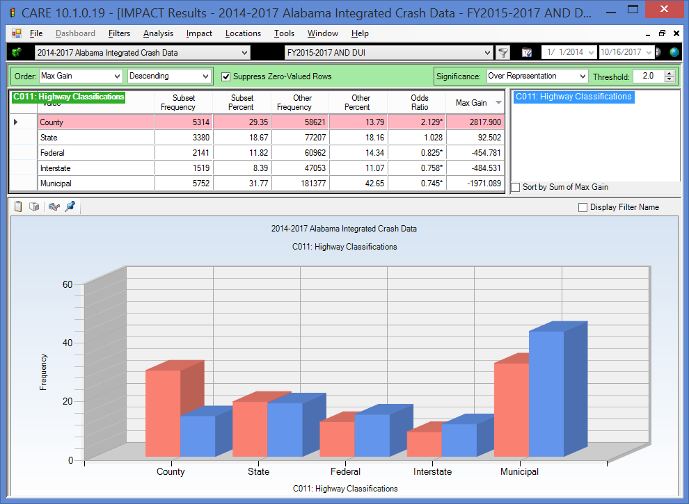

- Time Factors
  - Year – a discussion of the overall crash, fatal crash and ID fatal crash frequencies by year was given in the section of Appendix B entitled ID Update for FY2017 that appears right after the Introduction. The display in the Year attribute section presents and discusses the three fiscal years according to their calendar year occurrences.
  - Month – There only significant over-representations by month was in February and March, indicating that the number of ID crashes correlated well with the other crashes during the rest of the months. None of the months were significantly under-represented.
  - Day of the Week – This analysis is not only useful for the typical work week, but it also reflects the typical “holiday weekend” patterns. The days can be classified as follows:
    - Typical work weekday (Monday through Thursday) – these days are under-represented in ID crashes due to the need for many to go to work the following day.
    - Friday – this pattern is also reflected in the day before a weekend (or holiday), i.e., before a day off. The high ID frequency on this day is due to those who are getting an early start to the weekend, recognizing that they have no work responsibilities the following day.
    - Saturday – the “Saturday” pattern is the worse for ID crashes in that it has both an early morning component (like Sunday) and a late night component (like Friday). So, it could be viewed as a combination of the typical Friday and Sunday.
    - Sunday – since this is the last day of a holiday sequence or weekend, its over-representation comes strictly from those who start on Saturday night and do not complete their use of alcohol/drugs until after midnight.
  - “Holiday Weekends” – these can be viewed as a sequence of the weekend-pattern sequence. For example, the Wednesday before Thanksgiving would follow the Friday pattern assuming that most are at work on Wednesday. The Thursday, Friday and Saturday would follow the Saturday pattern, and the Sunday at the end of the weekend would follow the typical Sunday pattern. This is the reason that long holiday events (i.e., several days off) can be much more prone to ID crashes than the typical weekend. Three-day weekends typically give Monday off, so that Monday would behave like the typical Sunday, and both the Saturday and Sunday would follow the Saturday pattern.
  - Time of Day – The extent to which night-time hours are over-represented is quite striking. Optimal times for ID enforcement would start immediately following any rush hour details, and would continue through at least 3 AM.
  - Time of Day by Day of the Week – This quantifies the extent of the crash concentrations on Friday nights, Saturday mornings and Saturday nights and early Sunday mornings. This is a very useful summary for deploying selective enforcement details.

- Factors Affecting Severity
  - ID Crash Severity -- The rate of injuries and fatalities are consistently higher in ID crashes than that of non-ID crashes. Fatality crashes are over seven times their expected proportion, while the two highest non-fatal injury classifications have over twice their expected values when compared with non-impaired driving crashes The odds ratio is over three (3.204) for the highest non-fatal classification, Incapacitation Injury. The other variables analyzed in this section give the reasons for this disparity.
  - Speed at Impact – All impact speeds above 45 MPH are dramatically over-represented. See the next attribute.
  - Severity by Impact Speed –Past analyses have found the general rule of thumb that for every 10 MPH increase in speeds, the probability of the crash being fatal doubles. This was validated in the discussion of the cross-tabulation.
  - Severity Comparison FY2017 vs FY2016 – There was a reduction from 226 in FY2016 to 188 in FY2017, which was a 16.8% reduction in ID fatal crashes. Both the overall crashes and the fatality crashes were reduced, but the reduction in the fatality crashes were obviously much greater than that of the overall crashes.
  - Restraint Use by Impaired Drivers – The impaired drivers are close to 9 times more likely to be unrestrained than the non-ID causal drivers. Clearly ID drivers lose a good part of their concept of risk when they are willing to drive while being impaired.
  - Fatality Crashes by Restraint Use for Impaired Drivers – A comparison of the probability of a fatal crash indicates that a fatality is almost six (5.82) times more likely if the impaired driver is not using proper restraints. With restraints, one in 61 ID crashes are fatal; but without restraints, the fatal crash ratio is 1 in about 11. So the combined effect of lower restraint use and higher speed is a devastating combination that accounts for much of the high lethality of ID crashes.
  - Number Injured (Including Fatalities) – Not only are ID crashes generally more severe to the driver, but the number of multiple injuries in these ID crashes is over-represented as well. This might have something to do with the preference of those going out to socialize to take some of their friends with them.
  - Police Arrival Delay – ID crashes generally had longer police arrival delays; in this case all arrival delays over 31 minutes were over-represented. There can be little doubt that this has to do with the rural nature of these crashes and the potential that the late night occurrence might not be discovered for some time.
  - EMS Arrival Delay – Higher EMS delays were over-represented for impaired driving injury crashes in all categories above ten minutes, and dramatically for the very longer times of 46 to 60 minutes and above. This obviously contributes to the severity of crashes and the chances that the crash results in one or more fatalities. As for the very long times, these might be due to the delay in discovering the crash as much as their generally over-represented rural locations.

Display 1.1.3b ID Crashes (Red) vs Non-ID Crashes (Blue) for EMS Response Time

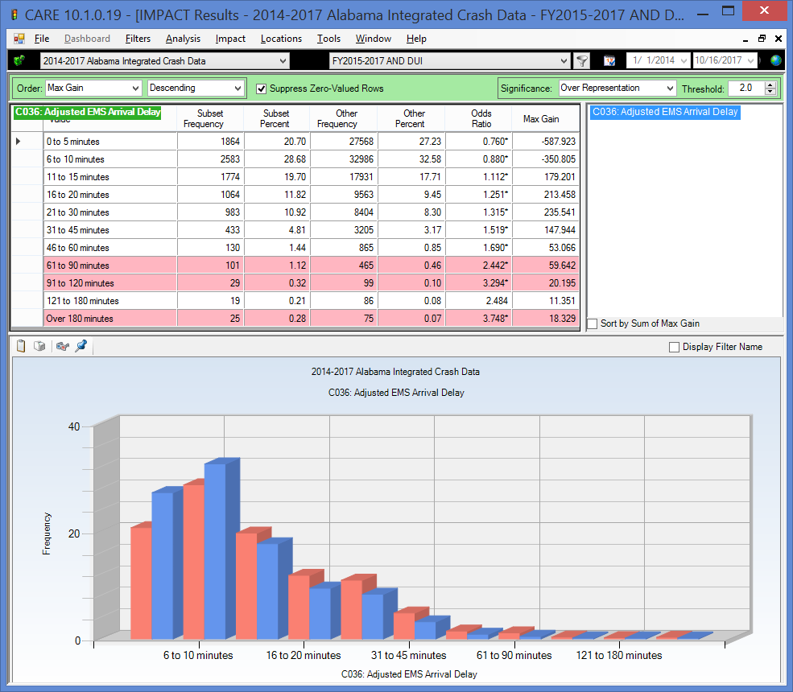

- Driver and Vehicle Demographics

  - Driver Age – Younger (16-20 year old) drivers have a very serious problem in crash causation even in the absence of impairment. However, these crashes are not generally caused by ID up until ages 19 and 20, and even at these ages they are under-represented. At 23, the first age over-representation takes place and continues on to age 55. There is a bi-modal distribution in the 21-54 year olds; 21 through about 35, and a second group from 36 to 55. Generally, the first of these might be classified as largely social drinkers; while it is inescapable that the middle aged caused ID crashes would be largely problem drinkers.

Display 1.1.3c ID Crashes (Red) vs Non-ID Crashes (Blue) for At-Fault Driver Age

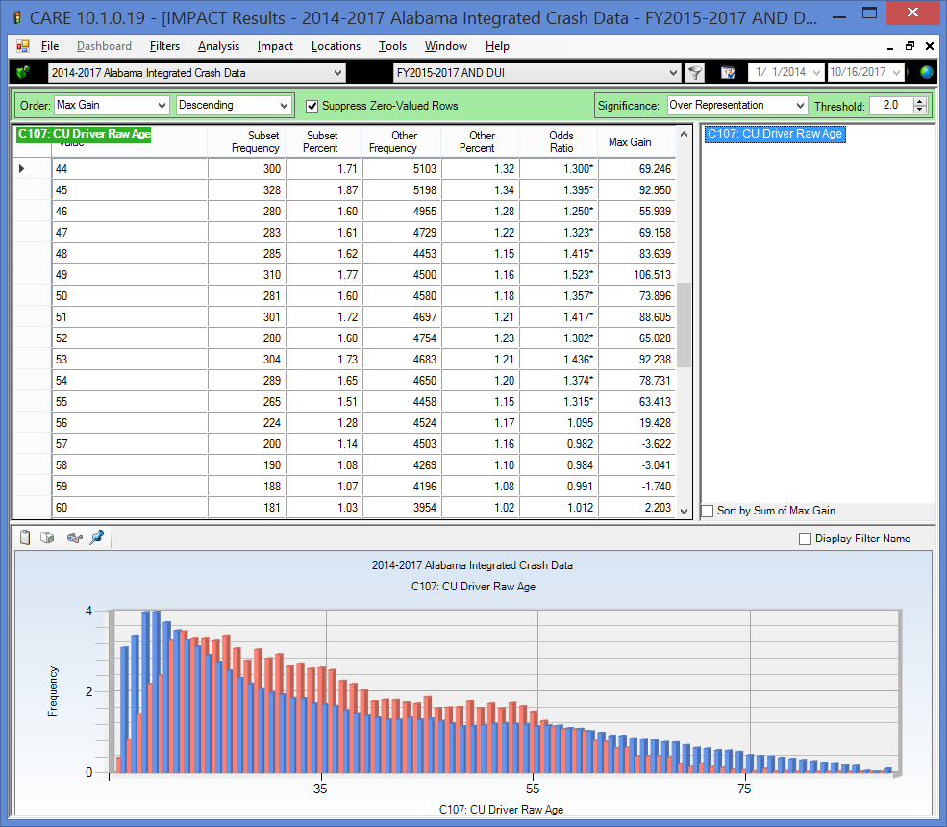

  - Impaired Driver Gender –Males are a far greater issue in ID crashes, and if there are countermeasures that can be directed toward them, doing so would be much more cost-effective than those that are not gender based, all other things being equal.
  - Causal Vehicle Type – Pick-ups, which up had a significant over-representation and came out at the top of the Max Gain order because of their large number of ID involvements. Motorcycles were also highly over-represented. Also of interest is the proportion of pedestrians that involve ID, which is close to three times their expected number. ATVs had the highest over-representation (Odds Ratio = 4.580), perhaps because drivers do not believe that the ID laws apply to them as long as they are not on the public highways.
  - Driver License Status – ID crashes are very highly over-represented in causal drivers without valid licenses challenging the effectiveness of license suspension and revocations as a traffic safety countermeasure, at least after the fact. There is no way to estimate its deterrent value.
  - Driver Employment Status –ID driver unemployment rate at 37.38% is about 90% higher than expected. This factor will be watched carefully going forward.

1.2 Strategic Plan Mission and Goal Statements

The Alabama Impaired Driving Strategic Plan (IDSP) was developed and approved with the input and direction provided by the Alabama Impaired Driving Prevention Council (AIDPC), and they based their development efforts on the following mission statement developed by the AIDPC membership.

Mission Statement: To maximize the impact of a harmonious collaborative efforts to reduce the reduction of ID fatalities, injuries and crashes to the lowest level possible, and ultimately to eliminate them altogether.

This mission statement recognizes the many efforts developed in the past and those currently ongoing. AIDPC members’ experience ranges back to the first ID strategic plan that was developed in the mid-1970s. Over this time Alabama has realized great gains in reducing the frequency and severity of impaired driving crashes. However, the AIDPC recognizes continued vigilance and improvement is needed to further reduce these devastatingly tragic events. As such, it has adopted the theory proposed by what Deming called “Continuous Improvement Forever” that mandates an attitude of never being satisfied with the current situation in recognition that improvement is always possible.

Immediate Short-Term Goal: Reduce the alcohol-impaired driving fatalities by 11.63 percent from the five year baseline average of 258 (2011-2015) to a five year average goal of 228 including 2017 (2014-2018).

The goal is from the Alabama 2018 HSP, item C-5: Number of fatalities in crashes involving a motor vehicle driver (including motorcycle operators) with a BAC of .08 and above, as measured by the FARS estimated data given below:

2011 | 2012 | 2013 | 2014 | 2015 | Baseline | Goal
261 | 240 | 259 | 265 | 247 | 254 | 228

Number of Fatalities Involving a Driver with a BAC .08 and Above
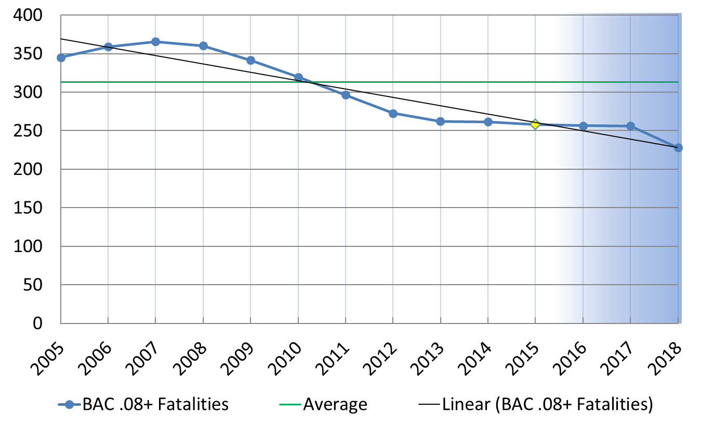

It is important to recognize that extrapolations from a limited number of past values can lead to extreme errors, especially since the last value that we have in most cases is 2017, requiring (for example) that the estimates of 2018 and 2019 all be based on an extrapolation of 2006 through 2017. Rarely if ever does such a linear trend establish an accurate prediction, especially in crash data where regression to the mean usually follows any dramatic departure (positive or negative) from the established trend. Nevertheless, these estimates are presented since they are the best figures available upon which to make and refine future estimates and goals.

The considerations above are particularly true of any metric that is dependent on fatality counts. Consistent with the national trend, Alabama experienced almost a 24% reduction in fatalities between CY 2007 and CY 2009. Because of several economic factors (price of fuel, alcohol, reduction in driving by high-risk groups, reduction in speeds for fuel conservation, and several other well established factors), the expected regression to the mean did not occur until 2015, and it is being dramatically realized over the course of 2017. Any trend line that includes fatality counts prior to 2008 will obviously produce a downward trend that is clearly not feasible to maintain by traffic safety countermeasures alone.

1.3 Guiding Principles in the ID Strategic Plan (IDSP) Development

Given the goal mission statements given above, it is important to understand the overall guiding principles that were followed in developing the IDSP. The purpose of the IDSP is to provide overall guidance to all agencies and private groups who are involved with various aspects of reducing the problems caused by ID. Specifically, the Alabama Impaired Driving Prevention Council (AIDPC) was formed not only to develop this plan but to guide its implementation and future enhancements. In this regard they were required to address all of the impaired driving issues, review strategies which have been proven effective in impacting those issues, and develop a strategic plan that will serve to guide all aspects of efforts within the state to deal with the ID problem. The membership and organization of the AIDPC will be detailed below under Program Management (Section 2).

The following are the guiding principles that were approved by the AIDPC at the outset of its deliberations:
- ID is a recognized public safety and health problem that has an enormous impact on our economy and the wellbeing of our citizens.
- While the AIDPC recognizes the many effective efforts made over past decades to address the problems created by ID, the large number of highway fatalities and injuries caused by ID indicates that these efforts should be reviewed and modified or augmented appropriately to provide for continuous improvement.
- There are a large number of partners in these efforts, all of whom have strong motivation to assist in the solution or mitigation of the ID problem, and as such, there is a critical need to coordinate these efforts so that they are not fragmented or even working at cross purposes.
- The ID problem cannot be addressed by emphasis on one aspect of the solution; in the past a lack of a balanced approach has tended to be counterproductive; thus a guiding principle is the respect that all involved disciplines must have for efforts outside of their direct purview.
- The problem is largely a cultural one and while strong deterrent and punitive measures are an essential part of the solution, they must be consistent with an overall change in the cultural attitudes that provide the environment in which ID can exist.

1.4 Relationship to the State Strategic Highway Safety Plan (SHSP) Efforts

The Impaired Driving Strategic Plan (IDSP) is closely coordinated with Alabama’s Strategic Highway Safety Plan (SHSP). The purpose of the SHSP is to improve highway safety in all areas of traffic safety. Since its goal is to be comprehensive of all traffic safety efforts within the state, it subsumes all planning efforts that are targeted at particular focus issues (e.g., occupant protection, traffic safety information systems, impaired driving, etc.). The SHSP has identified ID as a major continuing priority area because the problem identification analyses demonstrate that this is one of the top three causes of fatal crashes. Thus, the IDSP serves as a complement to the SHSP by describing the ID-specific strategies and action steps to improve traffic safety. The last SHSP was published in May 2013, and its planning horizon was 2012-2017. Efforts are being made within the Alabama Department of Transportation to re-activate the SHSP process to update this plan in 2018. Those active in developing the ADECA Highway Safety Plan (HSP) for NHTSA participated in the development of the 2013 SHSP. Since the HSP became an appendix of the 2013 SHSP, it is expected the IDSP and other strategic plans being developed will also become appendices according to the recently passed (signed December 4, 2015) Fixing America's Surface Transportation Act (FAST).

The following comes from Page 18 of the Strategic Highway Safety Plan for Alabama, 2nd Edition (May 2013): “Focus efforts on education and awareness programs to improve overall driver behavior and habits, specifically in the areas of speeding, alcohol/drug use while driving and increasing seatbelt/restraint use. The Highway Safety Plan (HSP) developed by the Alabama Department of Economic and Community Affairs (ADECA), Law Enforcement and Traffic Section (LETS) specifically addresses those driver behavior issues. As a result, the SHSP 2nd Ed. embraces the ADECA HSP as the primary resource for focusing state expertise and programs to combat these issues.”

A comparable statement is made on Page 22 of the SHSP: “The ADECA HSP specifically addresses the issues of speeding, alcohol/drug use and lack of vehicle restraint use by applying methods that address undesirable driver behavior. As a result, this SHSP 2nd Ed. embraces the ADECA HSP as the primary resource for offering focused state expertise and programs for combating driver behavioral issues. Although the HSP changes annually as pressing issues change, the SHSP steering committee endorses that action and has elected to accept the annual changes because ADECA LETS is suitably equipped to revise and implement focused programs addressing the new issues.” It can be assumed that the 2018 SHSP task force will be equally supportive of the ADECA efforts in the development of these plans, and a recent meeting of the ALDOT Outreach Team affirmed that these plans would become part (e.g., appendixes) of any forthcoming SHSP efforts.

In addition, the following recommendations regarding ID were made within the SHSP document:

- Plan enforcement activities for locations identified as being over-represented in speeding and alcohol/drug related crashes. (Selective Traffic Enforcement Program – STEP).
- Continue to promote the “Drive Sober or Get Pulled Over” Campaign which consists of signs displaying the Campaign slogan, roadblock checks, saturation and line patrols, and placing added emphasis on areas where a high number of alcohol-related crashes have occurred.
- Continue to promote the “Take Back Our Highways Campaign” which uses increased enforcement and awareness to address speeding and alcohol use while driving.
- Crashes related to speeding and alcohol/drug use are important areas for focused crash reduction efforts due to the typical higher level crash severity associated with them.

These statements are listed to demonstrate the complete cooperation that exists between the SHSP planning efforts and those required by FAST under the auspices of NHTSA.

1.5 Organization of the ID Strategic Plan

This strategic plan describes the components that Alabama’s impaired driving program will include. At the beginning of the process, the Alabama Impaired Driving Coalition (AIDPC) determined its strategic plan should have objectives and countermeasures that reflect the various aspects of impaired driving. The first section of the plan deals with program management. Subsequent sections are generally ordered according to the organization of the various impaired driving countermeasures, namely:

- Program Management
- Prevention
- Criminal Justice Approaches
- Communication Program
- Alcohol and other Drugs Misuse: Screen, Assessment, Treatment and Rehabilitation

A final section is dedicated to the subject of impaired driving program evaluation and data collection. Results of the problem identifications are given in the Appendices A and B. A third appendix is devoted to detailed legislative recommendations.

2.0 Program Management

The State of Alabama, including the Governor and the Legislature, have been very closely involved with strategic planning to address impaired driving issues, dating back to the mid-1970s when Dr. Russ Fine of the University of Alabama at Birmingham organized a task force and developed a strategic plan that has been updated over the years to take into account the many changing aspects of this complex issue. The State recognizes the need for strong leadership and sound policy development in these areas, and it has sought out the best within our traffic safety, law enforcement and medical communities to formulate this plan. This section of the plan deals with the overall management of the Impaired Driving (ID) program in the State. The administrative and management characteristics are organized into the following categories:

- Alabama Impaired Driving Prevention Council (AIDPC)
- Strategic Planning Organization
- Program Management
- Resources
- Data and Records
- Communication Program
These will be discussed in the following sections, respectively. In most cases additional references will be given to other sections of this document for added details and to avoid redundancy.

2.1 Alabama Impaired Driving Prevention Council (AIDPC)

The Alabama Impaired Driving Prevention Council (AIDPC) was assembled by AOHS to develop and approve this plan and to assure that all aspects of the impaired driving problem were considered and that as many alternative countermeasures as possible could be evaluated. To create a strategic plan that would focus on the problem areas with the greatest opportunity for improvement, and establish a successfully functioning Council, it was essential to have representation from agencies and organizations with a working knowledge and deep understanding of the various parts of Alabama’s impaired driving prevention system and how the parts interrelate. The individuals who participated in the AIDPC meetings and assisted in drafting the IDSP are identified in Table 2.1. AIDPC organizers are deeply grateful for the time and effort members devoted to development of the strategic plan and for the counsel, advice, and expertise they brought to the plan, and that they continue to bring toward implementing it.

The major charge given by the AIDPC in its commission was to foster leadership, commitment, and coordination among all parties interested in impaired driving issues. Further, they were charged with the responsibility to attend regular meetings as established by the Chair, and to generally manage and provide overall control to the program as described in the ID Strategic Plan.

Table 2.1 Members of the AIDPC

NAME | AGENCY | TITLE | FUNCTION
Adair, Bill | Alabama District Attorneys Association | President | Prosecution
Anthony, Terry | Pardon & Parole | Director of Field Service | Probation
Babington, Bill | Alabama Department of Economic and Community Affairs | Division Chief | SHSO
Blankinchip, Sgt. Chad | Alabama Law Enforcement Agency | DRE State Coordinator | Law Enforcement
Brown, Dr. David | University of Alabama | Professor – CAPS | Data/Traffic Records
Brown, Lt. Chris | Alabama Law Enforcement Agency | Motor Carrier Unit | Law Enforcement
Burleson, Richard | Alabama Department of Public Health | Director, Fatality Review | Public Health
Hamilton, Angie | Prosecutor | ADA, Lauderdale Co. | Prosecution
Harper, Dr. Curt | Alabama Department of Forensic Science | Toxicology Discipline Chief | Drug Toxicology
Harris, Jason | Alabama Office of Courts | Court Referral Program Specialist | Treatment & Rehabilitation
Jones, Jay | Lee Co. S. O. | Sheriff | Law Enforcement
Jones, Mike | Legislator | State Representative, 92nd District | Communication
King, Bettye | Municipal Clerk’s  Association | Municipal Clerk - Birmingham | Communication
Lindsey, Bill | TSRP | TSRP | Prosecution/Communication
Medley, Hon. Carole | Judiciary | District Judge, Lauderdale Co. | Adjudication
Morton, Pamela | MADD | State Victim Services Coordinator | Communication
Peacock, David | Alabama Beverage Control | Enforcement Attorney | Communication/Law Enforcement
Penton, Cpl. Jay | Alabama Law Enforcement Agency | Highway Patrol DRE Coordinator | Law Enforcement
Robinson, Michael | Alabama Law Enforcement Agency | Chief Counsel | Drivers Licensing
Sparks, Hon. Andra | Judiciary | Municipal Judge – Birmingham | Adjudication
Turner, Dr. Greg | Alabama Department of Forensic Science | Technical Director, Implied Consent Unit | Breath testing/Ignition Interlock

The IDSP was very heavily data-driven. In drafting the IDSP, members of the AIDPC relied on data on impaired-driving-related crashes, arrests, suspensions, and convictions data; also used were state-specific studies on youth and adult behavior and attitudes toward alcohol consumption/drug use specifically as they relate to impaired driving.

2.2 Strategic Planning Organization

Programs and activities are guided by problem identification, and they are carefully managed and monitored for effectiveness. The mission of the AIDPC requires the development and implementation an overall plan for short- and longer-term impaired driving prevention and remediation activities based on careful problem identification. Short-term refers to the projects and activities that will be part of the next Highway Safety Plan (HSP) and other non-supported volunteer efforts that will be implemented during the coming fiscal year. Longer term plans are those expected to be implemented in subsequent fiscal years.

Figure 2.2 presents the overall organization for the impaired driving strategic plan development within the State. The central focus of the effort is the AIDPC and all information from the other organizational entities will go through the AIDPC in order to be evaluated and formulated into the plan.

Figure 2.2 Impaired Driving Strategic Planning Organization

The major entities involved with this include:

- The Alabama Department of Economic and Community Affairs (ADECA), which is the overseer agency for the NHTSA traffic safety grants, the Community Traffic Safety Program Coordinators (CTSPs), and the state Traffic Records Coordinating Committee (TRCC), all of which operate within ADECA oversight.
- The committee which administers and develops the Statewide Highway Safety Plan (SHSP), which represents all agencies in state government that are involved in traffic safety, and thus this would involve all relevant state agencies in this process.
- Medical and Treatment Agencies also provide input to the AIDPC (these groups are typically not included in generally traffic safety planning activities).
- Advocacy Groups, i.e., non-governmental entities that have traffic safety interests, especially in the area of impaired driving.

2.3 Program Management

The plan provides an essential component of the control process, establishing goals and objectives for the total impaired driving efforts in the State both for the total effort and for its individual components. However, it is obvious that a plan alone is not going to solve the problem. The planned projects and programs must be effectively implemented. This requires an effective management control process. Using the plan as a road map, management must determine if adequate progress is being made in all projects toward their goals, and if those projects are effectively meeting the standards set forth for them. When it is detected that such is not the case, then management needs to step in and provide correction, either strategically or tactically, to get things back on track.

To accomplish this regular (quarterly, or as needed) meetings of the AIDPC are conducted with representatives of all of the entities that are performing projects under the plan. This will essentially provide a management-by-exception process that will assure that proper corrective action is taken in any projects that are not making their expected progress. At the same time it will provide a reporting mechanism to keep all AIDPC members and their respective agencies informed as to current impaired driving activities throughout the state.

2.4 Resources

The AIDPC planning effort is being performed under the assumption that sufficient funding, staffing, and other resources to support impaired driving programs will be forthcoming. The FAST Act has given the assurance of certain funding given that the State meets the planning and other legal requirements. It can be shown that the revenue generated from citations and reinstatement of licenses more than offsets the cost of the planned projects. However, since these monies go into the general fund and are not earmarked for impaired driving programs, they are not generally accessible to support the impaired driving countermeasure efforts. One of the major roles of the AIDPC will be to make inroads to assure that the planned programs should achieve self-sufficiency by transferring as much of their costs to impaired drivers.

2.5 Data and Records

This topic is covered in detail in Section 7 and further illustrated in Appendixes A and B. All management and planning functions have been and will continue to be both evidence and data driven. This process starts with an analysis of historical data in a problem identification that has the broadest possible perspective. That is, the initial research covers the past five calendar years (2011-2015), and it searches all Alabama crash data to answer the “who, what, where, when, and why,” as well as the “how many” in all aspects of impaired driving (all drugs including alcohol) related crashes. Once the general locations for impaired driving crashes are determined, more detailed hot-spot analyses are performed to direct the enforcement effort to those areas that have the highest concentration of impaired driving crashes. In addition other data sources are utilized, including the state electronic citation data (eCite), U.S. Census data to establish and compare demographics, Fatality Analysis Reporting System (FARS), Crash Outcome Data Evaluation System (CODES), and others as they surface.

Alabama has a complete evaluation capability in its crash records system. One module is called the before-after analytical tool, and it can be applied right down to the specific roadway location on which an improvement is implemented. Numeric goals are set for all projects and, to the extent practical, these capabilities are run to perform evaluations not only to determine past successes but to modify projects and programs to assure that the allocations of resources continue to improve.

Every aspect of this problem identification and evaluation effort will be guided by the statewide Traffic Records Coordinating Committee (TRCC), which represents the interests of all public and private sector stakeholders and the wide range of disciplines that need this information. Details of these studies will be published on-line and will be cited as appendices of this planning document.

2.6 Communication Program Management

The Communication Program is detailed in Section 5; this section will summarize the program management efforts that are associated with that program. In addition to the many focused Public Information and Education (PI&E) efforts, every project within the impaired driving program has
a communications and public relations component associated with it. Program management has as its goal to coordinate these various efforts to ensure they are unified and working together for a common purpose. Thus, a comprehensive communications program will be developed and maintained that supports priority policies and program efforts that are comprehensive, including the following agencies:

- The Alabama Department of Economic and Community Affairs (ADECA) has been involved with the development of Public Service Announcements (PSAs), supporting Public Information and Education (PI&E) in general, and focusing these efforts around particular holiday events.
- The Alabama Law Enforcement Agency (ALEA), Public Information/Education Unit has a wide range of ongoing activities throughout the year, responding to special requests for information and officer participation in news events as well as participating in holiday and other special events.
- The ALDOT Highway Safety Marketing Outreach Program is an effort that involves approximately nine agencies and service groups.
- The Traffic Safety Research Prosecutor (TSRP) maintains a web site that provides general ongoing information on courses conducted by the TSRP, and addresses the many issues that prosecutors of ID cases face.
- The Alabama Department of Public Health (ADPH) uses multiple platforms to inform the public about injury prevention, the child passenger restraint program, and the review of deaths among all ages.

See Section 5 for details of the Communication Program.

3.0 Prevention

The State’s prevention program has the goal of reducing impaired driving through public health approaches, including altering social norms, changing risky or dangerous behaviors, and creating safer environments. In order to accomplish the following objectives have been established:
- Apply formal and informal behavioral modification methods that center around the negative effects of alcohol and other drugs;
- Limit the availability of alcohol and other drugs, especially to those who are most apt to abuse them;
- Discourage or prevent those who are impaired by alcohol and other drugs from driving;
- Assure responsible alcohol service practices;
- Create and support transportation alternatives;
- Implement community-based programs:
  - In schools,
  - At work sites,
  - In conjunction with medical and health care facilities, and
  - By community coalitions.

Prevention efforts will be directed toward populations at greatest risk as determined by the problem identification efforts that were conducted in conjunction with the planning effort.

The subsections within the overall Prevention countermeasures address the various prevention projects that are generally organized within the following categories:
- Responsible Alcohol Service,
- Community Based Programs, and
- Transportation Alternatives Program.

3.1 Responsible Alcohol Service

There are two basic prevention approaches that fall under this countermeasure category:

- Prevent all underage drinking by people under age 21; and
- Prevent “over-service” to people age 21 and older.

Alabama’s Dram Shop Act, § 6-5-71, Ala. Code, 1975, provides:
(a) Every wife, child, parent, or other person who shall be injured in person, property or means of support by any intoxicated person or in consequence of the intoxication of any person shall have a right of action against any person who shall by selling, giving, or otherwise disposing of to another, contrary to the provisions of law, any liquors or beverages cause the intoxication of such person for all damages actually sustained, as well as exemplary damages.
(b) Upon the death of any party, the action or right of action will survive to or against his executor or administrator.
(c) The party injured, or his legal representative may commence a joint or separate action against the person intoxicated or the person who furnished the liquor, and all such claims shall be by civil action in any court having jurisdiction thereof.

This Act was passed into law in 1909 and has been on the books without change since enactment. The Dram Shop Act provides liability for selling, giving, or disposing of liquors or beverages "contrary to the provisions of law."
The Alabama Alcoholic Beverage Control (ABC) Board Enforcement Division employs 113 sworn agents spread out over fourteen districts across the state. They are responsible for regulating the sale of alcohol and tobacco products as set forth in Title 28, Code of Alabama, 1975, as amended. This includes the enforcement of the ABC Board’s Rules and Regulations, which have the full force and effect of law. They also license all manufactures, importers, wholesalers, and retailers of alcoholic beverages. Working with other city, county, state, and federal governmental agencies, they deal with the issues of under-age sales and service. The training that each of their agents receives each year exceeds the recommended minimum standards required by the State of Alabama’s Peace Officers Standards and Training Commission.
Action Items:
- Work closely with private restaurant and other trade organizations like the Century Council (http://www.centurycouncil.org/) to establish some formal programs for education and training with regard to server responsibilities, including Dram Shop provisions.

3.2 Community Based Programs

“Community” here is referring to those organizations and agencies that currently exist to fulfill other primary goals, but have a health and safety mission. The prevention strategies that they would participate in implementing would be primarily directed toward driver attitudes, but might also involve family or social interaction with drivers so as to influence them against taking the wheel when they are in no condition to do so. The ideal settings would include schools, places of employment, medical and health care environments, and other community coalitions and traffic safety programs implemented by advocate groups. Some of these will be detailed below.

3.2.1 Schools

School-based prevention programs must begin in elementary school and continue through college and trade school. If implemented properly, such programs play a critical role in preventing underage drinking and impaired driving, not only when the recipients attain the age of obtaining licenses themselves, but as a collective influence in the family and the community. Every effort in the planning process was made to assure that the proposed programs were developmentally appropriate, culturally relevant and coordinated with other drug prevention and health promotion programs ongoing in the community.

Action Items:
- Provide training to those involved with the educational system through the Drug Impairment Training for the Educational Professional (DITEP) courses (see Sections 4.2 and 4.7.3)

3.2.2 Employers

The loss of a key individual to either injury or death, or incarceration, can be devastating to an employer. This countermeasure type requires first the convincing of employers that it is in the best interests of their company or non-profit agency to conduct programs to show their employees the alternatives to impaired driving, and even to provide alternatives for them (e.g., alternative transportation). Employers also need to be made aware of the responsibility that rests upon them for company sponsored parties, which are often held near or on holidays when some participants may have already been indulging. These countermeasures provide information and technical assistance to employers and encourage them to offer programs to reduce underage drinking and impaired driving by employees and their families.

Action Items:

Initiate AIDPC interaction with private companies and trade organizations that have a common goal of reducing crashes caused by ID. These might include organizations exemplified by, but not limited to, the following entities:
- The Alabama Trucking Association (ATA; http://www.alabamatrucking.org/), which sponsors Infinit-i(tm) training for their membership:
(http://lmstrucking.infinit-i.net/articles/Alabama_Trucking_Association.htm); and
- The EDPM Company, which has as its mission is to help society combat the many problems related to substance abuse in the workplace and home by providing personalized, quality employment testing services to our clients in an ethical, cost-effective manner.
(http://www.edpm.com/index.php)

3.2.3 Community Coalitions and Programs

These countermeasure types support community coalitions and traffic safety programs that provide the opportunity to conduct prevention programs collaboratively with all interested parties at the local level. They may engage in such activities as providing communications toolkits for local media relations, advertising, and other public affairs activities. Coalitions may include representatives of government such as highway safety; enforcement; criminal justice; liquor law enforcement; public health; driver licensing and education; business, including employers and unions; the military; medical, health care and treatment communities; multicultural, faith-based, advocacy and other community groups.

Students Against Destructive Decisions (SADD) is a well-known National advocate movement for promoting safety and health within society, and especially within the student age groups, with the goal of reducing deaths and injuries. Alabama SADD chapters have concentrated on strengthening the State’s policy against the use of alcoholic beverages by underage youth (i.e., “No Use” policy), and, as such, they continue to call for more responsible marketing and advertising.

SADD supports passage and enforcement of comprehensive drinking age laws that prohibit the purchase, attempt to purchase, or possession of alcohol by a person under the age of 21. They believe that enforcement efforts should be directed at youth, adult providers, sellers, servers, and others who are in a position to endanger youth. They have taken actions against the use of fraudulent identification encouraging heightened security measures and increased enforcement of the law. They are promoting efforts to join with law enforcement and other members of the traffic safety community in raising awareness among adults as well as teens of the dangers of underage drinking and the consequences of promoting the violation of underage drinking laws.

Teens view large amounts of marketing and advertising materials from the alcohol, tobacco and auto industries. SADD supports efforts to encourage responsible marketing and advertising that does not target teens and is mindful of the impact these materials have on youth attitudes and behaviors. This covers not only the promotion of the use of drugs (including alcohol and tobacco), but also unsafe motor vehicle actions not only in auto ads, but in all phases of the media where driving is portrayed.

SADD is a comprehensive program that covers:
- Primary Safety Belt Laws,
- Violence,
- Graduated Driver’s License (GDL),
- Mental Health, and
- Alcohol and drugs.

Action Items:
- Support legislation that will help to eliminate all underage drinking and drug use (see Section 4.1);
- Promote stronger GDL laws and their enforcement;
- Create greater awareness of the role that negative advertising plays on young people in all areas of unsafe driving.

3.3 Transportation Alternatives Program

Transportation Alternatives (TA) is the generic name for the variety of ways in which those who have been impaired, either by alcohol or drugs, are prevented from driving by providing them with an alternative means of transportation. These services include the transport of those who should not be driving home from drinking establishments (or other applicable locations) using taxis (and pseudo-taxis, e.g., Uber), privately owned vehicles, buses, tow trucks, and law enforcement agents. Some programs provide drivers to drive the drinker’s car home along with the drinker. The goal of those participating in the TA program will be to ensure that the accessibility, availability, and ease of integration into the social activity is such to provide the greatest likelihood of encouraging drivers to choose an alternative transportation rather than driving while impaired.

The TA program will strive to develop and promote the most effective TA programs that provide the greatest coverage of times, geography, individuals, and which involve the fewest practical barriers to their use. The goal is to achieve maximum ridership among individuals who would otherwise drive while impaired. It is essential that such a program be conceptually broad and have an operationally strong program structure. This will be implemented with the recognition of the need for the program being appropriately integrated into the broader multi-faceted community approach to addressing impaired driving in general.

The TA program will draw upon the most accepted and frequently used alternatives, which are those that occur in the relevant social context. These include choosing to use a designated driver, family member, or friend as alternative to driving after drinking. This program will encourage the appropriate people to designate a person who will not drink or otherwise be impaired to provide them with a safe ride home. Potential incentives will be sought wherein a bar or restaurant offers free non-alcoholic drinks and/or food to the designated driver. Incentives will extend to convincing employers that it is in the best interests of their company (or non-profit agency) to conduct programs to show their employees the alternatives to impaired driving, and even to provide transportation alternatives for them.

4.0 Criminal Justice Approaches

This set of countermeasure approaches includes the entire criminal justice system, including laws, enforcement, prosecution, adjudication, criminal and administrative sanctions and related communications. The goal is to achieve both specific and general deterrence defined as:
- Specific deterrence focuses on individual offenders and seeks to ensure that impaired drivers will be detected, arrested, prosecuted, and subject to swift, sure, and appropriate sanctions, and thereby reduce recidivism;
- General deterrence seeks to increase the public perception that impaired drivers will face severe consequences, thus discouraging all individuals from driving impaired.
A multidisciplinary approach and close coordination among all components of the criminal justice system was sought in developing this plan. Special coordination through the Law Enforcement Liaison (LEL) efforts was planned to assure that all law enforcement agencies at the State, county, municipal, and tribal levels would continue to create and sustain both specific and general deterrence.

The plan will be discussed in the following subsections in terms of:
- Laws,
- Enforcement,
- Prosecution,
- Adjudication,
- Administrative Sanctions and Support Programs, and
- Training.

4.1 Laws

The State has enacted many laws that have proven to be sound, rigorous, and easy to enforce and administer. However, it is clear that efforts must continue, both in strengthening existing laws and in passing new laws that address issues that are developing within our society. Every attempt is being made to assure that these laws clearly define offenses, contain provisions that facilitate effective enforcement, and establish effective punitive measures for deterrence. Legislative efforts have been, and will continue to have goals of defining illegal activities and remedies, which include:
- Driving while impaired by alcohol or other drugs (whether illegal, prescription or over-the-counter) and treating both offenses in a comparable matter with similar punitive and remedial programs;
- Driving with a blood alcohol concentration (BAC) limit of .08 grams per deciliter, making it illegal “per se” to operate a vehicle at or above this level without having to prove impairment;
- Driving with a high BAC (i.e., .15 BAC or greater) with enhanced sanctions above the standard impaired driving offense;
- Zero Tolerance for underage drivers, making it illegal “per se” for people under age 21 to drive with any measurable amount of alcohol in their system (i.e., .02 BAC or greater);
- Repeat offender increasing sanctions for each subsequent offense;
- BAC test refusal with sanctions at least as strict, or stricter, than a high BAC offense;
- Driving with a license suspended or revoked for impaired driving, with vehicular homicide or causing personal injury while driving impaired as separate offenses with additional sanctions;
- Open container laws, prohibiting possession or consumption of any open alcoholic beverage in the passenger area of a motor vehicle located on a public highway or right-of-way;
- Authorization of law enforcement agencies to conduct sobriety checkpoints, (i.e., stop vehicles on a nondiscriminatory basis to determine whether operators are driving while impaired by alcohol or other drugs);
- Authorization of law enforcement to use passive alcohol sensors to improve the detection of alcohol in drivers;
- Authorization of law enforcement to obtain more than one chemical test from an operator suspected of impaired driving, including preliminary breath tests, evidential breath tests, and screening and confirmatory tests for alcohol or other impairing drugs; and
- Requiring law enforcement to conduct mandatory BAC testing of drivers involved in fatal crashes.
While most of the above provisions have been implemented in the State, they continue to be listed above since many of them require either strengthening or clarification.

In addition to the above general structure for the laws themselves, the following structure is part of the plan for establishing effective penalties:
- Administrative license suspension or revocation for failing or refusing to submit to a BAC or other drug test;
- Prompt and certain administrative license suspension of at least 90 days for first-time offenders determined by chemical test(s) to have a BAC at or above the State’s “per se” level or of at least 15 days followed immediately by a restricted, provisional or conditional license for at least 75 days, if such license restricts the offender to operating only vehicles equipped with an ignition interlock;
- Enhanced penalties for BAC test refusals, high BAC, repeat offenders, driving with a suspended or revoked license, driving impaired with a minor in the vehicle, vehicular homicide, or causing personal injury while driving impaired, including longer license suspension or revocation; installation of ignition interlock devices; license plate confiscation; vehicle impoundment, immobilization or forfeiture; intensive supervision and electronic monitoring; and threat of imprisonment;
- Assessment for alcohol or other drug abuse problems for all impaired driving offenders and, as appropriate, treatment, abstention from use of alcohol and other drugs, and frequent monitoring; and
- Driver license suspension for people under age 21 for any violation of law involving the use or possession of alcohol or illicit drugs.

The following are general areas of legislation recommended by the SHSP Legislative Task Team
(2014):
- Strengthen the Alabama Graduated Drivers’ License (GDL) law.
- Prohibit acts of aggressive driving (including excessive speeding, tailgating, unsafe lane changes, failing to yield right of way, ignoring traffic control devices, etc.).
- Prohibit the use of wireless communication devices while driving.
- Allow enforcement of Interstates by municipalities; since ALEA has limited patrol resources, allow the enforcement of Interstate highways by local law enforcement agencies.
- Review distribution of funds collected on issued citations; provide a portion of the proceeds of citations to local law enforcement agencies for use in additional enforcement.

Action Items:

AIDPC makes special recommendations to consider and promote the following legislative actions in the forthcoming legislative sessions (ordered randomly):
- Since some drugged driving (DUI/D) cases are being challenged to correlate findings with impairment (due to a number of factors), legislation is needed to shift to a concept of “internal possession” for both illicit and prescription drug abuse. While the number of drugs makes comprehensive legislation infeasible, there are a number of common drugs that can be identified by fairly simple and reliable tests. These should be codified at this point to initiate the more comprehensive process.
- There is a need for a preliminary tool to establish probable cause in DUI/D cases. Legislation is needed to enable the use of a roadside drug screen similar to the simple Preliminary Breath Test (PBT) devices now used for alcohol screening. Feasibility studies will need to be performed by Alabama Department of Forensic Sciences.
- Except in fatality crash cases there is no mandate for blood tests, and even in those cases only about 50% of the samples are captured. Urine is a marker of past use only (could be weeks, months), and cannot be effectively used for evidence since it is not necessarily correlated with impairment. Ideally both blood and urine would be collected in all DUI/D cases; the legal basis for this at least in extreme cases of impairment needs to be strengthened by legislation.
- Appendix B shows a tremendous over-representation of impaired drivers in violation of State statute 32-6-19 – driving while license privilege suspended or revoked as a result of a DUI or DUI related offense. To combat this, the following are recommended:
  - Impose an additional thirty day mandatory jail sentence, not subject to suspension, attached to violations of 32-6-19 for any third or subsequent violation of the statute when the suspension/revocation is as a result of a DUI charge.
  - Those most closely involved: come up with other options for sentencing that will address this issue similar to the third time DUI offenders discussed below.
- Alternative sentencing options for third time DUI offenders that would allow for a mandatory treatment requirement upon conviction. Upon a conviction for a third violation of 32-5A-191, the judge may elect any or all of the following:
  - Require a mandatory in-patient treatment program of not less than six months (or other time period to be determined), in order to help the defendant recover from their substance addiction.
  - Require that any driver, upon conviction for a second violation of 32-5A-191, carry a personal health insurance plan or an automobile coverage plan that would cover the costs of the treatment program.
  - Any driver who failed to procure the proper insurance plan would not be eligible to be sentenced to the treatment program, but instead would serve a 6 month mandatory jail sentence upon a third conviction.
  - These options would not apply to violations of 32-5A-191 that involved special circumstances (e.g., Vehicular Homicide).
- Add the fee that is now imposed on DUI convictions to also cover convictions for Driving While Suspended and Driving While Revoked when the suspension/revocation is the result of a DUI conviction. This fee goes into is the Alabama Chemical Testing Training and Equipment Trust Fund, which relies heavily upon these fees to remain viable.
- The following items were suggested as ways in which the Pardons and Paroles (P&P) tasks may not dramatically improved (see Section 4.5.4):
  - Enable courts to add a special condition of no alcohol for probationers convicted of impaired driving.
  - For those so sentenced, require defendants to be fitted with a Continuous Alcohol Monitoring Device that constantly measures the offender's alcohol content and communicates with P&P remotely, greatly reducing the number of visits and the amount of time the probation officers must spend meeting with impaired driving probationers. This will be a major savings in time and other resources for P&P in the area of impaired driving offender monitoring.
- The following items are detailed in the indicated section of Appendix C, Detailed Legislative Recommendations. A very brief description will be given of these here for reference purposes.
  - C1. Change the way that DUI is charged and create a per se DUI/Drug Offense. This change would remove the guesswork from charging DUI and make drugged DUIs comparable to alcohol DUIs.
  - C2. Increase refusal penalties. As the law currently reads, the offender not only has no incentive to take a chemical test, but has strong incentive to refuse a chemical test. This aspect of the law needs to be changed to make the penalty for refusing a chemical test the same as that of someone having a BAC of 0.15 or greater.
  - C3. Change the five-year roll off period for prior DUI convictions to ten years and eliminate the lookback requirement once an individual is charged and convicted of a felony DUI.
- Defense lawyers are confusing some juries about what the BrAC/BAC of the defendant was at the time of driving. The law needs to be changed by adding the qualifier that if the offenders BrAC / BAC is 0.080 or above within two hours of the event (driving, accident etc.), this is strong evidence of a violation of the current BAC law. For cases where the test is not administered within this time limit then extrapolation can be used (as it is now).

While all of the SHSP items above were not necessarily endorsed by all AIDPC members, it was felt best to include them so that they could be considered with all of the other legislative recommendations.

4.2 Enforcement

This is the major effort put forth by the state, and it has been totally data driven to assure that funding is allocated in the best possible way. The details of these analyses are covered in Section 7 and Appendix A. The goal is to conduct frequent, highly visible, well publicized and fully coordinated impaired driving (including zero tolerance) law enforcement efforts throughout the State, especially in those locations where location data analysis has determined that alcohol related fatalities are most likely to occur. To maximize visibility, the State is maximizing contact between officers and drivers by using sobriety checkpoints and saturation patrols. These efforts are being widely publicized before, during, and after they occur.

Highly visible, highly publicized efforts are scheduled periodically at focus times when impaired driving has been found to be over-represented, and also on a sustained basis throughout the year. To maximize resources, the State is coordinating efforts among State, county, municipal, and tribal law enforcement agencies. The plan involves the use of law enforcement liaisons (LELs) for activities such as promotion of national and local mobilizations and increasing law enforcement participation in such mobilizations, and for collaboration with local chapters of police groups and associations that represent diverse groups to gain support for enforcement efforts. In addition, the state plans to coordinate efforts with liquor law enforcement officials, and to conduct training of all law enforcement officers to increase the probability of detection, arrest, and prosecution, including Standardized Field Sobriety Testing, and selected officers will receive training in media relations and Drug Evaluation and Classification (DEC).

In addition to the deterrent and remediation benefits of ID enforcement, the decline in DUI arrests in the last ten years from a high of 31,000 to about 21,000 in CY2016, which has exacerbated the issue of funding for the Implied Consent Laboratory (ICL). This lab is essential to the total ID criminal justice effort, since its function is critical to making most DUI cases. The recent decline coupled with the fact that, on average, only 55% of the fine money is collected, has created a crisis situation for the ICL. This problem will be addressed by a planned increased emphasis on DUI detection and arrest. As many officers will be on patrol as the current force will allow. To the extent possible overtime will be used to increase the force. However, reductions in the numbers of patrol officers over the past few years have made it extremely difficult to obtain officer hours even on an overtime basis. Every effort will be made to address these issues.

4.2.1 Drug Recognition Expert (DRE) Program

Alabama is one of 49 states and the District of Columbia to implement the Drug Evaluation and
Classification Program (DECP). At the heart of this program is the Drug Recognition Expert
(DRE). A DRE is a law enforcement officer trained in detecting and recognizing impairment caused by substances other than alcohol. The Los Angeles Police Department originated the program in the early 1970s when officers noticed that many of the individuals arrested for driving under the influence had very low or zero alcohol concentrations. The officers reasonably suspected that the arrestees were under the influence of drugs, but lacked the knowledge and skills to support their suspicions. Working with medical doctors, research psychologists, and other medical professionals they developed a simple, standardized procedure for recognizing drug influence and impairment, which led to the first DRE program. In the early 1980s, the National Highway Traffic Safety Administration (NHTSA) took notice of the LAPD’s DRE program. The two agencies collaborated to develop a standardized DRE protocol which led to the DEC program. During the ensuing years, NHTSA and various other agencies and research groups examined the DEC program. Their studies demonstrated that a properly trained DRE can successfully identify drug impairment and accurately determine the category of drugs causing such impairment. Recent studies conducted by NHTSA have established the value of DRE programs.

The DRE comes into a case at the request of the arresting officer. A typical scenario: An officer initiates a traffic stop and subsequently conducts a DUI investigation. The officer makes a determination that the driver is impaired; however, there is either no evidence of alcohol consumption or a subsequent breath test result is not consistent with the level of impairment. At this point, the officer requests a DRE evaluation. The DRE follows a 12-step systematic and standardized process utilized by all DREs regardless of agency. The DRE uses a drug classification system based on the premise that each drug within a category produces similar signs and symptoms. It is a pattern of effects rather than a specific effect that is unique to the category.

Without proper training and adequate resources, the average law enforcement officer will find that convicting the drug impaired driver is almost infinitely more difficult than convicting the alcohol impaired driver. The presence of DREs in Alabama will impact both the highway and the courtroom.

A continuation and expansion of this program will enable law enforcement officers to better detect, apprehend, assess, document, and subsequently help the prosecutor prove, in court, the defendant was under the influence of a drug while driving (or committing any other improper act, e.g., domestic violence and homicide). There are also community outreach programs in place that utilize certified DREs such as Drug Impairment Training for the Educational Professional (DITEP) in which DREs go into school systems and teach educators observable signs and effects of drug impairment.

AIDPC acknowledges the fact that many courts are not familiar with program. Major efforts will be integrated into the training to focus on community outreach and informing judges, lawyers, and law enforcement officers on the structure of the DRE program and its benefits.

Action Items:
- Increase the number of DREs by at least six per year over the next four years. See Section 4.7.1.3.
- Under the oversight of the AIDPC, establish a special task force to study methods for the better implementation of the DRE program, especially to promote its value so that state and local agencies will take advantage of the DRE training opportunities.
- Determine if legislation or other state policies might be needed in support of the DRE program.

4.2.2 Intensive Focused Impaired Driving Enforcement Effort

Appendix A demonstrates the data-driven, evidenced-based approach that the State is taking to addressing its Impaired Driving problems. It consists of the following:

- Table of the impaired driving hotspots listed by ADECA. This shows how this distribution has changed over the years since the FY2009 (criteria for hotspots remaining constant).
- FY2018 23 Interstate hotspots.
- FY2018 30 State/Federal route hotspots.
- FY2018 77 intersection locations
- FY2018 30 non-mile posted segment locations

For each of these categories a distribution by region is given and then the specific locations within each of the regions is listed with further detailed data about that location. The breakdown is by CTSP region to facilitate each of the Coordinators efforts in administering this program through law enforcement agencies within their regions. The following table provides the number of hotspots determined for the past nine fiscal years, and a projection for FY2019 based on three years of data (CY2015-CY2017).

Number of Impaired Driving Hotspots for Three-Year Periods
Fiscal  Year | Calendar Year  Data Used | Impaired Driving  Hotspots
2009 | 2005-2007 | 191
2010 | 2006-2008 | 190
2011 | 2007-2009 | 194
2012 | 2008-2010 | 143
2013 | 2009-2011 | 144
2014 | 2010-2012 | 179
2015 | 2011-2013 | 198
2016 | 2012-2014 | 176
2017 | 2013-2015 | 166
2018 | 2014-2016 | 160

In each case, a list of locations is provided for those locations. As an example, the listing that follows is for the highest ID crash locations (involving an injury or fatality) in the “mileposted Interstate” category. Locations are defined as being segments of roadway that are no longer than five miles in length. Injury (including fatal) crashes are used in order to surface the more severe crashes.

Top 23 Mileposted Interstate Locations (5 miles in length)
in Alabama with 8 or More Impaired Driving Related Crashes
Resulting in Injury or Fatality

Action Items:
- Conduct the intensive ID enforcement effort as detailed in Appendix A.
- Continue to perform annual problem identifications to keep the focused enforcement efforts totally data driven and evidence based, and based on this information implement these efforts throughout each year.

4.3 Publicizing High Visibility Enforcement

The plan calls for the State to communicate its impaired driving law enforcement efforts and other efforts being put forth by the criminal justice system to increase the public perception of the risks of detection, arrest, prosecution and sentencing for impaired driving. The details given below specify a year-round communications plan that: (1) provides emphasis during periods of heightened enforcement, (2) provides sustained coverage throughout the year, (3) includes both paid and earned media and (4) uses messages consistent with national campaigns. Every effort is being made to assure that the publicity is culturally relevant, appropriate to the audience, and based on market research.

Action Items:
- Promote the concept among law enforcement that their efforts are multiplied at least 100% by the use of effective PI&E.
- Study the current PI&E efforts to determine areas in which they can be improved.
- Implement improved PI&E efforts as determined by the evaluations.

4.4 Prosecution

Impaired Driving cases are perhaps the most litigiously complex cases in the judicial system; yet they are routinely handled by the most inexperienced prosecutors. In recognition of this, the AIDPC calls for the State to utilize a comprehensive program to visibly, aggressively, and effectively prosecute and publicize impaired-driving-related efforts. It further recommends that the Traffic Safety Resource Prosecutor (TSRP) coordinate and deliver training and technical assistance to prosecutors handling impaired driving cases throughout the State.

Action Items:

- Continue to maintain a dedicated full time TSRP to provide ongoing support to all prosecution cases.
- Support the TSRP in conducting a number of training courses as specified in Section 4.7.
- Implement a pilot program called DUI/Drug (DUI/D) days. This will be a new program with the goal of ensuring that the courts and all other relevant persons in the criminal justice system are aware of the services provided by the Alabama Department of Forensic Sciences (ADFS), and that they are taking advantage of those services. This will also serve to reduce ADFS time out of the laboratory via effective time management and planning. The plan calls for the initiation of DUI/D days within specific courts, where a toxicologist is present to cover DUI/D specific docket for the day. This pilot should start out in some of the larger jurisdictions that have more DUI/D cases. Consideration will also be given to utilizing video conferencing testimony when available.

4.5 Adjudication

The plan calls for the State to impose effective, appropriate, and research-based sanctions, followed by close supervision and the threat of harsher consequences for continued non-compliance. Drug courts are being used to reduce recidivism among repeat and high-BAC offenders. These special courts involve all criminal justice stakeholders (prosecutors, defense attorneys, probation officers, and judges) along with alcohol and drug treatment professionals, and they use a cooperative approach to systematically change participant behavior. Every effort is used to strengthen the effectiveness of the enforcement and prosecution efforts are strengthened by knowledgeable, impartial, and consistent adjudication. The plan calls for state-of-the-art education to judges, covering Standardized Field Sobriety Test (SFST), Drug Evaluation and Classification (DEC), alternative sanctions, and emerging technologies.

The plan calls for the continued use and expansion of Drug and DUI (alcohol) Courts to improve case management and to provide access to specialized personnel, speeding up disposition and adjudication, recognizing that these courts increase access to testing and assessment to help identify impaired driving offenders (especially those with addiction problems) thus serving to prevent them from reoffending. Recognizing their value in sentence monitoring and enforcement, the plan calls for increased staffing and training for probation programs with the necessary resources, including technological resources, to monitor and guide offender behavior. Drug and DUI Courts currently only cover a limited number of jurisdiction, and their scope is limited due to funding considerations. Alabama supplements its Drug/DUI Courts with its Court Referral Officer (CRO) Program, which is a more comprehensive program that has been in existence for decades.

The AIDPC also considered the application of the 24/7 Sobriety Program in the context of all of the programs discussed in this section. This program, which was piloted in South Dakota in 2005 and is reportedly a tremendous success to this day, is exactly as its name implies – a twenty-four hour a day and seven day a week sobriety program that has the one main goal of total sobriety for each of the defendants in the program. The program monitors total abstinence from alcohol and drugs by requiring the participant to submit to the testing of their blood, breath, urine, or other bodily samples in order to determine the presence of alcohol, marijuana, or any controlled substance in their body. Targets of the program would include persons convicted of a second or subsequent DUI as well as persons convicted of a first DUI offense with a blood-alcohol content of 0.15 or greater. Participation in the program might also be a condition of bond for persons arrested for DUI who have previously been convicted of DUI at least once. While many details would need to be resolved, it was resolved that this program should be given consideration as a treatment option in all existing remediation initiatives.

4.5.1 Court Referral Officer Program

Court Referral Officer (CRO) and Court Referral Education programs have been providing assistance to court officials and defendants in Alabama for almost 30 years. The CROs perform evaluations and develop a customized program for each defendant that can include education, treatment, self-help meetings, adult education, drug and alcohol screening, volunteerism, anger management, and other available resources, resulting in a multi-faceted plan to address the circumstances that resulted in the criminal behavior. The education programs have been providing Level I, Level II, and Youth & Juvenile Classes as needed. The Mandatory Treatment Act of 1990, signed by the late Governor Guy Hunt, requires that defendants that have been arrested or found guilty of any alcohol-related or drug-related offense follow the guidelines laid down in that Act. The goal of the Alabama Court Referral Program is to combat substance abuse by providing monitoring, drug testing, case management, and education. During FY2016, CROs evaluated a total of 21,377 defendants that were court ordered, and performed a total of 111,242 monitoring sessions.

The following is an excerpt from MTA §12-23-2 establishing the CRO Program:

“To establish a specialized court referral officer program to promote the evaluation, education and rehabilitation of persons whose use or dependency on alcohol or drugs directly or indirectly contributed to the commission of an offense for which they were convicted in state or municipal courts, and to establish mandatory alcohol and drug abuse treatment programs to provide treatment and rehabilitation for these identified offenders.”

The Act requires that defendants that are arrested or found guilty be ordered to an evaluation by the Court Referral Officer (CRO). Once the CRO has completed the evaluation, the defendant will know if (and what type of) education classes or treatments are recommended. The Act recognizes that every person that gets a DUI doesn’t necessarily have a drinking or drug problem, and that all substance abuse problems are not remediated by the same treatments or treatment types. Thus educational classes and other treatment options have been made available for those that do not meet the more advanced treatment criteria. The Administrative Office of Courts (AOC) provides Level I and Level II educational classes.

The following provides the authority for courts to refer defendants to authorized education and/or treatment programs (MTA § 12-23-6):

“In order to effect the purposes of this chapter, all courts exercising jurisdiction over alcohol and drug related offenses shall be authorized to refer a defendant to a court referral program for evaluation and referral to an appropriate education and/or treatment program. At a minimum, every defendant who is not referred directly to drug or alcohol treatment shall be required to complete an alcohol and drug education program certified by the Administrative Office of Courts.”

If the CRO suspects that the defendant has a substance abuse problem, a treatment referral is recommended. CROs must refer defendants to certified treatment programs to ensure treatment quality and integrity.

The Alabama Department of Mental Health (DMH) is charged with the responsibility to develop policies and procedures and provisions for certification (MTA § 12-23-9):

“The Department of Mental Health shall develop policies and procedures which shall be followed in the treatment of offenders. These programs shall be certified by the Alabama Department of Mental Health or the Joint Commission on Accreditation of Health-care Organizations (JCAHO).)”

The plan calls for a standardized method including the following steps that defendants follow in their legal process:
- Accept defendant into the program.
- Refer the defendant to the appropriate CRO.
- CRO performs an evaluation of the defendant that involves standardized testing, interview, and a review of past history.
- CRO determines the level of education or treatment required.
- CRO recommends placement into education/treatment which is validated by the appropriate judge within the jurisdiction.
- Monitoring (monthly or more frequent, depending on defendant’s compliance) to include drug testing, checking on required self-help meetings, assisting with job opportunities, assuring payment of court costs and fines, and checks on compliance with education/treatment or any other requirements of the court. Continued guidance, encouragement, and support is offered when appropriate and needed.
- Reports on non-compliance will require additional action by the court.
- Upon completion, the defendant is presented with a certificate of completion.

The above process is monitored closely and defendants’ actions are tracked in the Model Impaired Defendant Access System (MIDAS), which was developed as a National Model by NHTSA in the early 2000s. This system assures that a defendant will not be in the CRO program in two different jurisdictions at the same time. It also keeps track of repeat offenders and assures that all defendants are treated uniformly and fairly. It also produces data on defendants that have been used in the past to validate the assignments of defendants by CROs to the appropriate levels. For more details and recommendations regarding MIDAS, see Section 6.3.

Action Items:
- Continue to implement the CRO program as described by the various planning activities described above.
- Assure that the CRO program is well publicized throughout the judicial system and take whatever steps are necessary to assure that this program is being used universally.
- Provide additional liaison between the CRO program and newly developing Drug and DUI (Alcohol) Courts, which are described below in Sections 4.5.2 and 4.5.3.
- Continue to maintain and further modernize MIDAS so that it stays current with existing information technology developments.

4.5.2 Specialty Courts

Specialty Courts (including Adult Drug Court, Juvenile Drug Court, Mental Health Court, Veterans Treatment Court, and Family Drug Court) exist in most of the counties in Alabama. The objective of Specialty Courts is to give offenders the tools they need to defeat their addictions or overcome other negative stimuli and learn to live sober and productive lives. If this goal is achieved, the outcome will be a marked reduction in prison populations, reduced crime, and greater cost savings to Alabama tax payers. Persons meeting certain acceptance criteria may choose to be sent to a Specialty Court in lieu of traditional justice system case processing. Specialty court participants are:
- Provided with intensive treatment and other services they require to get and stay clean/sober;
- Held accountable by the Specialty Court judge for meeting their obligations to the court, society, themselves, and their families;
- Randomly and regularly tested for drug use;
- Required to appear in court frequently so that the judge may review their progress; and
- Rewarded for doing well or sanctioned when they do not live up to their obligations.
At this time, there are 62 Adult Drug Courts, 16 Juvenile Drug Courts, 10 Mental Health Courts, 20 Veterans Treatment Courts, and 13 Family Drug Courts.

Action Items:
- Publicize the benefits of Specialty Courts to stakeholders in the justice system, as well as members of the community;
- Assure effective liaison between Specialty Courts and the CRO Programs; and
- Consider ways that the concept of the 24/7 Sobriety Program can be integrated into the Specialty Court programs.

4.5.3 DUI (Alcohol) Courts

Currently Alabama has one DUI (Alcohol) Court (henceforth called DUI Court) in Alabama. It is in the Birmingham area, and it is serving as a model for potential future expansion of these courts throughout the state. DUI Courts are analogous to Drug Courts, with the obvious exception that they deal with alcohol as opposed to other drugs. However, DUI Courts operate within a post-conviction model, as described in the excerpt from dwicourts.org which follows:
- DUI Court is an accountability court dedicated to changing the behavior of the hardcore DUI offenders. The goal of DUI Court is to protect public safety by using the highly successful Drug Court model that uses accountability and long-term treatment.
- A DUI Court is an accountability court dedicated to changing the behavior of the hardcore offenders arrested for DUI.
- Hardcore DUI offenders are defined as individuals who drive with a BAC of 0.15 percent or greater, or who are arrested for or convicted of driving while intoxicated after a prior DUI conviction.
- The goal of DUI Court is to protect public safety by using the highly successful Drug Court model that uses accountability and long-term treatment to address the root cause of impaired driving: alcohol and other substance abuse.
- Unlike Drug Courts, however, DUI Courts operate within a post-conviction model.
(Source: http://www.dwicourts.org/learn/about-dwi-court/what-dwi-court)

Action Items:
- Fully evaluate the costs and benefits both in terms of recidivism and its total impact on the criminal justice system.
- Modify the current model in any areas where deficiencies are found.
- Once validated, extent this model to at least five counties per year.
- Consider ways that the concept of the 24/7 Sobriety Program can be integrated into the DUI Court program.

4.5.4 Pardons and Paroles

The role of the Alabama Board of Pardons and Paroles is well established in the Alabama criminal justice system. As of this writing, Pardons and Paroles have approximately 121 offenders on supervision for impaired driving. This agency is committed to providing quality adult probation and parole services for the State. These services are provided to the Board of Pardons and Paroles in matters involving paroles, pardons, restoration of voting rights, and other issues within the Board’s authority and responsibility. Pre-sentence, pre-probation, youthful offender and other investigations and reports are provided to the sentencing courts throughout the state. The agency has sixty-one field offices positioned and staffed to provide these services to the courts, and supervision for those offenders placed on parole by the Board or probation by the courts. For more information, see: http://www.pardons.state.al.us/

The action items below are recommended to provide better supervision and reduce recidivism for DUI offenders currently being supervised by Pardons and Paroles (P&P).
Action Items:
- Advise probationers and parolees that impaired driving is not inclusive to only alcohol, and that individuals should be aware of their intake of narcotic and other pain medications.
- Officers should conduct evening and night home visits to help identify those offenders who are still drinking or abusing drugs.
- Establish a system such that arrest reports (details of offenses) for offenders under supervision from other agencies can be received within 72 hours of arrest for an impaired offense, and that an alert is sent out to the appropriate supervisor if/when there is any change to the offender’s record. This would greatly expedite the offender being brought back before the court or officer of the board in a timely manner.
- The following may not be policy decisions within P&P, and might require legislation; they have been included in the legislative recommendations of Section 4.1:
  - Have the courts add a special condition of no alcohol for probationers convicted of impaired driving.
  - For those so sentenced, require defendants to be fitted with a Continuous Alcohol Monitoring Device that constantly measures the offender's alcohol content and communicates with P&P remotely, greatly reducing the number of visits and the amount of time the probation officers must spend meeting with impaired driving probationers. This will be a major savings in time and other resources for P&P in the area of impaired driving offender monitoring.

4.6 Administrative Sanctions and Driver License Programs

The State uses administrative sanctions, including the suspension or revocation of an offender’s driver’s license; the impoundment, immobilization or forfeiture of a vehicle; the impoundment of a license plate; and the use of ignition interlock devices. As resources allow, consideration will be given to other licensing activities in preventing, deterring and monitoring impaired driving, particularly among novice drivers. It is recognized that publicizing these and related efforts is part of a comprehensive communications program. Separate consideration and definition will be given to this overall category in the following areas:

- Administrative license revocation,
- Vehicle sanctions, and
- Supportive programs.

4.6.1 Administrative License Revocation

Administrative sanctions in Alabama include the State’s Administrative Per Se Suspension (APS), and the use of ignition interlock devices (IIDs). This plan calls for the continued implementation of these laws and their potential modification as areas of the law are determined to need strengthening or further clarification.

The Alabama Law Enforcement Agency (ALEA) has been authorized by the Legislature to impose administrative penalties (generally called Administrative Per Se) including driver’s license suspension. The procedure is as follows upon arrest for impaired driving. If a breath test indicates .08% blood-alcohol or more, or the individual refuses to submit to chemical testing, his/her driver's license is immediately confiscated the driver is issued a pink sheet of paper that serves as a formal notice of immediate suspension and a temporary license valid for 30 days (during which the driver can obtain a hearing). After an ID arrest the individual has ten days within which to request an administrative hearing to contest the suspension. This is called the Administrative Per Se Suspension (APS). The APS suspension is based upon Alabama's "implied consent" laws: any person driving in this state is "presumed" to imply his/her consent to chemical testing if s/he is suspected of drunk driving.

Action Items:
- The Council will rely on ALEA and council members to notify the group for any changes that need to be addressed and promoted.

4.6.2 Vehicle Sanctions
In 2011, Alabama became the 50th state to enact driving under the influence (DUI) legislation that includes the use of ignition interlock devices (IIDs). Alabama courts are required to order the installation and maintenance of IIDs for first-time offenders, if their blood alcohol levels are .15 percent or higher, and for all repeat DUI offenders. IIDs must be installed on any and all vehicles operated by the offender. The offender is responsible for any and all costs associated with the IID, including installation, monthly lease payments, service fees and removal. If the offender installs IIDs on multiple vehicles, the offender is responsible for the costs of installing and maintaining all of the IIDs. Offenders must obtain IIDs from service providers that are certified by the State of Alabama. The IID is a small device that is connected to the vehicle’s ignition system. The driver is required to blow into the device to submit a breath sample. The IID measures the alcohol content of the breath sample and compares it to a pre-set limit. If the breath sample indicates an alcohol level that is above the pre-set limit, the IID prevents the vehicle from starting.
IIDs require drivers to submit random breath samples while operating vehicles. If a “rolling re-test” results in a breath alcohol content that is above a pre-set limit, the IID initiates an alarm sequence that includes sounding the vehicle’s horn and flashing the vehicle’s lights. The alarm sequence continues until the driver turns off the vehicle or submits a clean breath sample. In some situations, the IID initiates a permanent lockout phase during which the vehicle cannot be started under any circumstances. The vehicle must be towed to the service provider to have the permanent lockout released. The offender is responsible for any and all costs associated with the permanent lockout, including towing and fees imposed by the service provider.
In Alabama, a first-time DUI offender is subject to a jail sentence of up to one year, a $600 to $2,100 fine and a mandatory 90-day suspension of driving privileges. If the first-time DUI conviction involves a blood alcohol content of 0.15 or higher, the court orders the installation and maintenance of an IID.
A second-time offender is subject to jail time up to one year, a $1,100 to $5,100 fine, the revocation of driving privileges for a period of one year and an ignition interlock device requirement. There is mandatory minimum sentence of 5 days to serve in county or municipal jail or community service for not less than 30 days.
A third DUI conviction within five years of the previous conviction results in jail time up to one year, a $2,100 to $10,100 fine, the revocation of driving privileges for a period of three years and an IID requirement. The mandatory minimum jail sentence for this offense is 60 days in the county or municipal jail; there is no option for community service once you reach this level.
A fourth and subsequent DUI conviction within five years of a previous conviction is a Class C felony. The offender serves up to ten years in jail, with a minimum of 10 days to be served in the county jail, pays a $4,100 to $10,100 fine, has driving privileges revoked for a period of five years and must meet an IID requirement.
In addition to the jail time, fines, suspension or revocation of driving privileges and ignition interlock device requirements, individuals convicted of DUI in Alabama are required to pay a $100 fee to the Impaired Drivers Trust Fund for each conviction.” Source of quote:
http://www.lifesafer.com/ignition-interlock-alabama-laws/

Action Items:
- Investigate (by the AIDPC or a select panel) any issues regarding the full implementation of the IID laws to assure that any bottlenecks are removed and that the law can be fully implemented.
- Conduct a study of the current IID statute to determine if a wider scope of implementation is justified, and if so, implement that extension.

4.6.3 Supportive Programs

Programs under this category reinforce and complement the State’s overall program to deter and prevent impaired driving. Examples include the following types of countermeasures:
- Graduated driver licensing (GDL) for novice drivers, especially those parts of the GDL that deal with impaired driving;
- Education programs that explain alcohol’s effects on driving,
- The State’s zero-tolerance laws for minors, and
- Efforts to prevent individuals from using a fraudulently obtained or altered driver’s license.

Action Items:
- Evaluate all current supportive programs to determine those that are most effective. Evaluations may be of existing programs within the state or similar programs in other states.
- Move forward emphasizing those programs that show the greatest promise for success in Alabama.

4.7 Training

The various training activities described in this section will be conducted through cooperation between the Traffic Safety Resource Prosecutor (TSRP) and ALEA. The TSRP provides critical support to Alabama’s prosecutors, law enforcement officers, judges and other traffic safety professionals by offering competency and expertise in the area of impaired driving. The continued support for the TSRP is an essential element of this plan. The functions of this office include providing ongoing technical assistance and legal research to prosecutors on a myriad of legal issues pertaining to impaired driving prosecution. In addition to providing support and supervision for the training described in this section, the TSRP assists and/or leads prosecutions of impaired driving cases upon request. The TSRP also monitors legislative matters that impact impaired driving laws and communicates with other state agencies involved in impaired driving cases to promote uniform enforcement and prosecution of Alabama’s impaired driving laws. These activities are further described on the following website maintained by the TSRP:
http://www.alabamaduiprosecution.com/

The following categories define the following sections:
- Law enforcement training,
- Interdisciplinary training, and
- Public education training.

4.7.1 Law Enforcement Training

4.7.1.1 Standardized Field Sobriety Tests (SFSTs)

The Standardized Field Sobriety Testing (SFST) training prepares police officers and other qualified persons to administer and interpret the results of the SFST battery. This training, under the auspices and direction of the International Association of Chiefs of Police (IACP) and the National Highway Traffic Safety Administration (NHTSA), has experienced remarkable success in detecting and apprehending intoxicated drivers since its inception in the 1980s.

As in any educational training program, an instruction manual is considered a “living document” that is subject to updates and changes based on advances in research technology and science. A thorough review is made of information by the Drug Evaluation Classification Program (DECP) Technical Advisory Panel (TAP) of the Highway Safety Committee of the IACP with contributions from many sources in health care science, toxicology, jurisprudence, and law enforcement. Based on this information, any appropriate revisions and modifications in background theory, facts, examination and decision making methods are made to improve the quality of the instruction as well as the standardization of guidelines for the implementation of the SFST Training Curriculum. The reorganized manuals are then prepared and disseminated, both domestically and internationally.

It is the responsibility of the State SFST Coordinator to work with the training section of the Alabama Peace Officers Standards and Training Commission (APOST) to ensure that any curriculum changes are disseminated to the various police academies across the state. It will also be the responsibility of the State SFST Coordinator to monitor SFST instructor training and audit academies to ensure the standardization of the SFST Training Curriculum.

4.7.1.2 Advanced Roadside Impaired Driving Enforcement (ARIDE)

The Advanced Roadside Impaired Driving Enforcement (ARIDE) program was developed by the
National Highway Traffic Safety Administration (NHTSA) with input from the International Association of Chiefs of Police (IACP) Technical Advisory Panel (TAP) and the Virginia Association of Chiefs of Police. ARIDE was created to address the gap in training between the Standardized Field Sobriety Testing (SFST) and the Drug Evaluation and Classification (DEC) Program.

The SFST program trains officers to identify and assess drivers suspected of being under the influence of alcohol, while the DEC Program provides more advanced training to evaluate suspected drug impairment. The SFST assessment is typically employed at roadside, while an officer trained as a drug recognition expert (DRE) through the DEC Program conducts a drug evaluation in a more controlled environment such as at a detention facility.

ARIDE is intended to bridge the gap between these two programs by providing officers with general knowledge related to drug impairment and by promoting the use of DREs in states that have the DEC Program. One of the more significant aspects of ARIDE is its review and required student demonstration of the SFST proficiency requirements. The ARIDE program also stresses the importance of securing the most appropriate biological sample in order to identify substances likely causing impairment.

ARIDE is a 16-hour training course that can be taught by a team made up by a lead instructor who is a DRE Instructor, a DRE who is also a SFST Instructor, and assisted by a SFST Instructor for the SFST Refresher portion of the training. The planned training will be conducted under the control and approval of the DEC Program state coordinator. NHTSA and IACP highly recommend that this course be managed by state-qualified and IACP-credentialed DRE instructors. This requires that they (1) hold currently valid certificates as DREs; (2) have completed the joint NHTSA and IACP DRE Instructor Training Course; and (3) have completed the required delivery of both classroom and certification training, under the supervision of credentialed DRE instructors. At minimum, a qualified DRE with instructor credentials in other fields of occupational competency (not necessarily a DRE instructor) can be utilized to present ARIDE materials if instructor resources are limited and cannot be obtained without undue hardship.

A qualified SFST instructor will generally instruct the SFST Refresher portion leading to the preparation and evaluation of participants during the SFST proficiency examination. In addition to their occupational competencies, all instructors must be qualified trainers. They need to understand, and be able to apply, fundamental principles of instruction. Perhaps most importantly, they need to be competent coaches since much of the classroom training is devoted to hands-on practice. The quality of coaching will have a major impact on the success of those practice sessions. Every effort will be made to assure that as many instructors as possible are graduates of the NHTSA
IACP DRE Instructor Training Course.

Certain blocks of the instruction may enlist instructors with special credentials. For example, a physician would be well qualified to assist or teach session IV that covers medical aspects of impairment, and a prosecutor might be a good choice for session VIII that deals with legal issues. The training also promotes interaction with representatives from the state’s prosecution community. Part of the course is intended to be taught by a local prosecutor or the state’s traffic safety resource prosecutor (TSRP).

AIDPC members determined that there is a misconception in many courts and prosecutors that
Horizontal Gaze Nystagmus (HGN) is not admissible. A concerted effort will be made in the ARIDE training to extend the reach (by students as well as trainers and administrators) to educate the courts and other relevant person to have experts available when needed, and to ensure that officers are administering all tests according to standards, thus assuring the admissibility of HGN tests. The ARIDE classes will contain no more than 48 students, and they will be conducted at the Alabama Criminal Justice Training Center in Selma. The exact timing and other details of the courses will be resolved as they are scheduled.

4.7.1.3 Drug Recognition Expert (DRE) School

Alabama is one of 49 states and the District of Columbia to implement the Drug Evaluation and
Classification Program (DECP). At the heart of this program is the Drug Recognition Expert
(DRE). A DRE is a law enforcement officer trained in detecting and recognizing impairment caused by substances other than alcohol. The Los Angeles Police Department originated the program in the early 1970s when officers noticed that many of the individuals arrested for driving under the influence had very low or zero alcohol concentrations. The officers reasonably suspected that the arrestees were under the influence of drugs, but lacked the knowledge and skills to support their suspicions. Working with medical doctors, research psychologists, and other medical professionals they developed a simple, standardized procedure for recognizing drug influence and impairment, which led to the first DRE program. In the early 1980s, the National Highway Traffic Safety Administration (NHTSA) took notice of the LAPD’s DRE program. The two agencies collaborated to develop a standardized DRE protocol which led to the DEC program. During the ensuing years, NHTSA and various other agencies and research groups examined the DEC program. Their studies demonstrated that a properly trained DRE can successfully identify drug impairment and accurately determine the category of drugs causing such impairment. Recent studies conducted by NHTSA have established the value of DRE programs.

The DRE comes into a case at the request of the arresting officer. A typical scenario: An officer initiates a traffic stop and subsequently conducts a DUI investigation. The officer makes a determination that the driver is impaired; however, there is either no evidence of alcohol consumption or a subsequent breath test result is not consistent with the level of impairment. At this point, the officer requests a DRE evaluation. The DRE follows a 12-step systematic and standardized process utilized by all DREs regardless of agency. The DRE uses a drug classification system based on the premise that each drug within a category produces similar signs and symptoms. It is a pattern of effects rather than a specific effect that is unique to the category.

Without proper training and adequate resources, the average law enforcement officer will find that convicting the drug impaired driver is exceedingly more difficult than convicting the alcohol impaired driver. The presence of DREs in Alabama will impact both the highway and the courtroom.

A continuation and expansion of this program will enable law enforcement officers to better detect, apprehend, assess, document, and subsequently help the prosecutor prove, in court, the defendant was under the influence of a drug while driving (or committing any other improper act, e.g., domestic violence and homicide). There are also community outreach programs in place that utilize certified DREs such as Drug Impairment Training for the Educational Professional (DITEP) in which DREs go into school systems and teach educators observable signs and effects of drug impairment.

AIDPC acknowledges the fact that many courts are not familiar with this program. Major efforts will be integrated into the training to focus on community outreach and informing judges, lawyers, and law enforcement officers on the structure of the DRE program and its benefits. The plan calls for a training selected police officers and other approved public safety officials as drug recognition experts (DREs) through a three-phase training process:

- Drug Recognition Expert Pre-School (16 hours)
- Drug Recognition Expert DRE School (56 hours)
- Drug Recognition Expert Field Certification (Approximately 40 – 60 hours)

The training relies heavily on the Standardized Field Sobriety Tests (SFST’s), which provide the foundation for the DEC Program. Once trained and certified, DREs become highly effective officers skilled in the detection and identification of persons impaired by alcohol and/or drugs. Because of the complexity and technical aspects of the DRE training, not all police officers may be suited for the training. Experience has shown that training a well-defined group of officers proficient in impaired driving enforcement works well and can be very effective.

The plan is to conduct at least one DRE School annually choosing from graduates of an approved
ARIDE program and will be limited to no more than 24 students and will be conducted at the
Alabama Criminal Justice Training Center in Selma.

4.7.1.4 “Cops in Court” Trial Testimony Skills Course

Designed for law enforcement officers with a wide variety of trial testimony experience, this course includes discussion and instruction on all aspects of trial preparation and courtroom testimony in an impaired driving case. Experts in the fields of law enforcement and prosecution present the curriculum to law enforcement officers, allowing the participants to learn firsthand the challenges and difficulties in impaired driving cases. This course is designed to be taught in one day and includes a mock trial presentation, with optional direct and cross-examination exercises. Additional potential topic discussed throughout the Instructor Manual are used to expand the curriculum according to student needs and interests. Segments of this training include:
- Understanding the Importance of Courtroom Testimony,
- Report Writing,
- Courtroom Preparation,
- Direct Examination,
- Cross-Examination, and
- Mock Trial.

This course will be conducted every five years at the direction of the TSRP.

4.7.2 Interdisciplinary Training

4.7.2.1 Prosecuting the Drugged Driver: A Trial Advocacy Course

The Prosecuting the Drugged Driver course uses a curriculum developed by the cooperative efforts of NHTSA and the National Traffic Law Center. This course is designed to create a teambuilding approach between prosecutors and law enforcement officers to aid in the detection, apprehension, and prosecution of impaired drivers. Prosecutors and law enforcement officers participate in interactive training classes taught by a multidisciplinary faculty.

The course begins with an overview of the drug-impaired driving problem in the United States and the substantive areas of training that police officers receive to be certified as a drug recognition expert (DRE). Learning about drug categories, signs and symptoms of drug influence, the role of the DRE in establishing impairment, and the role of toxicology in these cases will assist the prosecutor in developing methods for effectively and persuasively presenting this information in court. The course also addresses how to qualify the DRE as an expert witness in court and how to respond to common defense challenges.

Each participant gets the opportunity to prosecute a mock case including the opportunity to conduct a direct examination of a DRE and a toxicologist. Each phase of the trial is videotaped. Participants receive critiques of the live and videotaped presentations from experienced faculty. Throughout every stage of the course, participants receive direct feedback on their courtroom skills with assistance in how to compose more persuasive arguments and deliver more dynamic presentations.

The plan calls for this course to be conducted at the direction of the Traffic Safety Resource Prosecutor (TSRP) every five years. The class would be made up of both certified DREs and prosecutors.

4.7.2.2 “Prosecuting the Impaired Driver: DUI Cases” Trial Advocacy Course

This course is designed to create a team-building approach between prosecutors and law enforcement officers to aid in the detection, apprehension, and prosecution of impaired drivers. Prosecutors and law enforcement officers participate in interactive training classes taught by a multidisciplinary faculty focusing on building skills in trying an alcohol-related impaired driving case. The course includes a discussion of the role of the prosecutor in both alcohol-impaired driving cases and community safety, and it covers standardized field sobriety tests, the pharmacology of alcohol and chemical testing. Each participant prosecutes a “case,” and is critiqued on his/her live performance and given an opportunity to view him/herself on videotape. Throughout every stage of the course, participants receive direct feedback on their courtroom skills with assistance in how to compose more persuasive arguments and deliver more dynamic presentations. The plan is for this course to be conducted every five years at the direction of the TSRP.

4.7.2.3 “Lethal Weapon: DUI Homicide” Advanced Trial Advocacy Course

Vehicular fatality cases are complex, requiring prosecutors to have a working knowledge of crash reconstruction and toxicology, as well as skills to work with expert witnesses and victims. The Lethal Weapon course is focused on assisting prosecutors to develop their knowledge and skills in trying these cases. A substantial portion of this four and a half day course involves presentations on crash reconstruction, technical investigation at the scene, and toxicology. The course also provides an advanced trial advocacy component in which participants receive a case file and participate in mock trial sessions where each of them conducts every stage of the trial. A unique feature of Lethal Weapon is the opportunity for prosecutors to conduct direct and cross-examinations of actual reconstructionists and toxicologists. Specifically, this course teaches prosecutors to:

- Learn how a crash reconstructionist determines speed from skid marks and vehicle damage
- Determine how vehicle and occupant kinematics assist in cases involving driving identification
- Understand the prosecutor’s role at the scene of a traffic fatality
- Calculate BAC by learning alcohol “burn‐out” rates and the Widmark formula
- Improve trial advocacy skills, particularly conducting direct and cross-examination of expert witnesses

The primary participants in this training are prosecutors with a preferred experience level of four years of trying impaired driving cases. It is also of interest to prosecutors who currently handle vehicular fatality cases, and to experienced prosecutors who want to increase their understanding of the technical evidence required to prove guilt in cases involving vehicular fatalities, and at the same time improve their trial advocacy skills. The plan is for this course to be conducted every five years at the direction of the TSRP.

4.7.2.4“Protecting Lives/Saving Futures” Interactive Participant-Centered Course

This model curriculum is designed to jointly train police and prosecutors in the detection, apprehension and prosecution of alcohol and drug impaired drivers. This training is unique in two ways:

- Experts in the fields of toxicology, optometry, prosecution and law enforcement designed and developed the curriculum; and
- Law enforcement officers and prosecutors are trained together by the experts in their respective disciplines. The training is the first of its kind to be developed nationally and is adaptable to all local jurisdictions.

The joint-training approach allows all the involved disciplines to learn from each other inside a classroom, as opposed to the ad hoc communications outside the courtroom shortly before a trial.
Each profession learns firsthand the challenges and difficulties the others face in impaired driving cases. This allows for greater understanding on the part of police officers as to what evidence prosecutors must have in an impaired driving case. Conversely, this training gives prosecutors the opportunity to learn to ask better questions in pretrial preparation, as well as in the courtroom. Both prosecutors and law enforcement officers learn firsthand from toxicologists about breath, blood and urine tests. A nationally recognized optometrist instructs police and prosecutors about the effects of alcohol and other drugs on an individual’s eyes, specifically, HGN. In turn, optometrists and toxicologists gain a greater appreciation for the challenges officers face at the scene in gathering forensic evidence and the legal requirements prosecutors must meet in presenting evidence in court. This exchange of information is beneficial to all involved. Some of the key subjects of the training include:
- Initial detection and apprehension of an impaired driver;
- Standardized Field Sobriety Tests (SFSTs) and the effective documentation of observations of suspects;
- The medical background of the Horizontal Gaze Nystagmus (HGN) test, including the correlation of HGN to alcohol and other drugs;
- The scientific background of the breath/blood/urine alcohol and drug tests, and advantages and limitations of forensic testing;
- Identification of impairment due to alcohol as well as other drugs; and
- The effective presentation of evidence in court through trial preparation exercises.

AIDPC members determined that there is a misconception in many courts and prosecutors that
HGN is not admissible. A concerted effort will be made in the conduct of this course to extend its reach (by students as well as trainers and administrators) to educate the courts and other relevant person to have experts available when needed, and to ensure that officers are administering all tests according to standards, thus assuring the admissibility of HGN tests. The plan is for this course to be conducted every five years at the direction of the TSRP.

4.7.2.5 TSRP Regional Training

This course is designed each summer to address current DUI trends in Alabama. Prosecutors and law enforcement officers participate in a joint session in the morning and separate break-out sessions in the afternoon. Speakers from around the state are utilized to enhance each participant’s specialization in investigating and prosecuting DUIs. The course is held throughout the state of Alabama four to five times a year.

4.7.3 Public Education Training

Drug Impairment Training for Educational Professionals (DITEP)

Generally instructors for this course are DREs who are also SFST Instructors, DRE instructors, or DREs with other verifiable instructor training. At a minimum, the instructor must have attended the Drug Impairment Training for Educational Professionals (DITEP) orientation briefing.

The planned DITEP training lasts for two days. The first day is for all who are interested in this type of training. Day one works well for high-level administrators since it focuses on general drug impairment and policies. Day two is best suited for those who will actually conduct the hands-on evaluations, e.g., school nurses and school resource officers.

Day one of the course program outline includes the following: introduction and overview; drugs in society; policy, procedures, and rules; overview of alcohol drug identification, categories and effects; contacting the parent(s); and other reference materials. Day two incudes: the use of eye examinations; vital signs; divided attention tests; poly drugs; assessment process; and conclusions and applications.

The plans calls for a DITEP course to be conducted annually utilizing the DRE instructors from
Alabama. This course would be conducted at the direction of the DRE Coordinator.

5.0 Communication

It is recognized that, in addition to the focused Public Information and Education (PI&E) efforts, every project within the impaired driving program could have some type of a communications and public relations component associated with it. It is important that these be coordinated, and for this reason they will be collectively addressed within this planning document. The goal of the management of this comprehensive PI&E effort will be to assure that there is coordination with regard to all of the efforts being made. Thus, a comprehensive communications program will be developed that supports priority policies and program efforts and is directed at impaired driving; underage drinking; and reducing the risk of injury, death, and resulting medical, legal, social, and other costs. So, while this category will overlap with efforts made in several other categories where public relations or publicity is part of the countermeasure, the purpose of breaking this out separately is to maintain coordination among these various efforts. Thus, this section will heavily reference many of the other sections of this plan.

The plan calls for a comprehensive communication program that supports priority policies and program efforts. Communication programs and material will be developed to be culturally relevant and multilingual as appropriate. These will include:

- Development and implementation of a year-round communication plan that includes
  - policy and program priorities;
  - comprehensive research;
  - behavioral and communications objectives;
  - core message platforms;
  - campaigns that are audience-relevant and linguistically appropriate;
  - key alliances with private and public partners;
  - specific activities for advertising, media relations, and public affairs;
  - special emphasis periods during high-risk times; and
  - evaluation and survey tools;
- Development and employment of a communications strategy principally focused on increasing knowledge and awareness, changing attitudes, and influencing and sustaining appropriate behavior;
- The use of traffic-related data and market research to identify specific audience segments to maximize resources and effectiveness; and
- The adoption of a comprehensive marketing approach that coordinates elements like media relations, advertising, and public affairs/advocacy.
The remainder of this chapter will be organized according to the agencies that will be involved in the communications efforts.

5.1 Alabama Department of Economic and Community Affairs (ADECA)

5.1.1 General Public Service Announcements

ADECA houses a Communications and External Affairs Division whose main focus is to share and promote activities and campaigns in which the department is involved. It is the principal contact for the news media, and the division prepares and distributes news releases about grants and other ADECA activities. The department’s Internet web site is also developed by this Divisions. ADECA has also worked with the state’s universities over the past few years in an attempt to develop Public Service Announcements (PSAs) that demonstrates creativity that has the maximum impact on Alabama drivers. These PSAs are supported by both paid and earned media. The following illustrate a pair of videos that were designed to be used together (although not necessarily at the same times).

http://vimeo.com/aumpg/goodbillylastcall

The idea is to demonstrate the contrast in making the right decision with that of making the wrong decision. The gap between seeing the two is anticipated to increase the effectiveness of the total package.

Action Items:
- Continue to use ADECA social media platforms and website to promote safe driving messages and awareness of Impaired Driving campaigns;
- Continue to support the year-round PSA efforts.

5.1.2 Safe Home Alabama (http://www.safehomealabama.gov/)

The SafeHomeAlabama.com traffic safety information portal is dedicated to providing comprehensive information both to the traffic safety community and to the general public, with the primary goal of reducing the number of people killed and the overall suffering and economic loss caused by traffic collisions. Being comprehensive, it has the objective of providing a communication conduit among all of those involved in traffic safety so that these efforts can be better coordinated. While it centers on efforts within Alabama, much of the information that is available has universal applicability.

This site is organized by the tabs on the top of the screen. Each tab contains a drop-down list of page titles that point toward specific subjects within the overall category. The following gives a brief overview of each of the tabs:

- SHA Home – recommended for those new to the site, this tab contains a drop-down of overall information about traffic safety in general and the site itself in particular. It points to several data sources both on this site and others, and gives indexes to all of the pages on this site.
- Service Groups – these are private advocacy groups and charitable institutions that have special interests in traffic safety.
- Government Agencies
  - State Agencies – this is a long list of the various governmental agencies that are involved in traffic safety in Alabama, as well as some of the multi-agency programs. Also there is a link to traffic safety web sites in all of the other states.
  - Federal Agencies – NHTSA, FHWA, FMCSA, and USDOT Volpe Center.
- University – university based traffic safety efforts within Alabama.
- Safety Topics – items under this tab generally refer to information and training materials generally used in public information and education efforts. The safety topic of particular concern for Impaired Driving is under the Driver Issues tab within this high level topical tab.
- Data/Analysis – This provides information on and access to Alabama and FARS crash data (e.g., CARE and ADANCE) as well as a number of efforts that are largely data intensive, such as IHSDM/HSM, Road Improvements, the SHSP Document and Work Zone efforts. It also contains information about the Alabama electronic crash report (eCrash) and the electronic citation issuance system (eCite).

Updates to SafeHomeAlabama.gov average at least two per work day, with the entire traffic safety community of Alabama invited to submit updates. All additions or modifications are posted by the Twitter SafeHomeAlabama account and can easily be located by #SafeHomeAL and seen by a more general audience on #TrafficSafety. Tweets are sent out as soon as updates are made informing interested parties of the most recent updates and providing them with direct links to their topics of interest.

Action Items:
- Continue to support the ongoing maintenance of the SHA web site with current topics.
- Bring the current web site up to date with a new version that assists users in finding what they are looking for on the site.

5.2 Alabama Law Enforcement Agency (ALEA)

The Alabama Law Enforcement Agency, Public Information/Education Unit is involved in a large number of ongoing communications activities. The following provides some examples of the current efforts:

- Sends out press releases and often holds press conferences prior to major travel holiday periods to promote highway safety and highlight our enforcement efforts.
- Performs enforcement efforts that target the driver behaviors that contribute to crashes with injuries and fatalities and provides PI&E and PSAs in conjunction with these enforcement efforts.
- Often partners in these communication and enforcement efforts with other traffic safety partners in the state, such as ALDOT, ADECA and local law enforcement agencies.
- Participates in NHTSA campaigns such as Click It Or Ticket, Drive Sober or Get Pulled Over, etc.
- Participates in the ADECA funded advertising campaigns, by appearing in TV commercials and billboards, for Alabama as well as holding press conferences (PI/E Unit).
- Involves their Public Information Officers (PIOs) in:
  - Conducting safety programs on a daily basis to promote safe driving habits.
  - Participating in traffic safety campaigns alongside private companies. The latest push has been Texting while Driving. Recently, we participated in campaigns with AT&T and TOYOTA to promote the dangers of distracted driving.
  - Being interviewed by local media to discuss/promote ID reduction efforts.
- Involves the PI/E Unit in:
  - Participating in the ADECA funded advertising campaigns, by appearing in TV commercials and billboards, for Alabama as well as holding press conferences.
  - Working with FMCSA on PSAs promoting commercial vehicle safety and changes/additions to the Federal Commercial Vehicle rules & regulations.
  - Working with DPS’ Driver License Division to educate the public about changes/additions to the driver license laws and issues.
  - Designing and producing “rack cards” posters and other educational type material to educate the public about various safety topics, including impaired driving.

While some of these efforts might focus on areas other than impaired driving, every effort is made to leverage all of these activities to focus on what has been established as the major killers on our highways today, and one of the highest ranking factor is that of impaired driving.

Action Items:
- Continue current communication efforts with strong coordination with ADECA, ALDOT and local agencies.
- Continue to leverage current activities to deal with impaired driving; an example is the addition of an impaired driving cause to the weekly news releases being sponsored in part by ALDOT to include the number caused by impaired driving. Currently only the number of fatalities that were not properly restrained is being publicized.
- Evaluate current PSA and PI&E efforts to establish strengths and weaknesses and move forward accordingly.

5.3 ALDOT Highway Safety Marketing Outreach Program

This is an ongoing effort by the Alabama Department of Transportation (ALDOT) that originated with the SHSP effort in 2011 and 2012. It involves participants from the following organizations:

- Alabama Department of Transportation
- Alabama Law Enforcement Agency
- Alabama Department of Economic and Community Affairs
- Federal Highway Administration
- National Highway Traffic Safety Administration
- Alabama Department of Public Health
- Alabama Department of Education
- University of Alabama Center for Advanced Public Safety
- Operation Lifesaver
- Mothers Against Drunk Driving (MADD)
- All other traffic safety advocate groups that wish to participate.

This program consists of monthly stakeholder meetings, an active research-based highway safety marketing campaign and an expanding program of community outreach. This program, under the branding umbrella of “Drive Safe Alabama,” focuses on messaging and activities related to seat belt use, speeding, distracted driving, impaired driving, work zone safety, railroad crossing safety, bicycle and pedestrian safety, and Alabama’s Move Over Law.

Action Items:

- Involve the ALDOT-hosted Outreach Team in all ID planning activities by establishing a formal liaison between the Outreach Team and the AIDPC.
- Enlist the support of the Outreach Team in assuring that the ID Plan is integrated into the forthcoming update to the SHSP as an appendix.

5.4 Traffic Safety Resource Prosecutor (TSRP)

The Traffic Safety Resource Prosecutor (TSRP) is employed by the Office of Prosecution Services, which is a state agency. A website (http://alabamaduiprosecution.com) maintained by the TSRP provides general ongoing information on courses and addressing the many issues that prosecutors of ID cases face. Prosecutors are tasked with making a number of decisions in every case; chief among them involves determining which witnesses to call in order to lay the proper foundation for the admission of evidence. For example, in impaired driving cases involving a blood draw and a subsequent analysis of the blood, it is essential to establish that a qualified person drew the blood. Beyond that, the officer’s testimony should be sufficient to establish the chain of custody of the blood evidence from the moment of the blood draw to the point where the officer places it in the evidence locker at the police station or delivers it to the Alabama Department of Forensic Sciences via U.S. mail or hand delivery. In addition to other information provided, the TSRP maintains a Facebook & Twitter account designed to improve the ability of Alabama prosecutors and law enforcement to effectively communicate with the TSRP.

The TSRP also maintains liaison with the Alabama Drug Abuse Task Force (ADATF), which is a statutorily created multi-agency and private sector entity (Legislative Act 2012-237). Its charter is to comprehensively study the drug abuse problem and to report the findings and recommendations to the Alabama Legislature and to the people of Alabama.

Action Items:
- Maintain support for the TSRP and promote and enlarge upon the communication efforts that are being made through the website and social media.
- Provide additional publicity to the ADATF and their reports so that all members of the AIDPC and the traffic safety community in general is aware of the ongoing findings.

5.5 Alabama Department of Public Health

The Alabama Department of Public Health, Injury Prevention Branch is involved in several ongoing communications activities. The following provides some examples of the current efforts:

- The Injury Prevention Branch website (http://www.adph.org/injuryprevention/) includes links to more detailed information on Motor Vehicle, Prescription Drug, and other injury topics and is periodically updated with new reports, press releases, infographics, etc. from CDC and other partners.
- The Alabama Child Death Review System (ACDRS) reviews all non-medical child (<18yo) deaths in Alabama and does in-depth local multidisciplinary reviews of several categories, including vehicular deaths. ACDRS publishes its findings, trend analysis, and prevention recommendations in annual reports. This effort also has developed and maintains a website (http://www.adph.org/cdr/) with all of this information and more, as well as links to state and national partners.
- ACDRS maintains a separate website (http://www.adph.org/teendriving/) and original publications, media ads, and social media content as part of a multifaceted Teen Driving Safety Campaign that focuses, along with other risk topics, on the dangers of impaired driving. In its first year, this campaign was individually singled out for recognition by the U.S. Secretary of Transportation.
- The Alabama Child Passenger Restraint Program (CPRP) disseminates information, conducts Car Seat Clinics, and distributes literature in support of its efforts.
- The Alabama Violent Death Reporting System (AVDRS) is a program that was scheduled to begin in FY2017 under a new National Violent Death Reporting System grant from CDC. AVDRS will review and analyze violent deaths in Alabama across all ages and its involvement in quantifying and preventing deaths due to impaired driving at all ages will be similar to what ACDRS (above) does for children less than 18 years old.
- ADPH and the Injury Prevention Branch also frequently partner in communication and outreach efforts with other traffic safety partners in the state, such as ALDOT, ADPS, ADECA, and state and local law enforcement agencies.

Many of these efforts cover multiple areas of fatality and injury risks but, due to the known prevalence, high risk, and compounding effect of impaired driving, it remains a primary focus in reviews, recommendations, and prevention strategies.

Action Items:
- Continue current/ongoing education, outreach, and prevention campaigns that address risks and trends of impaired driving.
- Use ACDRS/AVDRS findings to inform and support all appropriate impaired driving prevention efforts.
- Continue current communication efforts with strong coordination with ALDOT, ALEA, ADECA, and other partners.

6.0 Substance Abuse: Screen, Assessment, Treatment and Rehabilitation

This plan recognizes that impaired driving frequently is a symptom of a larger alcohol or other drug problem. Many first-time impaired driving offenders and most repeat offenders have alcohol or other drug abuse or dependency problems. Without appropriate assessment and treatment, these offenders are more likely to repeat their crimes. In addition, alcohol use leads to other injuries and health care problems. Frequent visits to emergency departments present an opportunity for intervention, which might prevent future arrests or motor vehicle crashes, and result in decreased alcohol consumption and improved health.

This part of the plan has the goal of encouraging employers, educators, and health care professionals to implement systems to identify, intervene, and refer individuals for appropriate substance abuse treatment. This effort will be organized according to the following components:

- Screening and assessment
  - Within the criminal justice system
  - Within medical and health care settings
- Treatment and Rehabilitation
- Monitoring of Identified Past Impaired Drivers.

6.1 Screening and Assessment

This plan calls for employers, educators, and health care professionals to have a systematic program to screen and/or assess drivers to determine whether they have an alcohol (or other drug) abuse problem and, as appropriate, briefly intervene or refer them for appropriate treatment. A marketing campaign will be developed for each of these to promote year-round screening and brief intervention to medical, health, and business partners and to other pertinent audiences. Special emphasis on screening and assessment will be given to that occurring within the criminal justice system and within medical can health care settings.

6.1.1 Criminal Justice System

The plan calls for the development of a system whereby people convicted of an impaired driving offense will be assessed to determine whether they have an alcohol/drug abuse problem, and to effectively determine what treatment they need. One objective is to make this assessment required by law and completed prior to sentencing or reaching a plea agreement.

Action Items:
- See Sections 4.5.1 (Court Referral Officer Program)

6.1.2 Medical and Health Care Settings

To the extent possible the medical and health care industry will be involved in screening. The plan calls for professionals within medical or health care settings to screen any adults or adolescents who they see to determine whether they may have an alcohol or drug abuse problem. If the person is found to have an alcohol/drug abuse or dependence problem, a brief intervention should be conducted and, if appropriate, the person should be referred for assessment and further treatment. While this approach is the ideal, it is recognized that issues of privacy and medical record confidentiality may prevent this ideal from being reached.

The Alabama Department of Public Health (ADPH) has established the Prescription Drug Monitoring Program (PDMP) to promote the public health and welfare by detecting diversion, abuse, and misuse of prescription medications classified as controlled substances under the Alabama Uniform Controlled Substances Act. PDMP monitors the distribution of prescription medications classified as controlled substances under the Alabama Uniform Controlled Substances Act. Under the Code of Alabama, 1975, § 20-2-210, which has enabled ADPH to establish, create, and maintain a controlled substances prescription database program. This law requires anyone who dispenses Class II, III, IV, V controlled substances to report the dispensing of these drugs to the database. PDMP goals include:

- To provide a source of information for practitioners and pharmacists regarding the controlled substance usage of a patient;
- To reduce prescription drug abuse by providers and patients;
- To reduce time and effort to explore leads and assess the merits of possible drug diversion cases; and
- To educate physicians, pharmacists, policy makers, law enforcement, and the public regarding the diversion, abuse, and misuse of controlled substances.

Action Items:
- Establish liaison between the AIDPC and the PDMP efforts in order to improve awareness all involved.
- If warranted augment the AIDPC with an appropriate representative from ADPH.

6.2 Treatment and Rehabilitation

Screening is of no value unless it is followed up by effective treatment and rehabilitation. The plan calls for a coordinated effort among health care professionals, public health departments, and third-party providers to establish and maintain treatment programs for persons referred through the criminal justice system, medical or health care professionals, and other entities. The goal is to ensure that offenders with alcohol or other drug dependencies begin appropriate treatment and complete recommended treatment, if appropriate as a condition for their licenses to be reinstated.

Action Items:
- See Section 4.5.1 (Court Referral Officer Program).

6.3 Monitoring of Identified Past Impaired Drivers

The State established a program called the Model Impaired Driver Access and System (MIDAS) well over a decade ago to facilitate close monitoring of identified impaired drivers. Continued controlled input and access to, and maintenance/enhancements of, this impaired driver tracking system, with appropriate security protections, is essential. Monitoring functions are currently housed in the Administrative Office of the Courts (AOC), and it is recognized that this system and the information generated by it needs to be made more readily available to driver licensing, judicial, corrections, and treatment agencies. MIDAS can determine the status of all offenders in meeting their sentencing requirements for sanctions and/or rehabilitation and it has the capability to alert courts of noncompliance. Additional efforts may be required to assure that monitoring requirements are established by law to assure compliance with sanctions by offenders and responsiveness of the judicial system so that noncompliant offenders are handled swiftly either judicially or administratively. It is critical that local drug courts also use MIDAS to monitor ID offenders.

Action Items:
- Maintain the Court Referral Officer (CRO) Program as described in Section 4.5.1.
- Enhance and modernize MIDAS to take advantage of the many advances in technology that have occurred since its development.

7.0 Program Evaluation and Data Collection

The State currently has easy access through the Critical Analysis Reporting Environment (CARE) to reliable data sources (e.g., crash reports and citations) that are being analyzed for problem identification and program planning. Several different types of evaluations are being performed to effectively measure progress, to determine program effectiveness, to plan and implement new program strategies, and to ensure that resources are allocated appropriately. CARE has been set up to process FARS and several other data sources. If it is seen to be essential to problem identification or evaluation, it will be extended to process other available data sources (e.g., Census or CODES) to fully support the ID program and planning efforts. A statewide Traffic Records Coordinating Committee (TRCC) has been established to represent the interests of all public and private sector stakeholders and the wide range of disciplines that need the information to guide the development and the use of records system for all phases of traffic safety. CARE is used on a daily basis to satisfy requests from the wide variety of interests in the traffic safety community.

The MIDAS system discussed above is maintained by AOC to: (1) identify impaired drivers; (2) maintain a complete driving history of impaired drivers; (3) receive timely and accurate arrest and conviction data from law enforcement agencies and the courts; and (4) provide timely and accurate driver history records to law enforcement and the courts. The plan calls for MIDAS data to be enhanced so that it can be subjected to further analysis by CARE (see Section 6.3).

This section will continue with discussions of the problem identification and evaluation current activities and future plans.

7.1 Problem Identification Process

Table 7.1 provides the context for the problem identification results summarized in this section. This table is sorted so that the crash type category with the highest number of fatal crashes (fatalities in the case of occupant restraints) is listed first, descending to the crash type category with the lowest number of fatal crashes listed last.

The categories given in Table 7.1 are not mutually exclusive (e.g., you could have unrestrained passengers in an alcohol/drug crash that involved speeding). However, they still tend to demonstrate the relative criticality of each of the particular categories. Clearly impaired driving is one of the most critical factors in fatality causation. For this reason the State has put considerable emphasis on impaired driving countermeasures, and extensive analyses (exemplified by Appendixes A and B) have been performed in an effort to determine the best approaches to combatting this problem.

Table 7.1: Crash Data Organized by Top Fatality Causes – CY2017
Crash Type (Causal Driver) |  | Fatal |  | Injuries
1. | Seat Belt Restraint Fault* | 409 | 3.98% | 4,112 | 40.06% | 5,744 | 55.96% | 10,265
2. | ID/DUI All Substances | 178 | 3.22% | 2,101 | 37.96% | 3,256 | 58.83% | 5,535
3. | Speed Involved | 122 | 4.78% | 1,172 | 45.94% | 1,257 | 49.27% | 2,551
4. | Hit Obstacle on Roadside | 214 | 3.26% | 2,082 | 31.69% | 4,274 | 65.05% | 6,570
5. | Ped., Bicycle, School Bus | 119 | 7.06% | 951 | 56.44% | 615 | 36.50% | 1,685
6. | Pedestrian Involved | 112 | 14.47% | 628 | 81.14% | 34 | 4.39% | 774
7. | License Status Deficiency Causal Driver | 93 | 1.43% | 2,129 | 32.71% | 4,287 | 65.86% | 6,509
8. | Mature (65 or Older) Causal Driver | 97 | 0.66% | 3,297 | 22.57% | 11,212 | 76.76% | 14,606
9. | Motorcycle Involved | 72 | 4.62% | 1,034 | 66.37% | 452 | 29.01% | 1,558
10. | Youth (16-20) Causal Driver | 81 | 0.35% | 5,080 | 21.84% | 18,095 | 77.81% | 23,256
11. | Distracted Driving | 55 | 0.38% | 3,243 | 22.28% | 11,258 | 77.34% | 14,556
12. | Large Truck Involved | 87 | 0.95% | 1,862 | 20.40% | 7,179 | 78.65% | 9,128
13. | Utility Pole | 34 | 1.39% | 836 | 34.16% | 1,577 | 64.45% | 2,447
14. | Fail to Yield or Ran (All) | 82 | 0.27% | 7,670 | 25.25% | 22,630 | 74.48% | 30,382
15. | Vehicle Defects – All | 33 | 0.79% | 983 | 23.50% | 3,167 | 75.71% | 4,183
16. | Work Zone Related | 25 | 0.80% | 643 | 20.70% | 2,439 | 78.50% | 3,107
17. | Vision Obscured | 14 | 1.18% | 340 | 28.57% | 836 | 70.25% | 1,190
19 | Child Restraint Fault* | 12 | 0.45% | 362 | 13.69% | 2,271 | 85.86% | 2,645
20. | Railroad Trains | 4 | 8.70% | 17 | 36.96% | 25 | 54.35% | 46
21. | Bicycle | 6 | 2.25% | 201 | 75.28% | 60 | 22.47% | 267
22. | School Bus Involved | 1 | 0.16% | 121 | 19.30% | 505 | 80.54% | 627
23. | Roadway Defects – All | 0 | 0.00% | 20 | 16.26% | 103 | 83.74% | 123
24. | Drowsy Driving | 44 | 1.25% | 1,410 | 39.93% | 2,077 | 58.82% | 3,531
25. | Aggressive Operation | 81 | 3.03% | 829 | 30.97% | 1,767 | 66.01% | 2,677
26. | Wrong Way Items | 79 | 1.66% | 1,081 | 22.66% | 3,611 | 75.69% | 4,771
* All categories list number of crashes except for the “Restraint Deficient” and “Child Restraint Deficient” categories. The restraint categories cannot accurately be measured by number of crashes so they list number of unrestrained persons for each severity classification.

As discussed above, there is also a very strong argument that impaired driving is under-reported on the crash reports. Even in the category of “officers’ opinion,” which theoretically does not have to be proven in a court of law, many law enforcement officers have indicated their reluctance to indicate this unless they can prove it in court. A comparison of Alabama impaired driving fatality estimates from the 2010 crash reports against the FARS estimate, which is generated based on other dependent variables provided by the State, Alabama had listed only about 84% of the fatalities estimated by FARS for the most recent three years (average of 2012-2014) for which FARS data are available. Using this as a scaling factor, the 232 fatal crash number in the table above would be adjusted up to an estimate of 276 fatal crashes.

Given that reducing impaired driving crashes is so important to fatality and injury reduction in general, the next step in the problem identification process is to determine the “who, what, where, when and why” of crashes involving impaired drivers, and thus to determine the best approaches for countermeasure implementation (i.e., the “how”). This starts by determining those types of crashes that are going to be targeted for impaired driver countermeasure implementation.

For the data-driven enforcement program, specific locations were identified where there were concentrations of crashes involving impaired drivers. Once the hotspots were defined and the locations were found using the Critical Analysis Reporting Environment (CARE) software, the Community Traffic Safety Program (CTSP/LEL) Coordinators from across the state were given information on the hotspot locations for the state as a whole. They were also provided detailed hotspot reports specific to their region to assist them in their focused efforts. Using the reports and maps developed for each region, the CTSP/LEL Coordinators will further develop their plans, including the time schedule and work assignments, for their region that focuses on the hotspot locations. The goals set on a regional basis will be in line with the goals and strategies laid out statewide. More details of these processes are given in Section and Appendixes A and B.

Action Items:
- Continue to support a data-driven evidence-based approach to all countermeasures to which analytical improvement might apply (e.g., locations, PI&E/PSA targeting, etc.).
- Evaluate the processes being used to identify hot spots and other key indicators for decision-making, and determine of the problem identification process itself might be improved.
- Continue to improve both the process and the results of the process recognizing value of the Deming approach of “continuous improvement forever.”

7.2 Evaluation Process

Evaluations generally fall into two categories: administrative and effectiveness. Administrative evaluations determine if what was planned in a given project was actually performed, independent of what effects it might have had. These types of evaluations will be part of the reporting process that is required of all projects funded through ADECA, with special emphasis upon meeting all of the NHTSA requirements in this regard.

Effectiveness evaluations strive to determine the crash or severity reductions that result from any given countermeasure project. The plan calls for the use of CARE to provide effectiveness evaluations on as many of the countermeasures given in this plan as resources will allow. These will be performed on a prioritized basis depending upon the resources consumed and the criticality of the countermeasure project. CARE has the ability to get down to specific locations on a before and after basis and compare test areas against control areas. However, it must be recognized that to perform a scientific evaluation on many of the proposed projects would cost as much (if not more in some cases) as the projects themselves. Where NHTSA and other federal agencies have supported evaluations in the past, these studies will not be repeated if it is seen that the results are transferable to the State.

In those cases where evaluations are warranted, CARE will be used to hone in on specific subsets of the crash or citation records in order to assure that the evaluations are as precise as possible.

Action Items:
- Define those areas that are most critical to the decision-making process for which analytical studies will be cost-beneficial.
- Provide support for those evaluation efforts determined to be most critical.

APPENDIXES

This document contains the following appendixes:

Appendix A. Specific Location Problem Identification Results

Appendix B. General Problem Identification Results

Appendix C. Detailed Legislative Recommendations

Appendix A. Specific Location Problem Identification Results

This appendix demonstrates the data-driven evidenced-based approach that the State is taking to addressing its Impaired Driving problems. It consists of the following:
- Table of Impaired Driving hotspots. This shows how this distribution has changed over the years since FY2009 (criteria for hotspots remaining constant).
- Top 11 Interstate hotspots.
  - Distribution by region
  - Listing of location
- Top 18 State/Federal route hotspots.
  - Distribution by region
  - Listing of location
- Top 291 intersection locations
  - Distribution by region
  - Listing of location
- Top 30 non-mile posted segment locations
  - Distribution by region
  - Listing of location

In the following table the hotspots for a given fiscal year’s selective enforcement is based on the most recent closed-out data that is available the previous complete calendar years; as an example, FY2019 was estimated based on CY2015-2017 data.

Number of Impaired Driving Hotspots for Three-Year Periods
Fiscal | Calendar Year | Impaired Driving
Year | Data Used | Hotspots
2009 | 2005-2007 | 191
2010 | 2006-2008 | 190
2011 | 2007-2009 | 194
2012 | 2008-2010 | 143
2013 | 2009-2011 | 144
2014 | 2010-2012 | 179
2015 | 2011-2013 | 198
2016 | 2012-2014 | 176
2017 | 2013-2015 | 166
2018 | 2014-2016 | 160
2019 | 2015-2017 | 350

FY2019 Top 11 mile posted Interstate Locations (5 miles in length) in Alabama with
ADECA Region | Hotspots
East Region | 6
North Region | 2
Southwest Region | 2
Southeast Region | 1
TOTAL | 11
8 or More Impaired Driving Related Crashes Resulting in Injury or Fatality
FY2019 Top 11 Mileposted Interstate Locations (5 miles in length) in Alabama with
8 or More Impaired Driving Related Crashes Resulting in Injury or Fatality

Rank | County | City | Route | Beg MP | End MP | Total Crashes | Fatal Crashes | Injury Crashes | S/CRS | C/MVM | MVM | ADT | Agency ORI
1 | Madison | Huntsville | I-565 | 11 | 16 | 8 | 1 | 7 | 20 | 0.01 | 669.93 | 73417 | Huntsville PD
2 | Mobile | Mobile | I-65 | 5.5 | 10.5 | 12 | 1 | 11 | 19.17 | 0.02 | 649.65 | 71194 | Mobile PD
3 | Jefferson | Birmingham | I-59 | 116.3 | 121.3 | 9 | 0 | 9 | 17.78 | 0.01 | 698.84 | 76585 | Birmingham PD
4 | Jefferson | Birmingham | I-59 | 126.5 | 131.5 | 11 | 0 | 11 | 16.36 | 0.01 | 1161.98 | 127340 | Birmingham PD
5 | Jefferson | Homewood | I-65 | 252 | 257 | 10 | 0 | 10 | 16 | 0.01 | 1090.61 | 119519 | Homewood PD
6 | Mobile | Mobile | I-65 | 0.2 | 5.2 | 19 | 0 | 19 | 15.79 | 0.02 | 804.08 | 88118 | Mobile PD
7 | Jefferson | Birmingham | I-59 | 121.5 | 126.5 | 21 | 1 | 20 | 15.24 | 0.02 | 1194.59 | 130914 | Birmingham PD
8 | Shelby | Alabaster | I-65 | 237 | 242 | 8 | 0 | 8 | 13.75 | 0.01 | 650.87 | 71328 | Alabaster PD
9 | Montgomery | Montgomery | I-85 | 1.2 | 6.2 | 14 | 0 | 14 | 12.86 | 0.01 | 933.61 | 102313 | Montgomery PD
10 | Madison | Huntsville | I-565 | 16 | 21 | 8 | 0 | 8 | 12.5 | 0.01 | 598.44 | 65582 | Huntsville PD
11 | Jefferson | Birmingham | I-65 | 258 | 263 | 14 | 0 | 14 | 12.14 | 0.01 | 1104.58 | 121050 | Birmingham PD

FY2019 Top 18 mile posted Locations on State and Federal Routes (5 miles in length)
with 9 or More Impaired Driving Related Crashes Resulting in Injury or Fatality

ADECA Region | Hotspots
East Region | 3
North Region | 3
Southwest Region | 0
Southeast Region | 12
TOTAL | 18

FY2019 Top 18 Mileposted State and Federal Route Locations (5 Miles in Length) in Alabama with
8 or More Impaired Driving Related Crashes Resulting in Injury or Fatality

Rank | County | City | Route | Beg MP | End MP | Total Crashes | Fatal Crashes | Injury Crashes | S/CRS | C/MVM | MVM | ADT | Agency ORI
1 | Russell | Rural Russell | S-8 | 210.6 | 215.6 | 8 | 0 | 8 | 21.25 | 0.04 | 209.67 | 22978 | Phenix City PD
2 | Russell | Phenix City | S-1 | 114.2 | 119.2 | 8 | 0 | 8 | 20 | 0.03 | 238.97 | 26189 | Phenix City PD
3 | Shelby | Rural Shelby | S-38 | 9.4 | 14.4 | 8 | 0 | 8 | 20 | 0.02 | 370.09 | 40558 | ALEA - Birmingham Post
4 | Russell | Phenix City | S-1 | 109.2 | 114.2 | 10 | 0 | 10 | 19 | 0.04 | 279.57 | 30638 | Phenix City PD
5 | Marshall | Boaz | S-1 | 278 | 283 | 8 | 0 | 8 | 18.75 | 0.04 | 210.29 | 23045 | Boaz PD
6 | Morgan | Decatur | S-67 | 38 | 43 | 8 | 0 | 8 | 17.5 | 0.03 | 267.44 | 29308 | Decatur PD
7 | Tuscaloosa | Tuscaloosa | S-13 | 194.4 | 199.4 | 8 | 0 | 8 | 17.5 | 0.02 | 421.96 | 46242 | Tuscaloosa PD
8 | Tuscaloosa | Northport | S-6 | 43.9 | 48.9 | 15 | 0 | 15 | 16.67 | 0.05 | 316.16 | 34648 | Northport PD
9 | Houston | Dothan | S-210 | 7 | 12 | 12 | 0 | 12 | 16.67 | 0.05 | 226.68 | 24842 | Dothan PD
10 | Morgan | Decatur | S-3 | 354.2 | 359.2 | 8 | 0 | 8 | 16.25 | 0.03 | 276.2 | 30268 | Decatur PD
11 | Houston | Dothan | S-12 | 206.8 | 211.8 | 8 | 0 | 8 | 15 | 0.03 | 230.63 | 25275 | Dothan PD
12 | Shelby | Rural Shelby | S-38 | 3.2 | 8.2 | 8 | 0 | 8 | 13.75 | 0.01 | 642.6 | 70422 | Mountain Brook PD
13 | Elmore | Wetumpka | S-9 | 119.7 | 124.7 | 12 | 0 | 12 | 13.33 | 0.06 | 213.46 | 23393 | Wetumpka PD
14 | Houston | Dothan | S-1 | 12.7 | 17.7 | 11 | 0 | 11 | 12.73 | 0.08 | 144.4 | 15825 | Dothan PD
15 | Tuscaloosa | Tuscaloosa | S-6 | 50.1 | 55.1 | 15 | 0 | 15 | 12.67 | 0.05 | 327.95 | 35940 | Tuscaloosa PD
16 | Tuscaloosa | Tuscaloosa | S-7 | 80.3 | 85.3 | 9 | 0 | 9 | 12.22 | 0.05 | 186.41 | 20429 | Tuscaloosa PD
17 | Houston | Dothan | S-210 | 0 | 5 | 18 | 0 | 18 | 11.67 | 0.06 | 304.53 | 33373 | Dothan PD
18 | Tuscaloosa | Rural Tuscaloosa | S-69 | 140.1 | 145.1 | 8 | 0 | 8 | 10 | 0.02 | 335.67 | 36786 | ALEA - Tuscaloosa Post

FY2019 Top 291 Intersection Impaired Driving Related Statewide Locations

ADECA Regions | Hotspots
East Region | 91
North Region | 72
Southwest Region | 54
Southeast Region | 74
TOTAL | 291

FY2019 Top 291 Intersection Locations Statewide with 3 or More Total Impaired Driving Related Crashes
Rank | County | City | Total Crashes | Fatal Crashes | Injury Crashes | Severity | Node 1 | Route | Location | Agency ORI
1 | Montgomery | Montgomery | 3 | 0 | 2 | 16.67 | 4308 | 8058 | CR-626 at BELL RD | Montgomery PD
2 | Mobile | Mobile | 3 | 0 | 3 | 16.67 | 8352 | 1342 | NO DESCRIPTION AVAILABLE | Mobile PD
3 | Mobile | Mobile | 5 | 0 | 3 | 14 | 1989 | 5985 | DAUPHIN ST at I-65 | Mobile PD
4 | Russell | Phenix City | 3 | 0 | 2 | 13.33 | 655 | 5672 | CRAWFORD RD at OPELIKA RD | Phenix City PD
5 | Jefferson | Birmingham | 3 | 0 | 2 | 13.33 | 920 | 3462 | AVENUE S at ENSLEY 5 POINTS W AVE | Birmingham PD
6 | Jefferson | Birmingham | 3 | 0 | 3 | 13.33 | 1984 | 6392 | 25TH ST N at FINLEY BLVD | Birmingham PD
7 | Madison | Huntsville | 3 | 0 | 2 | 13.33 | 5835 | 1042 | BOB WADE LN NW at NORTHGATE DR NW | Huntsville PD
8 | Mobile | Mobile | 3 | 0 | 2 | 13.33 | 3252 | 5002 | FAIRWAY DR at HALLS MILL RD | Mobile PD
9 | Montgomery | Montgomery | 3 | 0 | 2 | 13.33 | 3178 | 8058 | FIELDCREST DR at PERRY HILL RD | Montgomery PD
10 | Montgomery | Montgomery | 4 | 0 | 3 | 12.5 | 1456 | 8192 | AL-8 at ATLANTA HWY | Montgomery PD
11 | Montgomery | Montgomery | 4 | 0 | 3 | 10 | 5096 | 8062 | AL-53 at AL-6 | Montgomery PD
12 | Tuscaloosa | Tuscaloosa | 3 | 0 | 1 | 10 | 5030 | 1185 | 25TH AVE NE at JACK WARNER PKY NE | Tuscaloosa PD
13 | Jefferson | Birmingham | 3 | 0 | 1 | 10 | 1160 | 4352 | 10TH AVE S at 20TH ST S | Birmingham PD
14 | Mobile | Mobile | 3 | 0 | 2 | 10 | 40120 | 1359 | COTTAGE HILL RD at MOSS CREEK CT | Mobile PD
15 | Lee | Auburn | 3 | 0 | 2 | 10 | 449 | 5046 | E SAMFORD AVE at NO DESCRIPTION AVAILABLE | Auburn PD
16 | Morgan | Decatur | 3 | 0 | 2 | 10 | 118 | 5037 | CEDAR LAKE RD SW at SPRING AVE SW | Decatur PD
17 | Jefferson | Birmingham | 3 | 0 | 3 | 10 | 1876 | 6849 | 22ND ST N at 8TH AVE N | Birmingham PD
18 | Mobile | Mobile | 3 | 0 | 2 | 10 | 15961 | 8860 | NO DESCRIPTION AVAILABLE | Mobile PD
19 | Montgomery | Montgomery | 3 | 0 | 1 | 10 | 4600 | S-6 | AL-21 at AL-6 | Montgomery PD
20 | Jefferson | Homewood | 3 | 0 | 1 | 10 | 35025 | 2714 | I-65 at LAKESHORE PKY | Homewood PD
21 | Madison | Huntsville | 3 | 0 | 2 | 10 | 619 | 6178 | AL-1 at AL-2 | Huntsville PD
22 | Jefferson | Birmingham | 3 | 0 | 2 | 10 | 4679 | S-7 | PARKWAY E at NO DESCRIPTION AVAILABLE | Birmingham PD
23 | Jefferson | Trussville | 3 | 0 | 1 | 10 | 7781 | 1229 | CR-10 at CHALKVILLE RD | Trussville PD
24 | Madison | Huntsville | 3 | 0 | 1 | 10 | 3199 | S-53 | AL-20 at AL-53 | Huntsville PD
25 | Madison | Huntsville | 3 | 0 | 3 | 10 | 3858 | 6178 | MASTIN LAKE RD NW at PULASKI PIKE NW | Huntsville PD
FY2019 Top 291 Intersection Locations Statewide with 3 or More Total Impaired Driving Related Crashes – (Continued)
Rank | County | City | Total Crashes | Fatal Crashes | Injury Crashes | Severity | Node 1 | Route | Location | Agency ORI
26 | Montgomery | Montgomery | 7 | 0 | 3 | 8.57 | 4370 | S-6 | AL-21 at AL-53 | Montgomery PD
27 | Mobile | Mobile | 5 | 0 | 2 | 8 | 1979 | 6235 | DAUPHIN ST at E I-65 SERVICE RD N | Mobile PD
28 | Madison | Huntsville | 9 | 0 | 4 | 7.78 | 2065 | 7219 | DRAKE AVE SW at TRIANA BLVD SW | Huntsville PD
29 | Montgomery | Montgomery | 8 | 0 | 3 | 7.5 | 1378 | 5844 | ATLANTA HWY at EAST BLVD SER RD | Montgomery PD
30 | Mobile | Mobile | 4 | 0 | 2 | 7.5 | 1842 | 5253 | GAYLARK RD N at SUNNYVALE LN W | Mobile PD
31 | Jefferson | Bessemer | 4 | 0 | 1 | 7.5 | 13917 | 1027 | NO DESCRIPTION AVAILABLE | Bessemer PD
32 | Lee | Opelika | 4 | 0 | 2 | 7.5 | 237 | 5580 | AL-14 at AL-38 | Opelika PD
33 | Montgomery | Montgomery | 4 | 0 | 3 | 7.5 | 10607 | 8192 | AL-271 at AL-8 | Montgomery PD
34 | Mobile | Mobile | 9 | 0 | 4 | 6.67 | 2217 | 1346 | CR-56 at AIRPORT BLVD | Mobile PD
35 | Montgomery | Montgomery | 6 | 0 | 4 | 6.67 | 3124 | S-8 | AL-21 at AL-53 | Montgomery PD
36 | Madison | Huntsville | 3 | 0 | 1 | 6.67 | 1710 | 5500 | AIRPORT RD SW at HOSPITAL DR SW | Huntsville PD
37 | Madison | Madison | 3 | 0 | 1 | 6.67 | 190 | 1005 | GILLESPIE RD at WALL TRIANA HWY | Madison PD
38 | Madison | Huntsville | 3 | 0 | 1 | 6.67 | 2214 | 1907 | MARTIN RD SW at ZIERDT RD SW | Huntsville PD
39 | Geneva | Rural Geneva | 3 | 0 | 1 | 6.67 | 7523 | 1287 | CR-44 at CR-85 | ALEA - Dothan Post
40 | Montgomery | Montgomery | 3 | 0 | 2 | 6.67 | 15231 | 1726 | BELL CREEK CT at MILL RIDGE DR | Montgomery PD
41 | Jefferson | Bessemer | 3 | 0 | 1 | 6.67 | 14271 | 5358 | CR-36 at 15TH ST N | Bessemer PD
42 | Lee | Opelika | 3 | 0 | 1 | 6.67 | 568 | 5215 | S 10TH ST at AVENUE B | Opelika PD
43 | Montgomery | Montgomery | 3 | 0 | 1 | 6.67 | 596 | 6365 | BILTMORE AVE at COLISEUM BLVD | Montgomery PD
44 | Baldwin | Fairhope | 3 | 0 | 1 | 6.67 | 175 | 1066 | CR-48 at CR-98-SCENIC | Fairhope PD
45 | Lauderdale | Florence | 3 | 0 | 1 | 6.67 | 316 | 5074 | W DR HICKS BLVD at S PINE ST | Florence PD
46 | Jefferson | Birmingham | 3 | 0 | 2 | 6.67 | 4639 | S-7 | AL-7 at 1ST AVE N | Birmingham PD
47 | Jefferson | Trussville | 3 | 0 | 2 | 6.67 | 7786 | 1229 | NO DESCRIPTION AVAILABLE | Trussville PD
48 | Morgan | Decatur | 3 | 0 | 1 | 6.67 | 3426 | 5052 | BELTLINE ACCESS RD at CARRIDALE ST | Decatur PD
49 | Montgomery | Montgomery | 3 | 0 | 1 | 6.67 | 4002 | 8017 | E EDGEMONT AVE at NORMAN BRIDGE RD | Montgomery PD
50 | Lee | Auburn | 3 | 0 | 1 | 6.67 | 693 | 1137 | AL-267 at CR-137 | Auburn PD
FY2019 Top 291 Intersection Locations Statewide with 3 or More Total Impaired Driving Related Crashes – (Continued)
Rank | County | City | Total Crashes | Fatal Crashes | Injury Crashes | Severity | Node 1 | Route | Location | Agency ORI
51 | Montgomery | Montgomery | 3 | 0 | 2 | 6.67 | 6112 | S-8 | AL-21 at AL-53 | Montgomery PD
52 | Lauderdale | Florence | 3 | 0 | 1 | 6.67 | 9998 | 5486 | NO DESCRIPTION AVAILABLE | Florence PD
53 | Colbert | Muscle Shoals | 3 | 0 | 2 | 6.67 | 42 | 1216 | AL-13 at AL-157 | Muscle Shoals PD
54 | Russell | Phenix City | 3 | 0 | 2 | 6.67 | 361 | 5671 | MARTIN LUTHER KING JR PKY S | Phenix City PD
55 | Madison | Huntsville | 3 | 0 | 1 | 6.67 | 110 | S-53 | GOVERNORS DR SR-53 at MEMORIAL PKWY | Huntsville PD
56 | Mobile | Mobile | 3 | 0 | 2 | 6.67 | 7114 | S-42 | I-65 SERVICE RD E SIDE at MOFFAT RD | Mobile PD
57 | Jefferson | Birmingham | 3 | 0 | 1 | 6.67 | 971 | 4345 | AL-149 at 14TH ST S | UAB PD
58 | Mobile | Mobile | 3 | 0 | 1 | 6.67 | 4801 | 5985 | DAUPHIN ST at N FLORIDA ST | Mobile PD
59 | Montgomery | Montgomery | 3 | 0 | 2 | 6.67 | 4282 | 5845 | EASTERN BLVD at YOUNG BARN RD | Montgomery PD
60 | Jefferson | Birmingham | 3 | 0 | 2 | 6.67 | 570 | 3949 | CR-18 at DENNISON AVE SW | Birmingham PD
61 | Madison | Huntsville | 3 | 0 | 1 | 6.67 | 5697 | 6298 | BLUE SPRING RD NW at SPARKMAN DR NW | Huntsville PD
62 | Autauga | Prattville | 3 | 0 | 1 | 6.67 | 7472 | 1138 | AL-14 at CR-75 | Prattville PD
63 | Mobile | Mobile | 5 | 0 | 1 | 6 | 1595 | 1842 | GRELOT RD at HILLCREST RD | Mobile PD
64 | Colbert | Muscle Shoals | 7 | 0 | 3 | 5.71 | 314 | 5448 | AVALON AVE at JOHN R ST | Muscle Shoals PD
65 | Montgomery | Montgomery | 7 | 0 | 4 | 5.71 | 5745 | S-8 | AL-21 at AL-53 | Montgomery PD
66 | Montgomery | Montgomery | 7 | 0 | 3 | 5.71 | 4718 | S-6 | INTERSTATE 65 at SOUTH BLVD INTERCHANGE | Montgomery PD
67 | Dallas | Selma | 7 | 0 | 3 | 5.71 | 168 | 5316 | AL-14 at AL-8 | Selma PD
68 | Jefferson | Birmingham | 9 | 0 | 4 | 5.56 | 4685 | 7675 | AL-7 at AL-75 | Birmingham PD
69 | Jefferson | Birmingham | 4 | 0 | 1 | 5 | 1109 | 2714 | 3RD CT N at CENTER ST N | Birmingham PD
70 | Montgomery | Montgomery | 4 | 0 | 2 | 5 | 10611 | S-6 | AL-21 at AL-6 | Montgomery PD
71 | Madison | Huntsville | 4 | 0 | 1 | 5 | 2004 | 7228 | DRAKE AVE at PATTON RD | Huntsville PD
72 | Jefferson | Birmingham | 4 | 0 | 1 | 5 | 4660 | S-7 | AL-7 at 1ST AVE N | Birmingham PD
73 | Madison | Huntsville | 4 | 0 | 1 | 5 | 209 | 1305 | AL-1 at AL-2 | Huntsville PD
74 | Jefferson | Fairfield | 4 | 0 | 1 | 5 | 562 | 5065 | NO DESCRIPTION AVAILABLE | Fairfield PD
75 | Tuscaloosa | Tuscaloosa | 4 | 0 | 2 | 5 | 9844 | 1191 | AL-69 S at AL-69 | Tuscaloosa PD
FY2019 Top 291 Intersection Locations Statewide with 3 or More Total Impaired Driving Related Crashes – (Continued)
Rank | County | City | Total Crashes | Fatal Crashes | Injury Crashes | Severity | Node 1 | Route | Location | Agency ORI
76 | Madison | Madison | 4 | 0 | 1 | 5 | 41 | 1005 | AL-20 at MADISON BLVD | Madison PD
77 | Mobile | Mobile | 4 | 0 | 1 | 5 | 1196 | 1359 | COTTAGE HILL RD at UNIVERSITY BLVD S | Mobile PD
78 | Mobile | Mobile | 4 | 0 | 1 | 5 | 9783 | 5993 | MONDAY ST at PERSIMMON ST | Mobile PD
79 | Autauga | Prattville | 5 | 0 | 1 | 4 | 890 | 1002 | CR-75 at E MAIN ST | Prattville PD
80 | Madison | Huntsville | 5 | 0 | 1 | 4 | 773 | 6298 | ANDREW JACKSON WAY at U S HWY 72 E | Huntsville PD
81 | Montgomery | Montgomery | 5 | 0 | 2 | 4 | 138 | 8189 | AL-21 at AL-53 | Montgomery PD
82 | Madison | Madison | 5 | 0 | 2 | 4 | 1697 | 5163 | AL-20 at HUGHES RD | Madison PD
83 | Calhoun | Oxford | 5 | 0 | 1 | 4 | 156 | 5130 | AL-1 at AL-21 | Oxford PD
84 | Montgomery | Montgomery | 5 | 0 | 1 | 4 | 8534 | S-8 | AL-21 at AL-53 | Montgomery PD
85 | Montgomery | Montgomery | 9 | 0 | 2 | 3.33 | 1463 | 8192 | AL-8 at ATLANTA HWY | Montgomery PD
86 | Montgomery | Montgomery | 6 | 0 | 2 | 3.33 | 4286 | S-8 | AL-21 at AL-53 | Montgomery PD
87 | Montgomery | Montgomery | 3 | 0 | 1 | 3.33 | 4396 | S-6 | AL-21 at AL-6 | Montgomery PD
88 | Madison | Huntsville | 3 | 0 | 1 | 3.33 | 8116 | 1005 | MCCRARY RD at WALL TRIANA HWY | Huntsville PD
89 | Mobile | Mobile | 3 | 0 | 1 | 3.33 | 7061 | 5884 | RIDGEWOOD PL at NO DESCRIPTION AVAILABLE | Mobile PD
90 | Montgomery | Montgomery | 3 | 0 | 1 | 3.33 | 4599 | 5089 | CLOVER HILL DR at OAK ST | Montgomery PD
91 | Lauderdale | Florence | 3 | 0 | 1 | 3.33 | 1844 | S-133 | AL-133 at CR-32 | Florence PD
92 | Mobile | Mobile | 3 | 0 | 1 | 3.33 | 40245 | 7146 | NO DESCRIPTION AVAILABLE | Mobile PD
93 | Jefferson | Birmingham | 3 | 0 | 1 | 3.33 | 279 | 3611 | 17TH ST SW at PEARSON AVE SW | Birmingham PD
94 | Madison | Huntsville | 3 | 0 | 1 | 3.33 | 4762 | 6020 | CHURCH ST NW at MONROE ST NW | Huntsville PD
95 | Tuscaloosa | Tuscaloosa | 3 | 0 | 1 | 3.33 | 331 | 5188 | 21ST AVE at 9TH ST | Tuscaloosa PD
96 | Calhoun | Anniston | 3 | 0 | 1 | 3.33 | 1232 | 5022 | W 10TH ST at E 10TH ST | Anniston PD
97 | Mobile | Mobile | 3 | 0 | 1 | 3.33 | 4235 | 7005 | ST FRANCIS ST at N WATER ST | Mobile PD
98 | Jefferson | Birmingham | 3 | 0 | 1 | 3.33 | 4387 | 4017 | NO DESCRIPTION AVAILABLE | Birmingham PD
99 | Mobile | Mobile | 3 | 0 | 1 | 3.33 | 9715 | 1359 | MENAS AVE at DEAD END | Mobile PD
100 | Madison | Huntsville | 3 | 0 | 1 | 3.33 | 48 | S-20 | DECATUR HWY SR-20 at ZIERDT RD AT H'VILLE CL | Huntsville PD
FY2019 Top 291 Intersection Locations Statewide with 3 or More Total Impaired Driving Related Crashes – (Continued)
Rank | County | City | Total Crashes | Fatal Crashes | Injury Crashes | Severity | Node 1 | Route | Location | Agency ORI
101 | Jefferson | Birmingham | 3 | 0 | 1 | 3.33 | 4441 | 4248 | 1ST AVE S at 57TH ST S | Birmingham PD
102 | Mobile | Mobile | 3 | 0 | 1 | 3.33 | 17047 | 5568 | CHANDLER ST at HILLCREST RD | Mobile PD
103 | Jefferson | Birmingham | 3 | 0 | 1 | 3.33 | 4180 | 5149 | 6TH AVE N at 86TH ST N | Birmingham PD
104 | Madison | Huntsville | 3 | 0 | 1 | 3.33 | 8094 | 1023 | NO DESCRIPTION AVAILABLE | Huntsville PD
105 | Madison | Huntsville | 3 | 0 | 1 | 3.33 | 2313 | 6017 | AL-53 at HOLMES AVE NW | Huntsville PD
106 | Jefferson | Homewood | 3 | 0 | 1 | 3.33 | 180 | S-149 | NO DESCRIPTION AVAILABLE | Homewood PD
107 | Madison | Huntsville | 3 | 0 | 1 | 3.33 | 8024 | 1033 | AL-53 at ARDMORE HWY | Huntsville PD
108 | Mobile | Mobile | 3 | 0 | 1 | 3.33 | 2239 | 5194 | AIRPORT BLVD at CODY RD AT MOBILE CL | Mobile PD
109 | Jefferson | Homewood | 3 | 0 | 1 | 3.33 | 226 | 3011 | AL-149 at GREEN SPRINGS HWY | Homewood PD
110 | Calhoun | Oxford | 3 | 0 | 1 | 3.33 | 490 | 5022 | AL-4 at BARRY ST | Oxford PD
111 | Jefferson | Birmingham | 3 | 0 | 1 | 3.33 | 974 | S-149 | AL-149 at 18TH ST S | Birmingham PD
112 | Mobile | Mobile | 3 | 0 | 1 | 3.33 | 6778 | 5194 | CODY RD at ZEIGLER BLVD | Mobile PD
113 | Montgomery | Montgomery | 3 | 0 | 1 | 3.33 | 7762 | S-110 | MINNIE BROWN RD at RYAN RD | Montgomery PD
114 | Madison | Huntsville | 3 | 0 | 1 | 3.33 | 5573 | 6211 | BLUE SPRING RD NW at SHAWMONT DR NW | Huntsville PD
115 | Montgomery | Montgomery | 3 | 0 | 1 | 3.33 | 1059 | 8204 | ANN ST at MADISON AVE | Montgomery PD
116 | Montgomery | Montgomery | 7 | 0 | 1 | 2.86 | 4323 | 8058 | AL-271 at CR-626 | Montgomery PD
117 | Madison | Huntsville | 8 | 0 | 1 | 2.5 | 9584 | 1026 | NO DESCRIPTION AVAILABLE | Huntsville PD
118 | Montgomery | Montgomery | 4 | 0 | 1 | 2.5 | 5936 | 8192 | AL-8 at ATLANTA HWY | Montgomery PD
119 | Montgomery | Montgomery | 4 | 0 | 1 | 2.5 | 10608 | S-3 | NO DESCRIPTION AVAILABLE | Montgomery PD
120 | Lauderdale | Florence | 4 | 0 | 1 | 2.5 | 1881 | S-2 | AL-13 at AL-2 | Florence PD
121 | Jefferson | Birmingham | 4 | 0 | 1 | 2.5 | 677 | S-5 | AL-4 at AL-5 | Birmingham PD
122 | Jefferson | Birmingham | 4 | 0 | 1 | 2.5 | 4247 | 4388 | 19TH AVE N at 6TH ST N | Birmingham PD
123 | Madison | Huntsville | 4 | 0 | 1 | 2.5 | 62610 | S-2 | NO DESCRIPTION AVAILABLE | Huntsville PD
124 | Mobile | Mobile | 4 | 0 | 1 | 2.5 | 9709 | 8860 | ENGLISH ST at PECAN ST | Mobile PD
125 | Jefferson | Birmingham | 4 | 0 | 1 | 2.5 | 4844 | S-75 | AL-75 at PARKWAY E | Birmingham PD
FY2019 Top 291 Intersection Locations Statewide with 3 or More Total Impaired Driving Related Crashes – (Continued)
Rank | County | City | Total Crashes | Fatal Crashes | Injury Crashes | Severity | Node 1 | Route | Location | Agency ORI
126 | Montgomery | Montgomery | 4 | 0 | 1 | 2.5 | 4287 | 8058 | CR-626 at EASTERN BLVD | Montgomery PD
127 | Mobile | Prichard | 4 | 0 | 1 | 2.5 | 1234 | 1234 | AMBER ST at BEAR FORK RD | Prichard PD
128 | Montgomery | Montgomery | 4 | 0 | 1 | 2.5 | 4450 | S-6 | AL-21 at AL-6 | Montgomery PD
129 | Lauderdale | Florence | 4 | 0 | 1 | 2.5 | 1523 | 1653 | AL-133 at COX CREEK PKY | Florence PD
130 | Montgomery | Montgomery | 4 | 0 | 1 | 2.5 | 526 | S-8 | AL-21 at AL-53 | Montgomery PD
131 | Montgomery | Montgomery | 4 | 0 | 1 | 2.5 | 4481 | S-6 | AL-21 at AL-6 | Montgomery PD
132 | Montgomery | Montgomery | 4 | 0 | 1 | 2.5 | 435 | 6365 | COLISEUM BLVD at L DICKERSON DR | Montgomery PD
133 | Mobile | Mobile | 4 | 0 | 1 | 2.5 | 2005 | 1346 | CR-56 at AIRPORT BLVD | Mobile PD
134 | Montgomery | Montgomery | 4 | 0 | 1 | 2.5 | 4483 | 1171 | NARROW LANE RD at E SOUTH BLVD | Montgomery PD
135 | Jefferson | Birmingham | 4 | 0 | 1 | 2.5 | 4148 | S-38 | 37TH AVE N at 65TH ST N | Birmingham PD
136 | Madison | Huntsville | 4 | 0 | 1 | 2.5 | 4047 | S-2 | RIDEOUT RD SR-255 at BRIDGE UNIVERSITY DR | Huntsville PD
137 | Madison | Huntsville | 10 | 0 | 1 | 2 | 1711 | 5500 | AIRPORT DR SE at AIRPORT RD SW | Huntsville PD
138 | Jefferson | Birmingham | 5 | 0 | 1 | 2 | 1137 | S-3 | AL-149 at CLAIRMONT AVE S | Birmingham PD
139 | Madison | Huntsville | 5 | 0 | 1 | 2 | 2707 | 6298 | SPARKMAN DR at UNIVERSITY DR | Huntsville PD
140 | Mobile | Mobile | 5 | 0 | 1 | 2 | 45140 | 5031 | NO DESCRIPTION AVAILABLE | Mobile PD
141 | Mobile | Mobile | 5 | 0 | 1 | 2 | 9705 | 1359 | PATTON AVE at PEACAN ST | Mobile PD
142 | Montgomery | Montgomery | 5 | 0 | 1 | 2 | 1150 | 8192 | FEDERAL DR at MADISON AVE | Montgomery PD
143 | Lee | Opelika | 5 | 0 | 1 | 2 | 1505 | 5592 | AL-38 at GATEWAY DR | Opelika PD
144 | Mobile | Mobile | 5 | 0 | 1 | 2 | 4162 | 7005 | GOVERNMENT ST at S WATER ST | Mobile PD
145 | Madison | Huntsville | 6 | 0 | 1 | 1.67 | 8017 | 1305 | MOORES MILL RD at WINCHESTER RD NE | Huntsville PD
146 | Mobile | Mobile | 6 | 0 | 1 | 1.67 | 1939 | 1346 | AIRPORT BLVD at I-65 | Mobile PD
147 | Montgomery | Montgomery | 6 | 0 | 1 | 1.67 | 4449 | 1254 | AL-21 at AL-6 | Montgomery PD
148 | Mobile | Mobile | 6 | 0 | 1 | 1.67 | 30035 | 5884 | N UNIVERSITY BLVD at ZEIGLER BLVD | Mobile PD
149 | Madison | Huntsville | 7 | 0 | 1 | 1.43 | 5860 | S-2 | AL-2 at ENTERPRISE WAY NW | Huntsville PD
150 | Madison | Huntsville | 8 | 0 | 1 | 1.25 | 8087 | S-2 | AL-2 at SLAUGHTER RD | Huntsville PD
FY2019 Top 291 Intersection Locations Statewide with 3 or More Total Impaired Driving Related Crashes – (Continued)
Rank | County | City | Total Crashes | Fatal Crashes | Injury Crashes | Severity | Node 1 | Route | Location | Agency ORI
151 | Mobile | Mobile | 10 | 0 | 1 | 1 | 2139 | 1346 | CR-56 at AIRPORT BLVD | Mobile PD
152 | Jefferson | Birmingham | 8 | 0 | 0 | 0 | 35549 | S-38 | AL-38 at COLONNADE DR | Birmingham PD
153 | Mobile | Mobile | 7 | 0 | 0 | 0 | 1587 | 5253 | CR-37 at CODY RD S | Mobile PD
154 | Mobile | Mobile | 7 | 0 | 0 | 0 | 9795 | 1346 | SHORT at DAVIDSON | Mobile PD
155 | Tuscaloosa | Tuscaloosa | 7 | 0 | 0 | 0 | 283 | 5558 | 15TH ST at HACKBERRY LN | Tuscaloosa PD
156 | Montgomery | Montgomery | 7 | 0 | 0 | 0 | 3122 | 8648 | AL-21 at AL-53 | Montgomery PD
157 | Madison | Huntsville | 6 | 0 | 0 | 0 | 1363 | 5932 | OAKWOOD AVE NW at PULASKI PIKE NW | Huntsville PD
158 | Madison | Huntsville | 6 | 0 | 0 | 0 | 1746 | 5614 | DRAKE AVE SW at L AND N DR SW | Huntsville PD
159 | Mobile | Mobile | 6 | 0 | 0 | 0 | 2061 | 6215 | DAUPHIN ST at MCGREGOR AVE S | Mobile PD
160 | Shelby | Alabaster | 5 | 0 | 0 | 0 | 1720 | 6068 | NO DESCRIPTION AVAILABLE | Alabaster PD
161 | Montgomery | Montgomery | 5 | 0 | 0 | 0 | 2748 | 5955 | ARBA ST at S UNION ST | Montgomery PD
162 | Jefferson | Birmingham | 5 | 0 | 0 | 0 | 4249 | S-149 | 19TH AVE N at CARVER AVE | Birmingham PD
163 | Madison | Huntsville | 5 | 0 | 0 | 0 | 8161 | 1088 | HENDERSON RD at HENDERSON RD 1395 | Huntsville PD
164 | Jefferson | Birmingham | 5 | 0 | 0 | 0 | 4613 | 7036 | AL-4 at CRESTWOOD BLVD | Birmingham PD
165 | Madison | Huntsville | 5 | 0 | 0 | 0 | 3181 | 5420 | DRAKE AVE SE at DRAKE AVE SW | Huntsville PD
166 | Mobile | Mobile | 5 | 0 | 0 | 0 | 1091 | S-16 | AL-16 at AZALEA RD | Mobile PD
167 | Jefferson | Birmingham | 5 | 0 | 0 | 0 | 44813 | S-38 | NO DESCRIPTION AVAILABLE | Birmingham PD
168 | Tuscaloosa | Tuscaloosa | 5 | 0 | 0 | 0 | 591 | 1365 | AL-6 at MCFARLAND BLVD NE | Tuscaloosa PD
169 | Montgomery | Montgomery | 5 | 0 | 0 | 0 | 4345 | S-6 | AL-21 at AL-53 | Montgomery PD
170 | Mobile | Prichard | 5 | 0 | 0 | 0 | 2222 | 1111 | NO DESCRIPTION AVAILABLE | Prichard PD
171 | Houston | Dothan | 5 | 0 | 0 | 0 | 351 | 1276 | FORTNER ST at ROSS CLARK CIR | Dothan PD
172 | Shelby | Pelham | 5 | 0 | 0 | 0 | 167 | 1300 | NO DESCRIPTION AVAILABLE | Pelham PD
173 | Montgomery | Montgomery | 5 | 0 | 0 | 0 | 7740 | S-271 | INTERSTATE 85 at CITY LIMIT | Montgomery PD
174 | Madison | Huntsville | 5 | 0 | 0 | 0 | 2356 | S-53 | AL-2 at AL-53 | Huntsville PD
175 | Jefferson | Birmingham | 5 | 0 | 0 | 0 | 1875 | 4353 | 21ST ST N at 8TH AVE N | Birmingham PD
FY2019 Top 291 Intersection Locations Statewide with 3 or More Total Impaired Driving Related Crashes – (Continued)
Rank | County | City | Total Crashes | Fatal Crashes | Injury Crashes | Severity | Node 1 | Route | Location | Agency ORI
176 | Mobile | Mobile | 5 | 0 | 0 | 0 | 1346 | 5732 | AZALEA RD at PACE LN | Mobile PD
177 | Jefferson | Birmingham | 4 | 0 | 0 | 0 | 1758 | S-4 | AL-4 at AL-5 | Birmingham PD
178 | Madison | Huntsville | 4 | 0 | 0 | 0 | 41081 | S-53 | AL-255 at AL-53 | Huntsville PD
179 | Jefferson | Birmingham | 4 | 0 | 0 | 0 | 4698 | S-75 | AL-75 at PARKWAY E | Birmingham PD
180 | Jefferson | Birmingham | 4 | 0 | 0 | 0 | 38001 | S-38 | AL-38 at GRANDVIEW PKY | Birmingham PD
181 | Jefferson | Birmingham | 4 | 0 | 0 | 0 | 2800 | S-3 | AL-3 at 12TH AVE N | Birmingham PD
182 | Jefferson | Hoover | 4 | 0 | 0 | 0 | 846 | 5067 | LORNA RD at PATTON CHAPEL RD | Hoover PD
183 | Elmore | Prattville | 4 | 0 | 0 | 0 | 922 | 1140 | AL-6 at COBBS FORD RD | Prattville PD
184 | Jefferson | Birmingham | 4 | 0 | 0 | 0 | 656 | 3462 | BESSEMER RD at ENSLEY AVE | Birmingham PD
185 | Mobile | Mobile | 4 | 0 | 0 | 0 | 2241 | 5194 | CODY RD at OLD SHELL RD | Mobile PD
186 | Jefferson | Birmingham | 4 | 0 | 0 | 0 | 149 | 4294 | CR-18 at DOWNEY ST | Birmingham PD
187 | Montgomery | Montgomery | 4 | 0 | 0 | 0 | 3470 | 6012 | W FAIRVIEW AVE at GOODE ST | Montgomery PD
188 | Madison | Huntsville | 4 | 0 | 0 | 0 | 2856 | 5718 | AL-1 at GALLATIN ST SW | Huntsville PD
189 | Montgomery | Montgomery | 4 | 0 | 0 | 0 | 9739 | 8058 | CENTRAL PKY at VAUGHN RD | Montgomery PD
190 | Jefferson | Birmingham | 4 | 0 | 0 | 0 | 663 | S-5 | AL-5 at AL-7 | Birmingham PD
191 | Montgomery | Montgomery | 4 | 0 | 0 | 0 | 15366 | S-271 | NO DESCRIPTION AVAILABLE | Montgomery PD
192 | Montgomery | Montgomery | 4 | 0 | 0 | 0 | 3014 | 6009 | ANN ST at I-85 INTERCHANGE | Montgomery PD
193 | Jefferson | Birmingham | 4 | 0 | 0 | 0 | 15582 | S-38 | NO DESCRIPTION AVAILABLE | Birmingham PD
194 | Mobile | Mobile | 4 | 0 | 0 | 0 | 8525 | 1346 | AIRPORT BLVD at I-65 SER RD WEST SIDE | Mobile PD
195 | Jefferson | Homewood | 4 | 0 | 0 | 0 | 9926 | 2714 | NO DESCRIPTION AVAILABLE | Homewood PD
196 | Russell | Phenix City | 4 | 0 | 0 | 0 | 878 | 1430 | CR-427 at DOBBS DR | Phenix City PD
197 | Lee | Auburn | 4 | 0 | 0 | 0 | 834 | 5198 | AL-147 at AL-267 | Auburn PD
198 | Russell | Phenix City | 4 | 0 | 0 | 0 | 606 | 5268 | 13TH ST at BROAD ST | Phenix City PD
199 | Mobile | Mobile | 4 | 0 | 0 | 0 | 5983 | 1346 | NO DESCRIPTION AVAILABLE | Mobile PD
200 | Madison | Huntsville | 4 | 0 | 0 | 0 | 10162 | S-2 | CROMWELL CIR at DEAD END | Huntsville PD
FY2019 Top 291 Intersection Locations Statewide with 3 or More Total Impaired Driving Related Crashes – (Continued)
Rank | County | City | Total Crashes | Fatal Crashes | Injury Crashes | Severity | Node 1 | Route | Location | Agency ORI
201 | Jefferson | Vestavia Hills | 4 | 0 | 0 | 0 | 15612 | 5690 | NO DESCRIPTION AVAILABLE | Vestavia Hills PD
202 | Lee | Auburn | 4 | 0 | 0 | 0 | 75 | 6077 | AL-14 at OPELIKA RD | Auburn PD
203 | Jefferson | Birmingham | 3 | 0 | 0 | 0 | 903 | 3293 | AVENUE T at PIKE RD | Birmingham PD
204 | Jefferson | Birmingham | 3 | 0 | 0 | 0 | 4378 | 4392 | NO DESCRIPTION AVAILABLE | Birmingham PD
205 | Montgomery | Montgomery | 3 | 0 | 0 | 0 | 3020 | 6009 | ANN ST at POPLAR ST | Montgomery PD
206 | Jefferson | Bessemer | 3 | 0 | 0 | 0 | 1870 | 2714 | AL-150 at LAKESHORE PKY | Bessemer PD
207 | Jefferson | Birmingham | 3 | 0 | 0 | 0 | 4248 | 971 | 19TH AVE N at 84TH ST N | Birmingham PD
208 | Cullman | Cullman | 3 | 0 | 0 | 0 | 5 | 5023 | AL-69 at CHEROKEE AVE SW | Cullman PD
209 | Jefferson | Birmingham | 3 | 0 | 0 | 0 | 4350 | 4243 | NO DESCRIPTION AVAILABLE | Birmingham PD
210 | Madison | Huntsville | 3 | 0 | 0 | 0 | 2593 | 6298 | SPARKMAN DR NW at TECHNOLOGY DR NW | Huntsville PD
211 | Madison | Rural Madison | 3 | 0 | 0 | 0 | 8045 | 2455 | CAPSHAW RD at JEFF RD NW | ALEA - Huntsville Post
212 | Lee | Auburn | 3 | 0 | 0 | 0 | 337 | 5148 | E GLENN AVE at N ROSS ST | Auburn PD
213 | Mobile | Mobile | 3 | 0 | 0 | 0 | 9022 | S-42 | AL-42 at BAY SHORE AVE | Mobile PD
214 | Lauderdale | Florence | 3 | 0 | 0 | 0 | 362 | 5128 | AL-13 at AL-157 | Florence PD
215 | Shelby | Alabaster | 3 | 0 | 0 | 0 | 7502 | 1301 | COUNTY ROAD 264 at MONTEVALLO RD SR-119 | Alabaster PD
216 | Jefferson | Homewood | 3 | 0 | 0 | 0 | 191 | 5054 | OXMOOR RD at W OXMOOR BLVD | Homewood PD
217 | Jefferson | Birmingham | 3 | 0 | 0 | 0 | 2515 | 6491 | 20TH ST N at 5TH AVE N | Birmingham PD
218 | Jefferson | Birmingham | 3 | 0 | 0 | 0 | 2325 | S-4 | AL-4 at 3RD AVE S | Birmingham PD
219 | Dallas | Selma | 3 | 0 | 0 | 0 | 766 | 5213 | BROAD ST at SELMA AVE | Selma PD
220 | Russell | Phenix City | 3 | 0 | 0 | 0 | 890 | 5349 | LAKEWOOD DR at S RAILROAD ST | Phenix City PD
221 | Madison | Huntsville | 3 | 0 | 0 | 0 | 1810 | 5420 | SPRINGHOUSE RD SE at TEAKWOOD DR SW | Huntsville PD
222 | Mobile | Mobile | 3 | 0 | 0 | 0 | 4173 | S-16 | AL-16 at AL-42 | Mobile PD
223 | Jefferson | Birmingham | 3 | 0 | 0 | 0 | 2398 | S-7 | AL-7 at 1ST AVE N | Birmingham PD
224 | Jefferson | Birmingham | 3 | 0 | 0 | 0 | 391 | 3378 | BRIGHTON RD at DANIEL DR | Birmingham PD
225 | Jefferson | Fairfield | 3 | 0 | 0 | 0 | 474 | 5158 | 37TH ST at RICHARD M SCRUSHY PKY | Fairfield PD
FY2019 Top 291 Intersection Locations Statewide with 3 or More Total Impaired Driving Related Crashes – (Continued)
Rank | County | City | Total Crashes | Fatal Crashes | Injury Crashes | Severity | Node 1 | Route | Location | Agency ORI
226 | Tuscaloosa | Tuscaloosa | 3 | 0 | 0 | 0 | 846 | 1185 | GREENSBORO AVE at JACK WARNER PKY | Tuscaloosa PD
227 | Tuscaloosa | Rural Tuscaloosa | 3 | 0 | 0 | 0 | 7331 | 1201 | CR-66 at BEAR CREEK RD E | ALEA - Tuscaloosa Post
228 | Shelby | Birmingham | 3 | 0 | 0 | 0 | 3086 | 3086 | AL-3 at 11TH AVE N | Birmingham PD
229 | Madison | Madison | 3 | 0 | 0 | 0 | 89 | 1352 | MILL RD at SULLIVAN ST | Madison PD
230 | Montgomery | Montgomery | 3 | 0 | 0 | 0 | 10925 | 8192 | AL-8 at ATLANTA HWY | Montgomery PD
231 | Jefferson | Birmingham | 3 | 0 | 0 | 0 | 4921 | 4392 | 22ND ST S at HIGHLAND AVE S | Birmingham PD
232 | Madison | Huntsville | 3 | 0 | 0 | 0 | 3727 | 5420 | FOUR MILE POST RD SE at WHITESBURG DR S | Huntsville PD
233 | Madison | Huntsville | 3 | 0 | 0 | 0 | 4769 | 5868 | CHURCH ST NW at PRATT AVE NW | Huntsville PD
234 | Jefferson | Birmingham | 3 | 0 | 0 | 0 | 649 | S-5 | AL-5 at AL-7 | Birmingham PD
235 | Madison | Huntsville | 3 | 0 | 0 | 0 | 3730 | 5420 | VINCENT RD SE at WHITESBURG DR S | Huntsville PD
236 | Jefferson | Homewood | 3 | 0 | 0 | 0 | 416 | 5033 | NO DESCRIPTION AVAILABLE | Homewood PD
237 | Jefferson | Birmingham | 3 | 0 | 0 | 0 | 1044 | 4107 | 6TH AVE S at 8TH ST S | Birmingham PD
238 | Madison | Huntsville | 3 | 0 | 0 | 0 | 7740 | 1305 | NO DESCRIPTION AVAILABLE | Huntsville PD
239 | Mobile | Saraland | 3 | 0 | 0 | 0 | 317 | 1665 | NO DESCRIPTION AVAILABLE | Saraland PD
240 | Montgomery | Montgomery | 3 | 0 | 0 | 0 | 10785 | S-8 | AL-21 at AL-53 | Montgomery PD
241 | Madison | Huntsville | 3 | 0 | 0 | 0 | 92 | S-1 | AL-1 at AL-20 | Huntsville PD
242 | Madison | Huntsville | 3 | 0 | 0 | 0 | 41240 | 7608 | NO DESCRIPTION AVAILABLE | Huntsville PD
243 | Tuscaloosa | Tuscaloosa | 3 | 0 | 0 | 0 | 354 | 6148 | AL-13 at AL-69 | Tuscaloosa PD
244 | Lee | Auburn | 3 | 0 | 0 | 0 | 315 | 5047 | MAGNOLIA AVE at SR 147 COLLEGE ST | Auburn PD
245 | Tuscaloosa | Northport | 3 | 0 | 0 | 0 | 905 | 1356 | AL 13 US 43 at CITY ST 1356 & CL | Northport PD
246 | Mobile | Mobile | 3 | 0 | 0 | 0 | 7106 | 7991 | 5A at SPRING HILL AVE | Mobile PD
247 | Madison | Huntsville | 3 | 0 | 0 | 0 | 1231 | 5932 | AL-53 at JORDAN LN NW | Huntsville PD
248 | Tuscaloosa | Tuscaloosa | 3 | 0 | 0 | 0 | 65 | 5970 | AL-6 at 37TH ST E | Tuscaloosa PD
249 | Mobile | Mobile | 3 | 0 | 0 | 0 | 2340 | 5884 | CR-70 at OLD SHELL RD | Mobile PD
250 | Madison | Huntsville | 3 | 0 | 0 | 0 | 5854 | 3122 | BAILEY COVE RD SE at CARL T JONES DR SE | Huntsville PD
FY2019 Top 291 Intersection Locations Statewide with 3 or More Total Impaired Driving Related Crashes – (Continued)
Rank | County | City | Total Crashes | Fatal Crashes | Injury Crashes | Severity | Node 1 | Route | Location | Agency ORI
251 | Madison | Huntsville | 3 | 0 | 0 | 0 | 3277 | S-53 | DRAKE AVE at MEMORIAL PKWY S | Huntsville PD
252 | Jefferson | Homewood | 3 | 0 | 0 | 0 | 344 | S-3 | INDEPENDENCE DR at MONTGOMERY HWY | Homewood PD
253 | Jefferson | Homewood | 3 | 0 | 0 | 0 | 185 | 5033 | 256B at I-65 | Homewood PD
254 | Shelby | Hoover | 3 | 0 | 0 | 0 | 8230 | 1250 | INTERSTATE 65 at VALLEYDALE RD | Hoover PD
255 | Madison | Huntsville | 3 | 0 | 0 | 0 | 4241 | 5537 | AL-53 at GOVERNORS DR SW | Huntsville PD
256 | Montgomery | Montgomery | 3 | 0 | 0 | 0 | 4540 | 8017 | AL-21 at AL-6 | Montgomery PD
257 | Montgomery | Montgomery | 3 | 0 | 0 | 0 | 1271 | 8192 | ATLANTA HWY at JEFFERSON DAVIS HWY | Montgomery PD
258 | Lauderdale | Florence | 3 | 0 | 0 | 0 | 1671 | S-133 | AL-13 at AL-133 | Florence PD
259 | Jefferson | Hoover | 3 | 0 | 0 | 0 | 10640 | 7000 | AL-150 at GALLERIA BLVD | Hoover PD
260 | Madison | Huntsville | 3 | 0 | 0 | 0 | 2161 | 1028 | AL-2 at PULASKI PIKE NW | Huntsville PD
261 | Madison | Huntsville | 3 | 0 | 0 | 0 | 8150 | 1001 | ROCKHOUSE RD SW at SWANCOTT RD SW | Huntsville PD
262 | Madison | Madison | 3 | 0 | 0 | 0 | 200 | 1005 | AL-2 at WALL TRIANA HWY | Madison PD
263 | Mobile | Mobile | 3 | 0 | 0 | 0 | 5985 | 1989 | NO DESCRIPTION AVAILABLE | Mobile PD
264 | Shelby | Alabaster | 3 | 0 | 0 | 0 | 1721 | 5012 | NO DESCRIPTION AVAILABLE | Alabaster PD
265 | Jefferson | Birmingham | 3 | 0 | 0 | 0 | 11850 | 9600 | 11TH PL S at GREEN SPRINGS AVE S | Birmingham PD
266 | Shelby | Birmingham | 3 | 0 | 0 | 0 | 8671 | S-38 | 74TH ST S at ROME AVE | Birmingham PD
267 | Montgomery | Montgomery | 3 | 0 | 0 | 0 | 5554 | S-6 | AL-271 at AL-53 | Montgomery PD
268 | Coffee | Enterprise | 3 | 0 | 0 | 0 | 140 | 5119 | AL-12 at AL-167 | Enterprise PD
269 | Montgomery | Montgomery | 3 | 0 | 0 | 0 | 4663 | S-6 | AL-21 at AL-6 | Montgomery PD
270 | Mobile | Mobile | 3 | 0 | 0 | 0 | 9874 | S-17 | PLEASANT AVE at ALA 17 & ST STEPHENS RD | Mobile PD
271 | Baldwin | Fairhope | 3 | 0 | 0 | 0 | 7760 | 1066 | CR-27 at CR-48 | Fairhope PD
272 | Madison | Huntsville | 3 | 0 | 0 | 0 | 2467 | S-255 | BRADFORD BLVD at RIDEOUT RD | Huntsville PD
273 | Jefferson | Birmingham | 3 | 0 | 0 | 0 | 4388 | S-149 | NO DESCRIPTION AVAILABLE | Birmingham PD
274 | Madison | Huntsville | 3 | 0 | 0 | 0 | 212 | S-1 | AL-1 at AL-2 | Huntsville PD
275 | Madison | Huntsville | 3 | 0 | 0 | 0 | 8057 | 1088 | SHANEY DR at TERRICA DR | Huntsville PD
FY2019 Top 291 Intersection Locations Statewide with 3 or More Total Impaired Driving Related Crashes – (Continued)
Rank | County | City | Total Crashes | Fatal Crashes | Injury Crashes | Severity | Node 1 | Route | Location | Agency ORI
276 | Baldwin | Fairhope | 3 | 0 | 0 | 0 | 108 | 1055 | AL-42 at CR-46 | Fairhope PD
277 | Montgomery | Montgomery | 3 | 0 | 0 | 0 | 1471 | S-8 | AL-21 at AL-53 | Montgomery PD
278 | Montgomery | Montgomery | 3 | 0 | 0 | 0 | 6344 | 8192 | AL-8 at ATLANTA HWY | Montgomery PD
279 | Jefferson | Birmingham | 3 | 0 | 0 | 0 | 17927 | S-38 | AL-38 at PERIMETER PARK S | Birmingham PD
280 | Jefferson | Birmingham | 3 | 0 | 0 | 0 | 3084 | 3084 | NO DESCRIPTION AVAILABLE | Birmingham PD
281 | Madison | Huntsville | 3 | 0 | 0 | 0 | 55626 | 8130 | TANTALLON DR SE at WHISTLER LN SE | Huntsville PD
282 | Etowah | Gadsden | 3 | 0 | 0 | 0 | 1044 | 5659 | AL-291 at AL-759 | Gadsden PD
283 | Lee | Auburn | 3 | 0 | 0 | 0 | 8006 | S-147 | SR 147 COLLEGE ST at SR 267 | Auburn PD
284 | Mobile | Mobile | 3 | 0 | 0 | 0 | 8860 | 1346 | GOV BLVD SER RDat GOV BLVD | Mobile PD
285 | Mobile | Mobile | 3 | 0 | 0 | 0 | 10905 | 1346 | CR-56 at AIRPORT BLVD | Mobile PD
286 | Baldwin | Gulf Shores | 3 | 0 | 0 | 0 | 316 | 1144 | AL-59 at CR-4 | Gulf Shores PD
287 | Jefferson | Birmingham | 3 | 0 | 0 | 0 | 2831 | 6741 | AL-79 at TALLAPOOSA ST | Birmingham PD
288 | Mobile | Mobile | 3 | 0 | 0 | 0 | 8945 | 5985 | DAUPHIN ST at N SAGE AVE | Mobile PD
289 | Madison | Huntsville | 3 | 0 | 0 | 0 | 1708 | 5500 | AIRPORT RD SW at QUEENSBURY DR SW | Huntsville PD
290 | Montgomery | Montgomery | 3 | 0 | 0 | 0 | 3165 | S-8 | AL-21 at AL-53 | Montgomery PD
291 | Jefferson | Birmingham | 3 | 0 | 0 | 0 | 960 | 4294 | AL-149 at CR-18 | Birmingham PD

FY2019 Top 30 Segment Locations Statewide with 3 or More Total Impaired Driving
Related Crashes

ADECA Regions | Hotspots
East Region | 8
North Region | 3
Southwest Region | 7
Southeast Region | 12
TOTAL | 30

FY2019 Top 30 Segment Locations Statewide with 3 or More Total Impaired Driving Related Crashes
Rank | County | City | Total Crashes | Fatal Crashes | Injury Crashes | Severity | Node 1 | Node 2 | Route | Location | Agency ORI
1 | Montgomery | Montgomery | 3 | 0 | 2 | 13.33 | 5745 | 3122 | S-8 | AL-21 at AL-53 and AL-21 at AL-53 | Montgomery PD
2 | Russell | Phenix City | 6 | 0 | 2 | 6.67 | 606 | 1426 | 5268 | 13TH ST at BROAD ST and 13TH ST at 3RD AVE | Phenix City PD
3 | Mobile | Mobile | 3 | 0 | 1 | 6.67 | 2061 | 2067 | 5985 | DAUPHIN ST at MCGREGOR AVE S and ASHLEY DR | Mobile PD
4 | Jefferson | Birmingham | 3 | 0 | 2 | 6.67 | 1244 | 4919 | 4392 | 21ST PL S at HIGHLAND AVE S and 21ST WAY S | Birmingham PD
5 | Mobile | Mobile | 3 | 0 | 1 | 6.67 | 1794 | 1509 | 1842 | GRELOT RD at UNIVERSITY BLVD S and GRELOT RD | Mobile PD
6 | Houston | Dothan | 6 | 0 | 2 | 5 | 1250 | 1259 | 5488 | AL-12 at ENTERPRISE HWY and AL-1 at AL-53 | Dothan PD
7 | Montgomery | Montgomery | 4 | 0 | 1 | 5 | 4323 | 10712 | 8058 | AL-271 at CR-626 and CR-626 at LAURELWOOD LN | Montgomery PD
8 | Madison | Huntsville | 4 | 0 | 1 | 5 | 1711 | 1809 | 5420 | AIRPORT RD SW and WHITESBURG DR S at WHITESPORT DR SW | Huntsville PD
9 | Shelby | Hoover | 4 | 0 | 1 | 5 | 8230 | 8815 | 1250 | INTERSTATE 65 at VALLEYDALE RD and SOUTHLAKE PARKWAY | Hoover PD
10 | Mobile | Mobile | 3 | 0 | 1 | 3.33 | 2340 | 2406 | 6200 | CR-70 at OLD SHELL RD and CR-70 at COSGROVE DR | Mobile PD
11 | Madison | Huntsville | 3 | 0 | 1 | 3.33 | 404 | 1744 | 5536 | AIRPORT RD SW at MEMORIAL PKY SW and DRAKE AVE SW | Huntsville PD
12 | Montgomery | Montgomery | 3 | 0 | 1 | 3.33 | 327 | 210 | S-152 | JACKSON FERRY RD and LOWER WETUMPKA RD | Montgomery PD
13 | Autauga | Prattville | 3 | 0 | 1 | 3.33 | 892 | 917 | 1002 | MAIN ST E at PROP. RD CS 5121 and COBBS FORD RD | Prattville PD
14 | Montgomery | Montgomery | 3 | 0 | 1 | 3.33 | 5745 | 10785 | S-8 | AL-21 at AL-53 and AL-21 at AL-53 | Montgomery PD
15 | Tuscaloosa | Tuscaloosa | 3 | 0 | 1 | 3.33 | 533 | 532 | 5558 | AL-6 at CR-37 and 7TH AVE E at HARGROVE RD E | Tuscaloosa PD
16 | Montgomery | Montgomery | 3 | 0 | 1 | 3.33 | 1463 | 8523 | 8192 | AL-8 at ATLANTA HWY and AL-8 at ATLANTA HWY | Montgomery PD
17 | Lee | Opelika | 3 | 0 | 1 | 3.33 | 406 | 240 | 5580 | AL-14 at PEPPERELL PKY and AL-14 at N 20TH ST | Opelika PD
18 | Autauga | Prattville | 4 | 0 | 1 | 2.5 | 1050 | 867 | 1002 | GLYNWOOD DR at E MAIN ST and GREYSTONE WAY at E MAIN ST | Prattville PD
19 | Mobile | Mobile | 7 | 0 | 0 | 0 | 9783 | 9709 | 8860 | MONDAY ST at PERSIMMON ST and ENGLISH ST at PECAN ST | Mobile PD
20 | Mobile | Mobile | 6 | 0 | 0 | 0 | 9795 | 56742 | 8860 | SHORT at DAVIDSON and NO DESCRIPTION AVAILABLE | Mobile PD
21 | Montgomery | Montgomery | 4 | 0 | 0 | 0 | 15366 | 7740 | S-271 | INTERSTATE 85 at CITY LIMIT | Montgomery PD
22 | Jefferson | Birmingham | 4 | 0 | 0 | 0 | 15582 | 44813 | S-38 | NO DESCRIPTION AVAILABLE | Birmingham PD
23 | Mobile | Mobile | 3 | 0 | 0 | 0 | 2217 | 2214 | 1346 | CR-56 at AIRPORT BLVD and CR-56 at AIRPORT BLVD | Mobile PD
24 | Mobile | Mobile | 3 | 0 | 0 | 0 | 10230 | 10429 | 5985 | NORTHGATE DR and DAUPHIN ST at DAUPHIN SQ CONN | Mobile PD
25 | Morgan | Decatur | 3 | 0 | 0 | 0 | 2764 | 326 | 1205 | SPRING AVE SW at SPRINGVIEW ST SW and MODAUS RD | Decatur PD

FY2019 Top 30 Segment Locations Statewide with 3 or More Total Impaired Driving Related Crashes – (Continued)
Rank | County | City | Total Crashes | Fatal Crashes | Injury Crashes | Severity | Node 1 | Node 2 | Route | Location | Agency ORI
26 | Talladega | Sylacauga | 3 | 0 | 0 | 0 | 49 | 436 | 1618 | AL-38 at AL-53 and CR-511 at JAMES PAYTON BLVD | Sylacauga PD
27 | Jefferson | Homewood | 3 | 0 | 0 | 0 | 820 | 185 | 5033 | AL-149 at GREEN SPRINGS HWY and 256B at I-65 | Homewood PD
28 | Montgomery | Montgomery | 3 | 0 | 0 | 0 | 2996 | 10484 | 6022 | ANN ST at ZELDA RD and F SCOTT DR at ZELDA RD | Montgomery PD
29 | Jefferson | Birmingham | 3 | 0 | 0 | 0 | 1760 | 1762 | S-4 | MORGAN ST at PIEDMONT AVE and MORGAN ST at OZARK AVE | Birmingham PD
30 | Shelby | Hoover | 3 | 0 | 0 | 0 | 86 | 93 | 1250 | LITTLE VALLEY CT at VALLEYDALE RD and RIVERCHASE PKWY E | Hoover PD

Appendix B. General Problem Identification Results

This appendix presents the results of a comparison of ID crashes compared to non-ID crashes over a recent three year period (FY2015-FY2017). An over-represented value of an attribute is a situation found where that attribute has a greater share of ID crashes than would be expected if it were the same as that same attribute in non-ID crashes. That is, the non-ID crashes are serving as a control to which the ID crashes are being compared. In this way anything different about ID crashes surfaces and can be subjected to further analyses.

The analytical technique employed on most of the displays below are called Information Mining Performance Analysis Control Technique (IMPACT) outputs. For a detailed description of the meaning of each element of the outputs, see:

http://www.caps.ua.edu/software/care/

Introduction

This appendix presents the results of a comparison of ID crashes compared to non-ID crashes over a recent three year period (FY2015-2017). An over-represented value of an attribute is a situation found where that attribute has a greater share of ID crashes than would be expected if it were the same as that same attribute in non-ID crashes. That is, the non-ID crashes are serving as a control to which the ID crashes are being compared. In this way anything different about ID crashes surfaces and can be subjected to further analyses.

[Fiscal years (FY) are defined to be the last three months of the previous calendar year coupled with the first 9 months of the nominal calendar year; for example, FY2017 consists of October-December of 2016 plus January-September of 2017.]

The analytical technique employed to generate most of the displays below is called Information Mining Performance Analysis Control Technique (IMPACT). For a detailed description of the meaning of each element of the IMPACT outputs, see:

http://www.caps.ua.edu/software/care/

The first section below will compare FY2017 ID crashes against FY2015-2016 ID crashes to determine any significant changes that have occurred in FY2017 from the previous two fiscal years. After this, the comparison between ID and non-ID crashes will be presented under the following headings:

• Geographic Factors
• Time Factors
• Factors Affecting Severity
• Driver and Vehicle Demographics

A summary of findings is given after these analyses are presented.

Impaired Driving (ID) Update for FY2017

This section will compare ID crashes that occurred in FY2017 with those that occurred in the previous two fiscal years (FY2015-2016). The goal of this comparison is to surface factors that have undergone a significant change in the FY2017 time frame. A comparison by severity gives the highest level overview.

Overall Crashes by Year

Before getting into the ID subset, it is good to get a feel for the overall difference in the crash frequencies over the past fiscal years. The following table gives a monthly comparison of total crashes over the three fiscal years. Please realize that the October, November and December months are from the previous calendar years despite their being shown in the normal monthly sequence.

Crashes by Month for Fiscal Years 2015-2017
 | FY2015 | FY2016 | FY2017 | TOTAL
January | 11362 | 12135 | 12251 | 35748
February | 10939 | 12557 | 11878 | 35374
March | 12295 | 13764 | 13497 | 39556
April | 12836 | 13327 | 13115 | 39278
May | 12525 | 12822 | 13857 | 39204
June | 11201 | 12204 | 13522 | 36927
July | 11963 | 12498 | 12096 | 36557
August | 12698 | 13861 | 13275 | 39834
September | 12333 | 12916 | 12540 | 37789
October | 12403 | 14034 | 13647 | 40084
November | 11755 | 13228 | 12938 | 37921
December | 12554 | 14455 | 13625 | 40634
TOTAL | 144864 | 157801 | 156241 | 458906
Percent | 31.57% | 34.39% | 34.05% | 100.00%

We conclude from considering the percentage numbers at the bottom of the table that FY2017 was not significantly different in total crashes from FY2016, there being only a 0.31% difference. However, it is clear from looking at the low percent in FY2015, as well as the numbers themselves, that there as a significant increase from FY2015 to FY2016. This reflects the general findings with regard to dramatic increase in CY2016, and it does not appear that there has been a large regression to the mean in the first 9 months of CY2017 to overcome this increase. With regard to interpreting the remainder of the findings, we should view FY2017 as quite comparable in number to FY2016, and thus, retaining the increase over FY2015. However, we shall see that the frequency of fatal crashes was significantly lower in FY2017, and that a major factor in this reduction was the reduction in the ID fatal crashes.

Overall Severity Comparisons

The following presents a comparison of the severities of crashes in FY2017 against those of FY2015-2016. In the table above the chart the Subset Frequency and Percent is for FY2017, which the Other Frequency and Percent is for the previous two fiscal years, and thus the order of magnitude of the frequencies is about double that of FY2017. Comparisons must be against the percentages to determine if there is a trend direction being set in increased or decreased severity for these crashes.

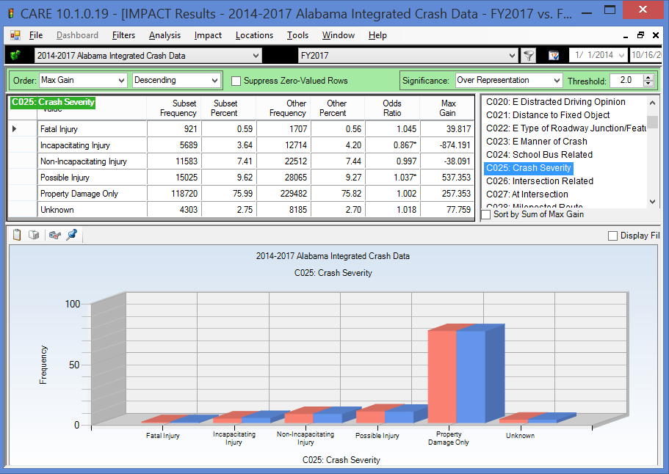

The increase in the proportion of the number of fatal injuries (0.03%) is not significant recognizing that the comparisons take into account the differences in overall crashes. It is a 4.5% increase in the proportions, which are quite small for the overall fatality crash rate per crash. The difference in the average of the two before years is 853.5, which makes a difference in FY2017 of an increase of 67.5 fatal crashes.

In the other injury severities, there is a significant decrease in the Incapacitating Injury and a significant increase in the Possible Injury. This difference tends to balance out the increase in the fatal crashes, since quite often the characteristics of an incapacitating injury crash are not at all different from that crash being fatal. Thus, this reduction should be seen as quite favorable. The difference in Non-Incapacitating Injury is not seen to be significant.

Considering fatal crashes by individual years, the totals for the three years are given in the table below for all crashes and for ID crashes.

 | FY2015 | FY2016 | % Over FY2015 | FY2017 | % Over FY2016
All Fatal Crashes | 766 | 941 | 22.8% | 921 | -2.1%
ID Fatal Crashes | 207 | 226 | 9.2% | 188 | -16.8%
ID % of all Fatal | 27.0% | 24.0% | - | 20.4% | -

Clearly there is a significant trend away from reported ID being the cause of fatal crashes. This should be taken into consideration in the interpretation of the findings regarding the various attributes that are given in the remainder of this problem identification. The increase in overall fatalities from FY2015 to FY2016 was 22.8%, and this decrease was only 2.1% in FY2017. Similarly, the ID fatal crashes had a 9.2% increase and a 1.7% decrease.

Geographical Factors

County

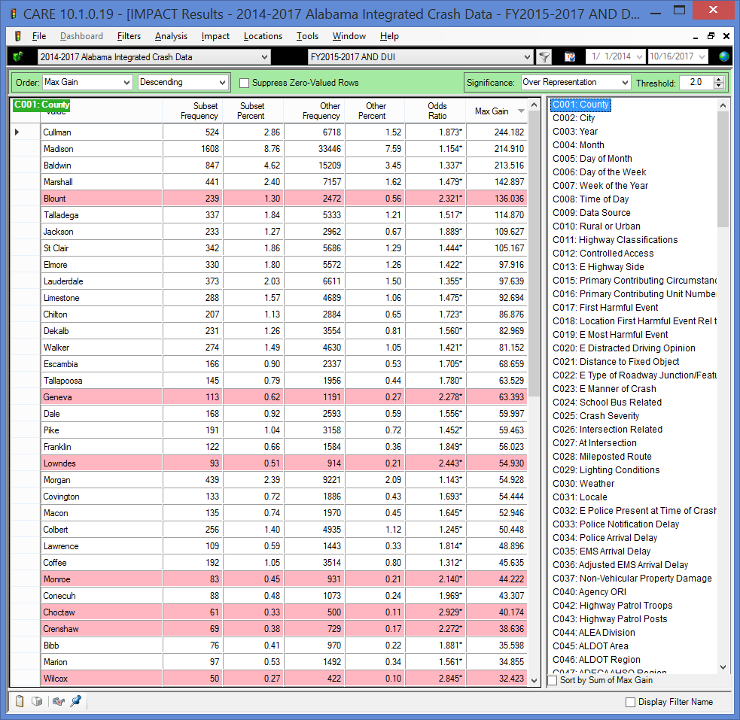

The above has been arranged in highest Max Gain order to indicate the counties that have the highest potential for gain (by reducing the over-representation) at the top. The following output is the rest of the counties in the ordering, so it contains those that are under-represented.

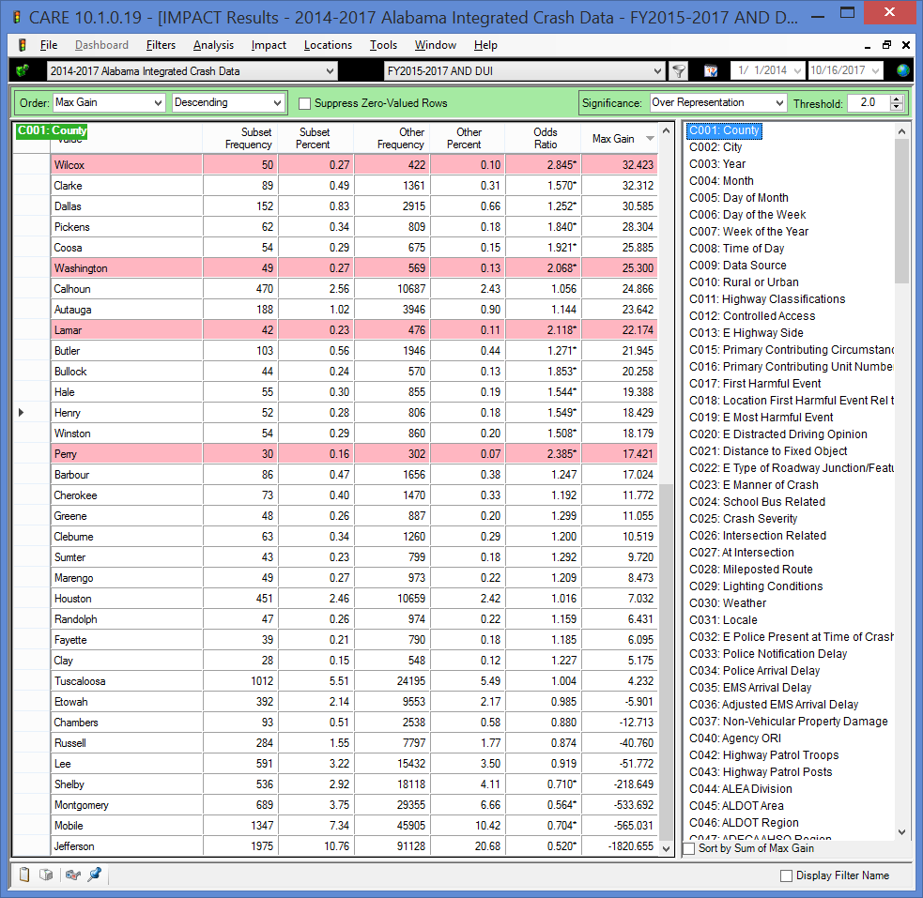

Cullman, Madison, Baldwin, Marshall and Blount have the highest potential for ID crash reduction. At the other end of the spectrum, the counties with the largest cities (e.g., Jefferson, Mobile and Montgomery counties) were the most under-represented counties for impaired driving crashes. Generally, the over-represented counties contain larger rural areas. See the rural-urban comparison below.

Cities Over-represented by Twice the Expected Proportions

For comparison purposes, the rural areas of counties are considered to be “virtual cities” in that crashes that occur there are listed as “Rural County” so that these crashes can be duly accounted for. Generally those rural areas that are adjacent to (or contain) significant urban areas. Contrasted with this finding, there was significant under-representation for impaired driving crashes in the largest cities themselves (e.g., Birmingham, Mobile, Montgomery, Huntsville, Tuscaloosa, etc.). This can be attributed to a number of possible factors in urban areas:
- Less need for motor vehicle travel to the drinking establishments;
- Larger police presence in the metropolitan areas; and
- Lower speeds in rural areas result in a lower severity of crashes, which may be less apt to be reported as caused by impaired driving. Urban crashes contain many described as fender-benders or low-speed rear-end bumper crashes.

The output display below is a list of what are considered to be the most critical cities because of their proportional increases in FY2017 over that occurring in FY2015-2016. The criteria for this list was (1) a total of 100 or more ID crashes in FY2015-2017, and (2) at least twice the expected proportion in the original state-wide IMPACT run. Note that the reduced IMPACT run displayed is a comparison of only the cities shown, so the Odds Ratios do not show the original over-representations, all of which were over 2.00. This display has been placed in Max Gain ordering to put those cities that have the highest potential for ID crash reduction at the top; however, since the original comparison showed all of these (virtual) cities to have an Odds Ratio of greater than 2.00, they should all be of comparable potential for reduction.
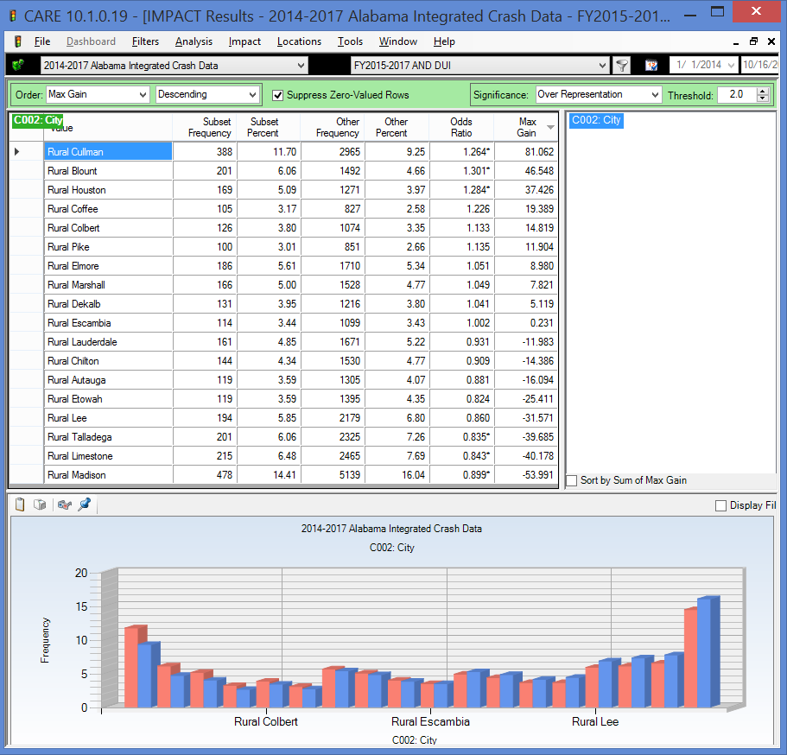

Cities by Number of ID Crashes in FY2015-2017

The following display gives the cities with over 200 ID crashes in FY2015-2017

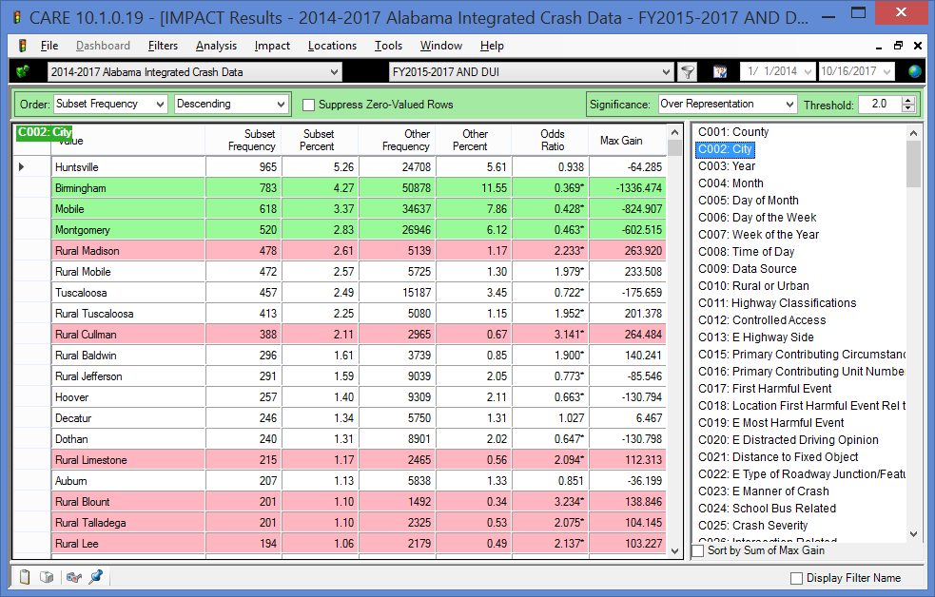

Huntsville, at the top of the list, is interesting in that it also has a relatively high proportion of non-ID crashes (5.61%). And while it is at the top of the list for frequency, it is slightly under-represented in ID crashes (5.26/5.61=0.938). The three largest cities that follow are shown with a green background in that their Odds Ratios are less than 0.500, i.e., they have less than half of the ID crashes that you would expect from the proportion of non-ID crashes.

Use the Odds Ratio to determine which of these cities has more ID crashes (labeled Subset) than would be expected based on their non-ID crashes (labeled Other). The red background indicates that the cell has over twice the expected number of ID crashes.

The following lists cities with 100-200 ID crashes, where some overlap with the other tables is shown in the first and last cells.

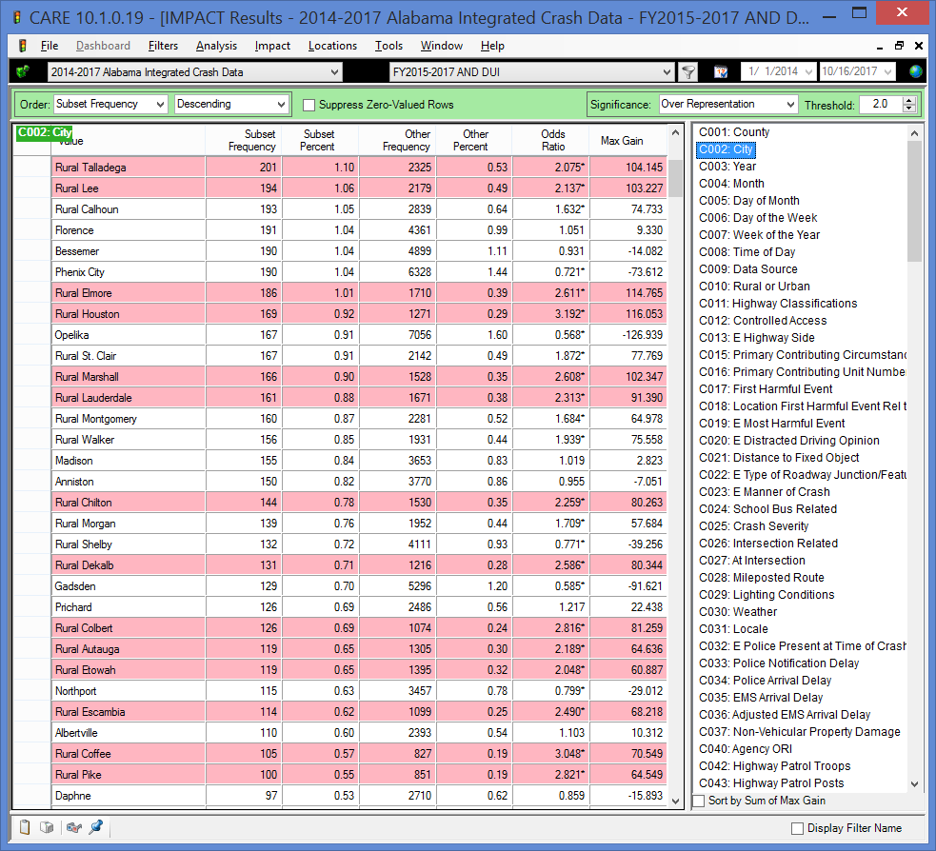

The following lists cities with 60-100 ID crashes, where some overlap with the other tables is shown in the first and last cells.

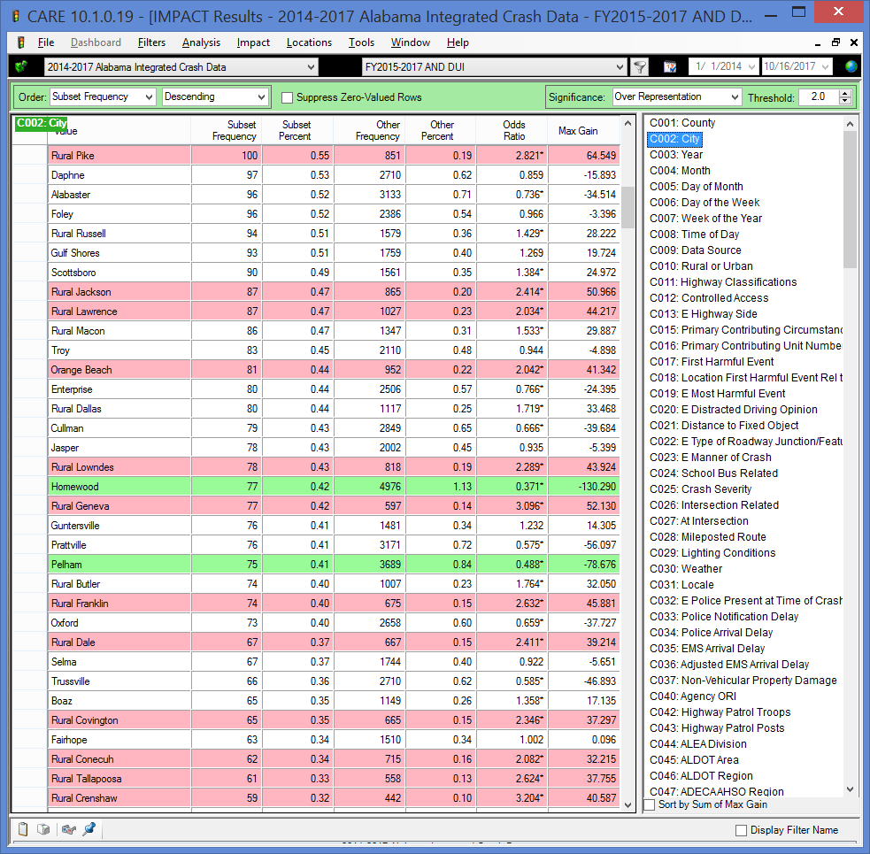

Severity of Crash by Rural-Urban

It is obvious in the above outputs that the rural areas tend to be more over-represented in ID crashes than do the urbanized areas. It is interesting to perform a cross-tabulation over the rural and urban areas to determine to what extent their crashes might be causing relatively more fatalities than would be expected from just a comparison of their crash frequencies. The following gives this analysis.

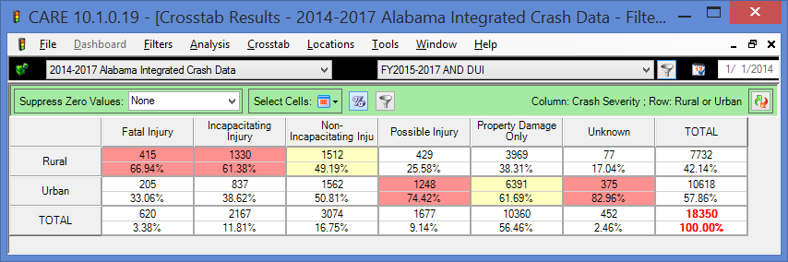

The red cells in the cross-tabulation above indicate over-representation by more than 10%. For example, while 42.14% of crashes occur in rural areas, close to 67% of the fatal crashes occur there. It is imperative to take into consideration crash severity when making geographical decisions regarding countermeasure implementation. Any of the geographic analyses shown in this report could be restricted to fatal crashes or some combination of fatal and injury crashes.

Clearly fatalities and the highest severity of injuries are over-represented in the rural areas.

Some recent ads have stated that the urban areas contain the ID hotspots. This is only true if looking at the total frequency of the ID crashes as the criterion and ignoring severity. It also ignores the high number of crashes in general that are expected to occur in population centers.

Rural or Urban

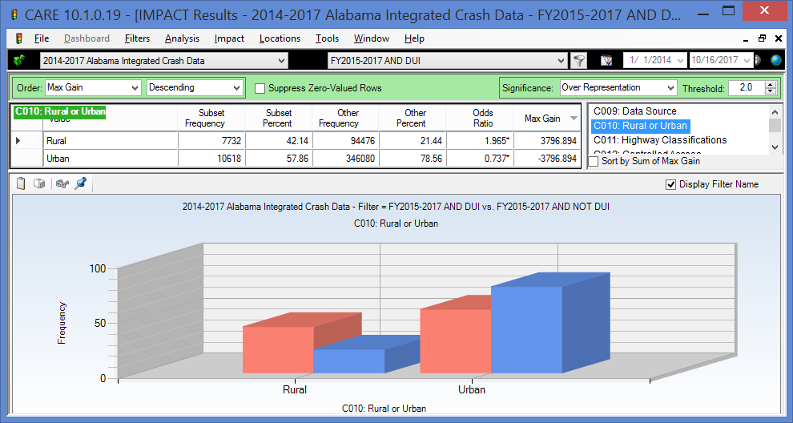

Not only are impaired driving crashes more severe in rural areas, but the chart above shows that 42.14% of the ID crashes occur in the rural areas. This is about double what would be expected from the rural crashes in general (21.44%).

Highway Classifications

Analysis of highway classifications indicates that ID crashes had their greatest over-representation on county roads. County roads had well over twice their expected proportion of crashes, while all other roadway classifications were under-represented. It is very possible that ID locals in the rural areas use the county road system to evade police. Their cunning in this regard does not seem to extend to making it home safely. It is recommended that further analysis be performed to identify the specific county roads that are most highly over-represented, and that some enforcement activities be conducted on the county roads in an attempt to move the ID traffic onto the safer (more forgiving) roadways.

Locale

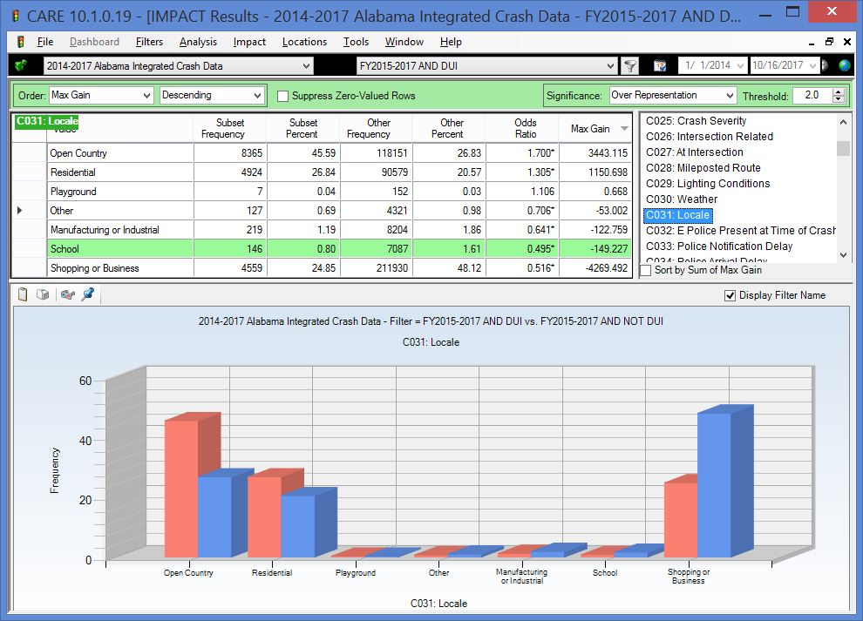

Reflecting the urban over-representation, open country and residential roadways show a higher level of over-representation as compared to the more urbanized roadways.

Time Factors

Year

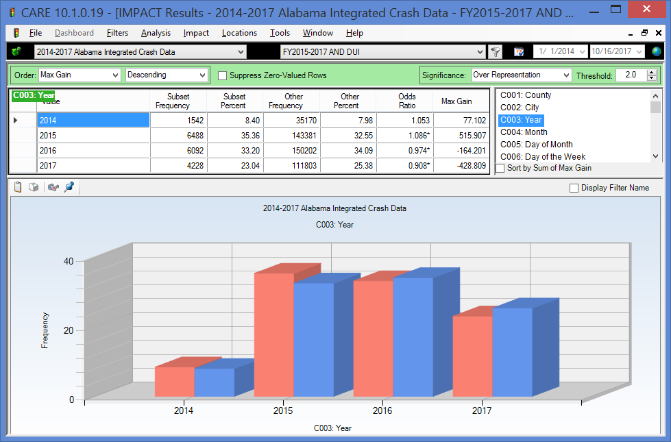

See the Introduction section for a crash frequency comparison of the three fiscal years being considered in these analyses. While the above cannot give a good reading on the overall absolute increase/decrease in ID crashes, it is useful for tracking the relative changes. This is because the 2014 calendar year is only three months (October-December), while the 2017 calendar year displayed is only 9 months (January-September).

However, this does not prevent us from discovering that ID crashes were significantly over-represented in CY2015. The two were almost as expected in the last three months of 2014. In CY2015 the proportion of ID crashes was significantly higher than that for non-ID crashes. This trend was reversed for CY 2016 where almost the opposite under-representation occurred. This gain continued into the first nine months of 2017, and a benefit of nearly 429 crashes was obtained for ID in comparison to the non-ID crash proportion.

This is a good time to emphasize that the ID reports being considered here are those reported to have been DUI (Alcohol or Drugs), which is about 6% of the total reported crashes. While this is an accurate statement of the number reported as such, no one claims that this is the actual number of ID crashes. Many ID caused crashes cannot be verified, and they are therefore not reported as such. These reports over time provide excellent insight into the nature of ID crashes despite their not being a complete set of ID reports. As the severity of the crashes increases, the completeness of the reports in attributing them to ID also increased dramatically. For example, the amount of effort that goes into investigating a fatal crash is at least 10 to 20 times more effort than goes into reporting and obtaining all of the details of most property damage only crashes.

Month

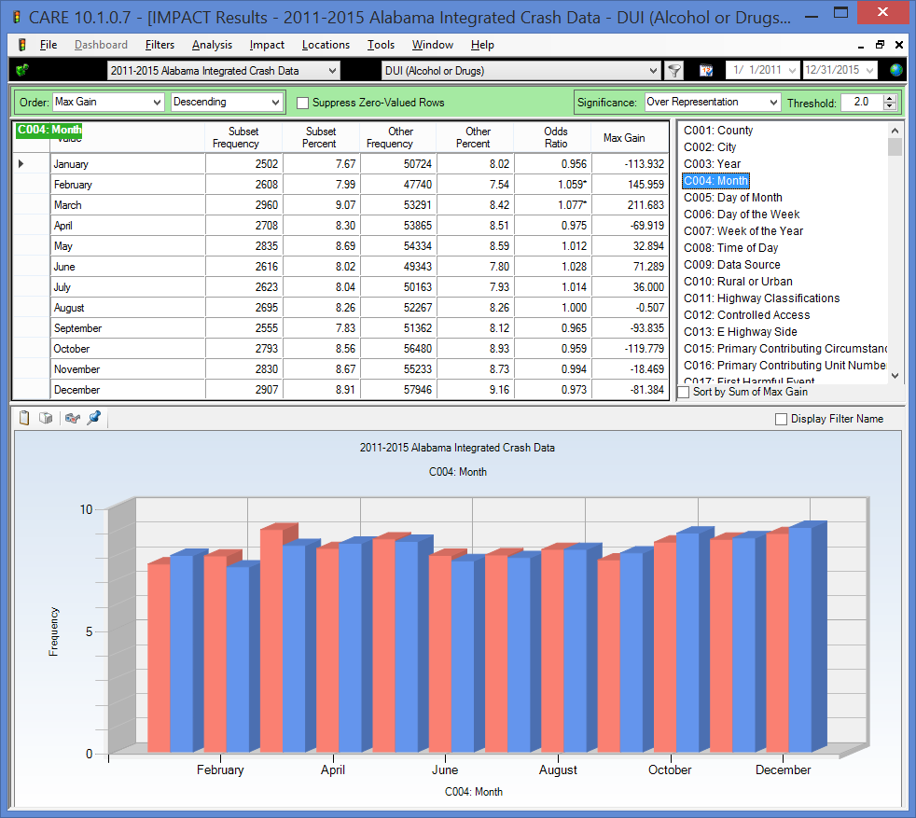

The only significant over-representations by month were in February and March, and there we no significant under-representations. Otherwise the number of ID crashes correlated well with non-ID crashes during each of the remaining months.

Day of the Week

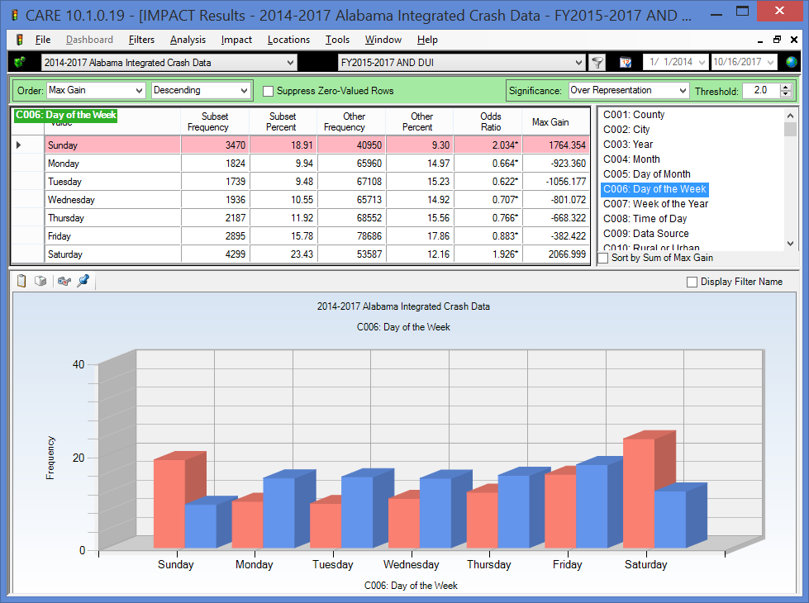

The chart above shows the typical non-holiday week pattern that has been experienced for ID for decades. The days can be classified as follows:
- Weekday (Monday through Thursday) – these days are under-represented in ID crashes we would surmise due to the need for many to go to work the following day.
- Friday – the day before a weekend (or holiday) before a day off work. The Friday pattern is slightly under-represented in ID crashes, not because they do not occur more frequently than weekdays, but because non-ID crashes occur even more. This is due to the increased traffic of combined commuters and vacationers (including short week-end vacations) that causes a bad traffic mix. It may be only slightly denser than a typical rush hour, but it is not homogeneous and restricted to commuters as is the case during most weekday rush hours. No doubt much drug use and increased alcohol consumption is initiated on Friday afternoons.
- Saturday – the “Saturday” pattern is the worse for ID crashes in that it has both an early morning component (like Sunday) and a late (pre-midnight) night component (like Friday). So, it could be viewed as a combination of the typical Friday and Sunday, with one exception. It does not have the increased complexity of the Friday afternoon commuters.
- Sunday – this is the last day of a holiday sequence or as given above, the weekend. Its over-representation comes strictly from those who start on Saturday night and do not complete their use of alcohol/drugs until after midnight.

A holiday “weekend,” such as Thanksgiving, can be viewed as a sequence of a Friday-, Saturdays- and Sunday-pattern sequence. The Wednesday before Thanksgiving would follow the Friday pattern assuming that most are at work that Wednesday. The Thursday, Friday and Saturday would follow the Saturday pattern, and the Sunday would follow the typical Sunday pattern. Holidays that fall mid-week could also be so mapped. This is the reason that long holiday events (i.e., several days off from work) can be much more prone to ID crashes than the normal weekend. There could be a cumulative effect that could show up at any time of the day for some problem abusers. Recently the trend on the pre-Thanksgiving week has been for the holiday to start earlier and earlier in the week, so that Wednesday itself is not one of the worse crash days of the year, as it had been a decade or more ago. This if favorable in reducing the concentration of the traffic and the resultant conflicts.

Time of Day

It is no surprise to find ID crashes over-represented during the late night/early morning hours. The extent of these over-representations, however, is quite amazing. The blue bars above follow the typical traffic patterns of high traffic in the morning and afternoon rush hours. ID crashes are just getting started in the afternoon rush hours and they continue to grow through midnight and the early morning hours, not tapering off until about 5:00 AM. It is clear that if selective enforcement is going to have an effect on ID crashes, it would have to be conducted at the times when these crashes are most occurring. Optimal times for enforcement would start immediately following any rush hour details, and would continue through at least 3:00 AM.

So generally, the worst times in any day are given in red for that day. This works well for Saturday and Sunday mornings, and also for Friday night. Why does it not work for Saturday night? The answer is that Saturday morning has drained all the red into its cells, so to speak, and there is none left over for Saturday night. Note, for example, that the frequencies of crashes on Saturday exceed those on Friday for all time slots. However, because of the high numbers and proportions on Saturday morning, the proportions on Saturday night are lower despite the frequencies being higher. We urge users to look at both the numbers and the colors. This is also especially true when the numbers in all of the cells is relatively low. When the cell numbers get less than 20, it is best to ignore the colors and just look at the cell frequencies to get a feel for the situation.

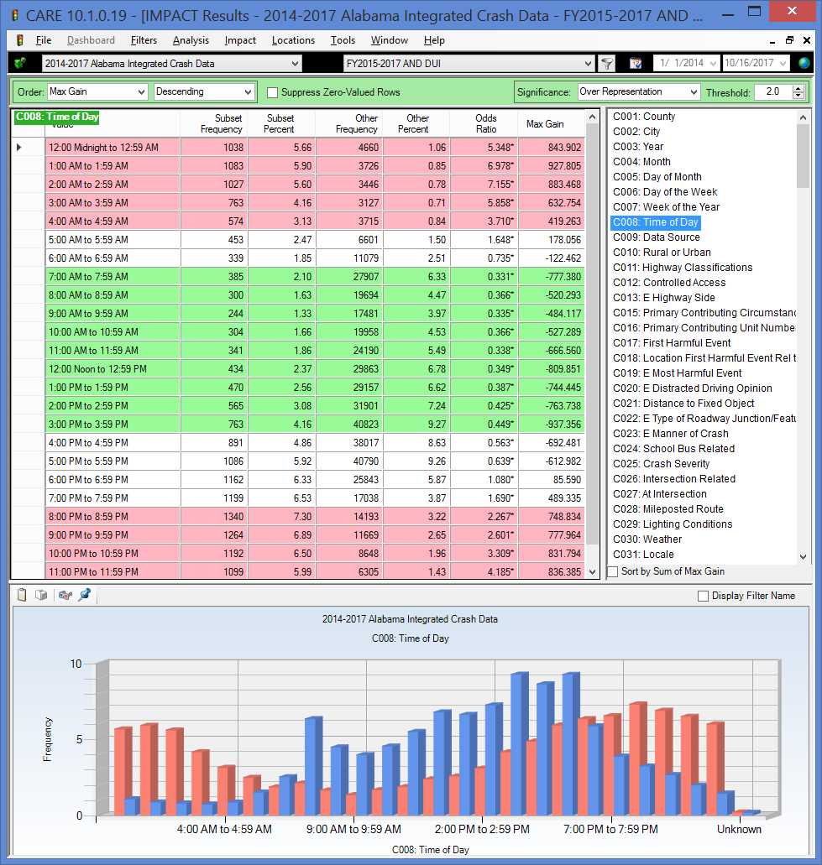

Time of Day by Day of the Week

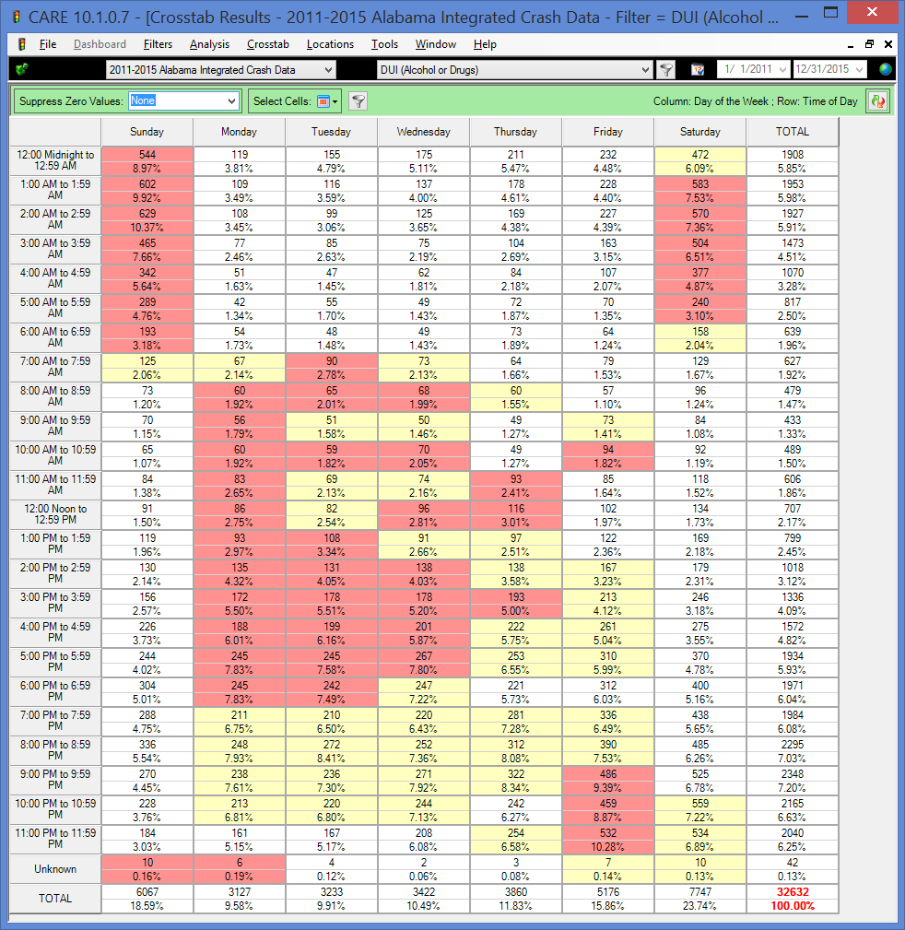

The Time of Day by Day of the Week cross-tabulation (given in the next section) shows the optimal times for selective enforcement, with one qualifier: Saturday night (before midnight). This is an excellent example to demonstrate how the color coding of CARE cross-tabulations can be misleading in some special cases. The red background indicates that the over-representation of the cell is greater than expected. The expected proportion for all cells in a given row is given at the extreme right in the total row percentage for that row. If there were absolutely no over-representations for the columns, then all of the proportions for that column cell would be identical to the one for the total. Notice for example, the 12 midnight to 12:59 AM row has a total percentage value of 5.85%. Those that are under this value have a neutral (white) background. Those that are higher, but not more than 10% of the proportion are yellow; and those above 10% of the proportion are red.

Factors Affecting Severity

ID Crash Severity

The following compares crash severities for ID (Subset, red bars) vs. Non-ID crashes (Other, blue bars).

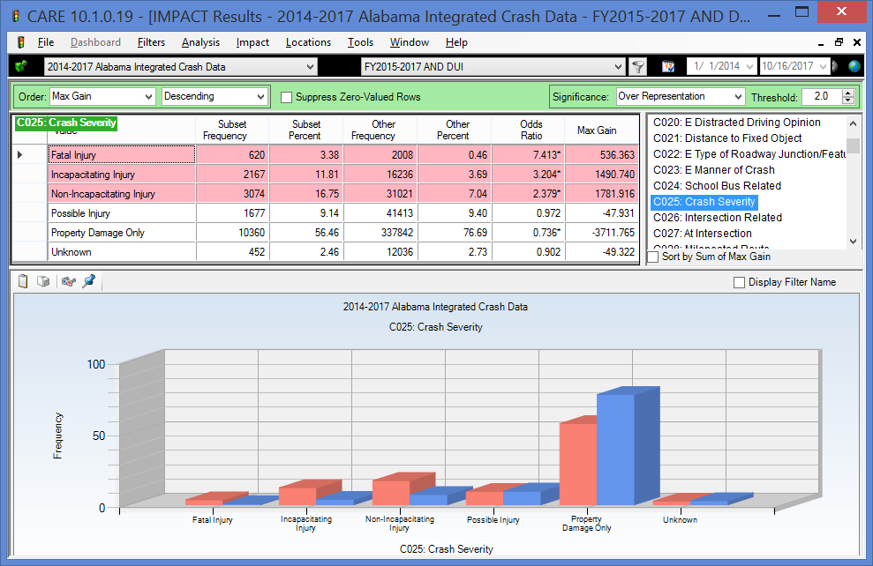

The rate of fatal injury crashes and the two highest injury classifications are consistently higher in ID crashes than that of non-ID crashes. Fatality crashes have over seven times their expected proportion, while the two highest non-fatal injury classifications have over twice their expected values when compared with non-impaired driving crashes. The Speed-at-Impact variable, considered next, indicates one of the primary reasons for this.

Speed at Impact

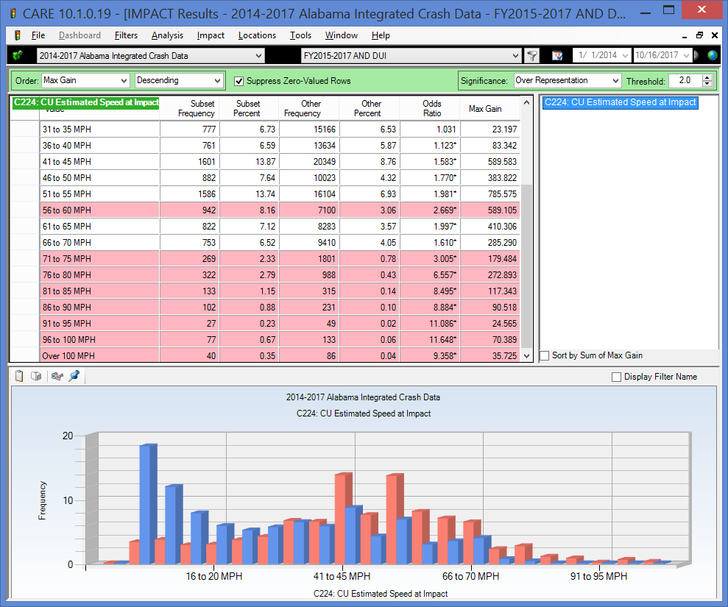

It should be noted that the speed limit on country roads is generally 45 MPH. All speeds above 40 MPH are dramatically over-represented, and the over-representation increases with the increase in impact speeds, from about 1.6 at 45 MPH to 11.6 at 100 MPH.

The next cross-tabulation quantifies how this relates to the severity of the crash for ID crashes.

Severity by Impact Speed

The following display presents information on the effect of increased impact speed on the severity of the crash.

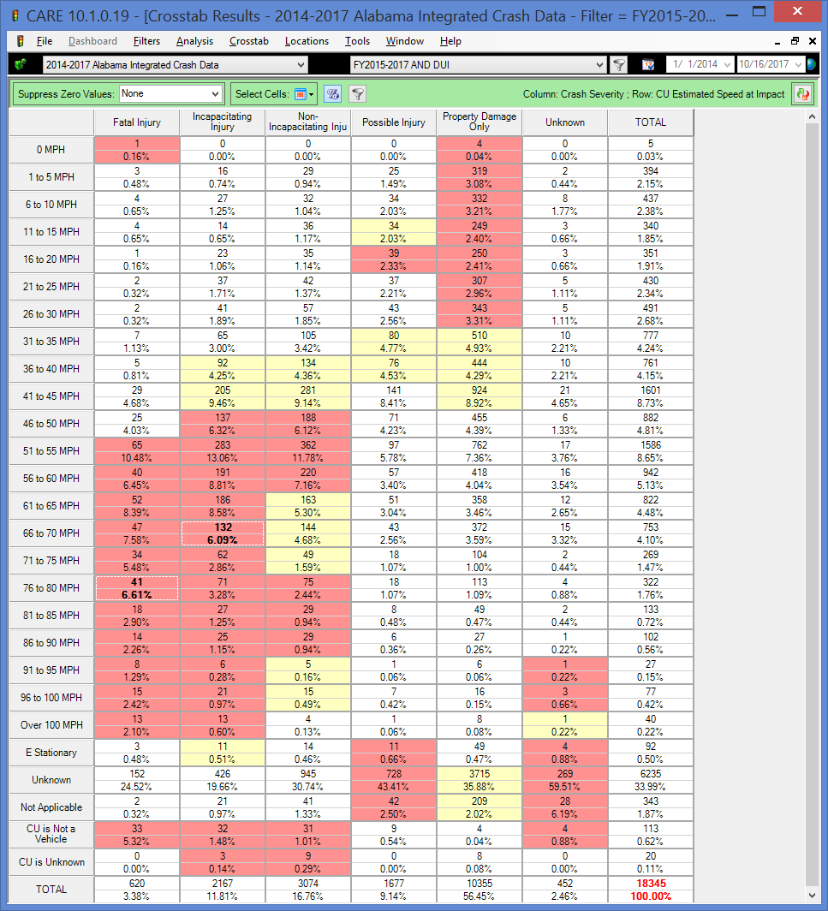

Notice the red in the fatality and severe injury cells as speeds increase. What is more enlightening is the probability that the crash results in a fatality as a function of impact speed. In the 41-45 MPH impact speed the probability is only a little over one in every 55 crashes. As impact speeds climb to the 51-55 MPH, this probability more than doubles to one in about 24 crashes. At 61-65 MPH it increases again (exponentially) to one in about every 16 crashes, and at 71-75 it is about one in eight, which is about double again. For above 90 MPH it is about one in 4 crashes.

The rule of thumb is that for every 10 MPH increase in speeds, the probability of the crash being fatal doubles. Conversely, a reduction in impact speeds by 10 MPH would cut the number of fatal crashes in half. This is the reason that selective enforcement is effective. However, there is another major factor in effect as well – the failure of ID drivers to be properly restrained, which will be covered in a separate attribute below (Restraint Use by Impaired Drivers).

It was found in a comparison of the first 9 months of 2017 vs. 2016 that there was a dramatic decrease in fatalities caused by ID. Further analyses determined the reason for this was the reduction in impact speeds. In FY2016, 54.3% of the impact speeds were 50 MPH or above; in FY2017 this number was reduced to 50.3%. This reduction in impact speeds for ID crashes is the major cause of the reduction in ID fatality crashes in FY2017 as shown in the next section.

Severity of ID Crashes Comparing FY2016 vs FY2017

The following display shows the reduction in FY2017 (Other, blue bars) that occurred as compared to FY2016 (Subset, red bars). The reduction was from 226 to 188, which was a 16.8% reduction in ID fatal crashes. The proportions do not show as dramatic a decrease since the overall number of ID crashes also was also down significantly, from a total of 6304 crashes (all severities) to 5808, which was a 7.9% overall decrease. So both the overall crashes and the fatality crashes were reduced, but the reduction in the fatality crashes were obviously much greater than that of the overall crashes.

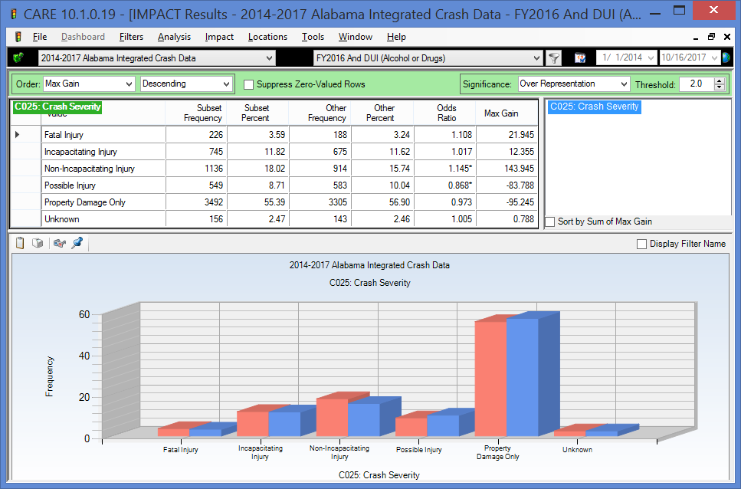

Restraint Use by Impaired Drivers

The following display presents a comparison of ID driver safety belt use against those who were not ID in the same time period.

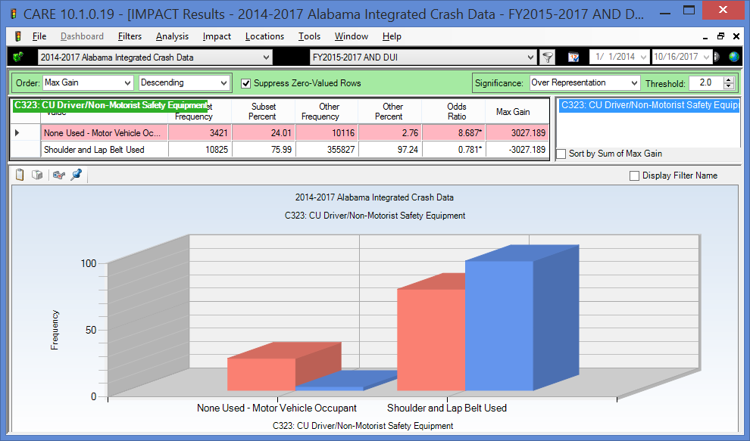

Risk-taking involved in ID does not stop with excess speed; it extends to not being properly restrained. The above analysis demonstrates that the impaired driver is close to nine (8.687) times more likely to be unrestrained as in the non-ID crash. The next analysis demonstrates how this contributes to fatality crashes.

Fatality Crashes by Restraint Use for Impaired Drivers

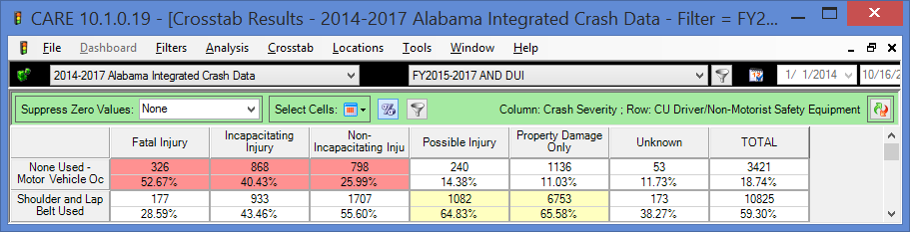

A comparison of the probability of a fatal crash indicates that a fatality is almost six (5.82) times more likely if the impaired driver is not using proper restraints. The probability is estimated by 326 fatality crashes out of 3,421 when restraints were not used (=1 in 10.5), as opposed to only 177 fatal crashes out of 10,825 crashes when restraints were used (1 in 61.2). So the combined effect of lower restraint use and higher speed is a devastating combination that accounts for the high lethality of ID crashes. But that is not all; see the following three items for additional related information.

Number Injured (Including Fatalities)

The following display presents a comparison of ID crash number of injuries against number of injuries in crashes that were not ID in the same time period.

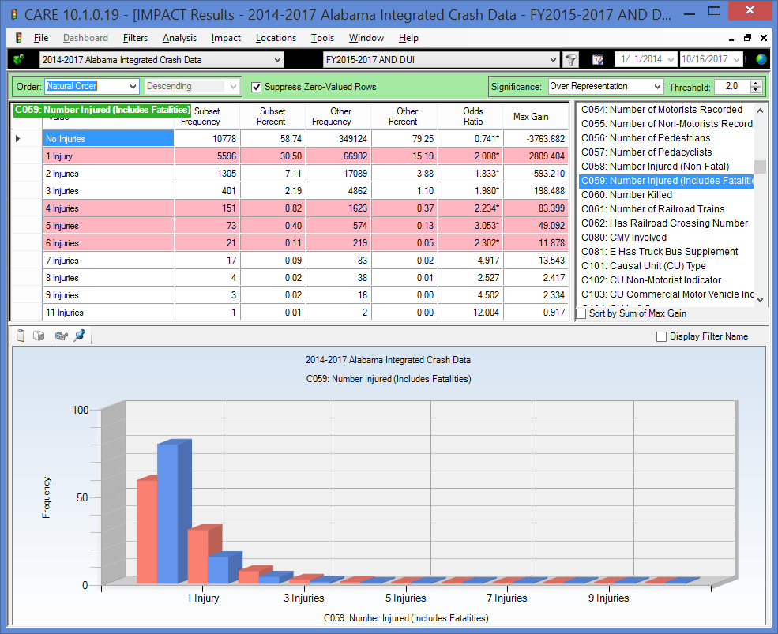

The above shows that not only are ID crashes more severe to those injured, but also the number of multiple injuries in these ID crashes is over-represented as well. Some might suspect that an ID crash might involve just a driver returning home from a night of indulgence. However, rarely is the impaired driver alone, and, of course, if another vehicle is involved, then that would also generally increase the number of injuries. It is interesting that all of the multiple-injury categories are over-represented.

Police Arrival Delay

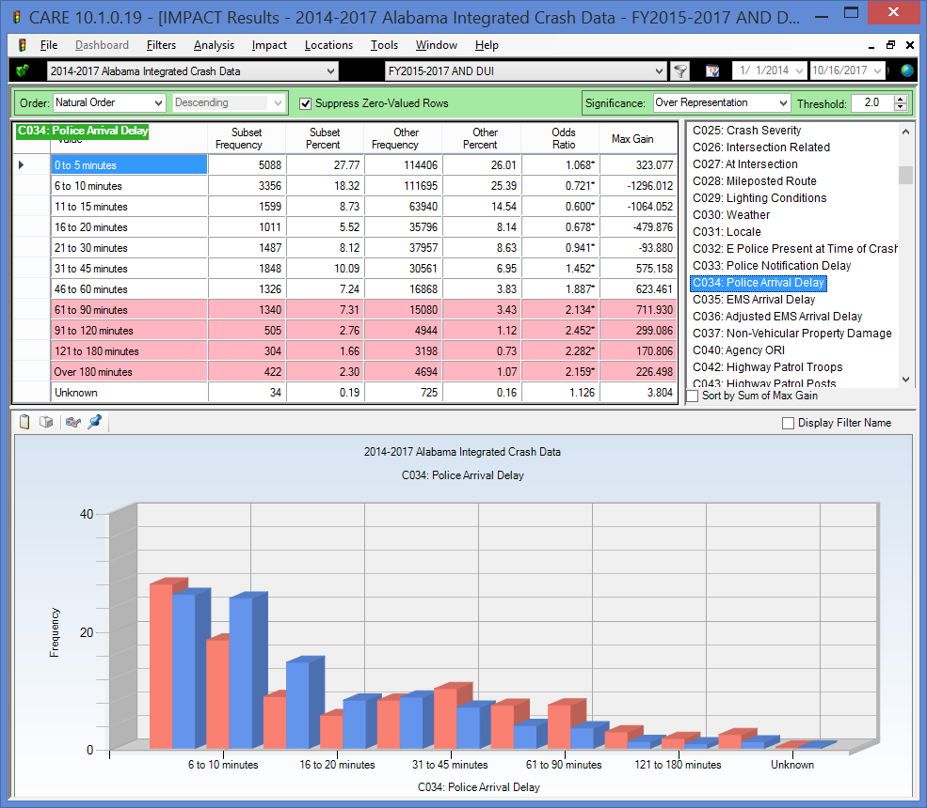

ID crashes generally had longer police arrival delays; in this case all arrival delays over 30 minutes were over-represented. There can be little doubt that this has to do with the rural nature of these crashes and the potential that at night they would not be discovered for some time. The analysis below shows how this impacts EMS arrival time, which is a comparison of crashes that include injuries, and thus would generally call for an EMS response.

EMS Arrival Delay

For much the same reasons as the longer police arrival delays, EMS delays were over-represented for impaired driving crashes in all categories above ten minutes, and dramatically for the very longer times of 61 minutes and above (indicated by the red background in the table). This obviously contributes to the severity of crashes and the chances that the crash results in one or more fatalities. As for the very long times, these might be due to the delay in discovering the crash since they generally over-represented late night in rural locations.

Driver and Vehicle Demographics

Driver Age

The following display presents a comparison of ID crash causal driver age against the same for crashes that were not ID in the same time period.

The blue (non-ID) bars illustrate the problems that 16-20 year old drivers have in general. On the bright side, these issues are not generally caused by ID up until ages 19 and 20, and even at these ages they are under-represented. The first age with a significant over-representation starts at age 24 and continues on to age 55. It is clear that the legal drinking age is having a very positive effect on keeping the numbers down for the 16-20 year old drivers, and any attempt to decrease this legal age should be fought strenuously by the traffic safety professionals despite evidence to the contrary presented by other disciplines.

There is a bi-modal distribution in the 21-55 year olds; 21 through about 35, and a second group from 36 to 54. Generally the first of these might be classified as social drinkers. However, it is hard to escape the fact that those who are in their late 30s up through their middle ages would not be largely problem drinkers. Countermeasures for these two groups will typically be quite different.

Impaired Driver Gender

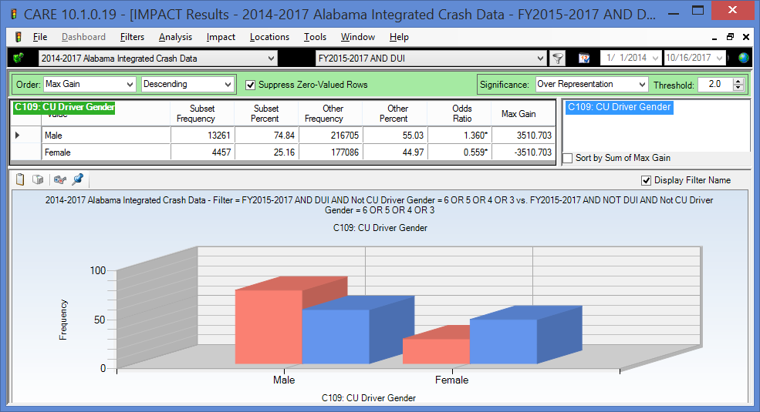

The red bars and the blue bars each sum to 100%. So the breakdown in male IS causal drivers is 74.84% male and 25.16% female. For non-ID, the percentage is 55.03 male and 44.97 female. These differences certainly indicate that males are a far greater issue, and if there are countermeasures that can be directed toward them, doing so would be much more cost-effective, all other things being equal.

Causal Vehicle Types with 30 or more Crashes

The following display presents a comparison of ID crash causal unit type against the same for crashes that were not ID in the same time period.

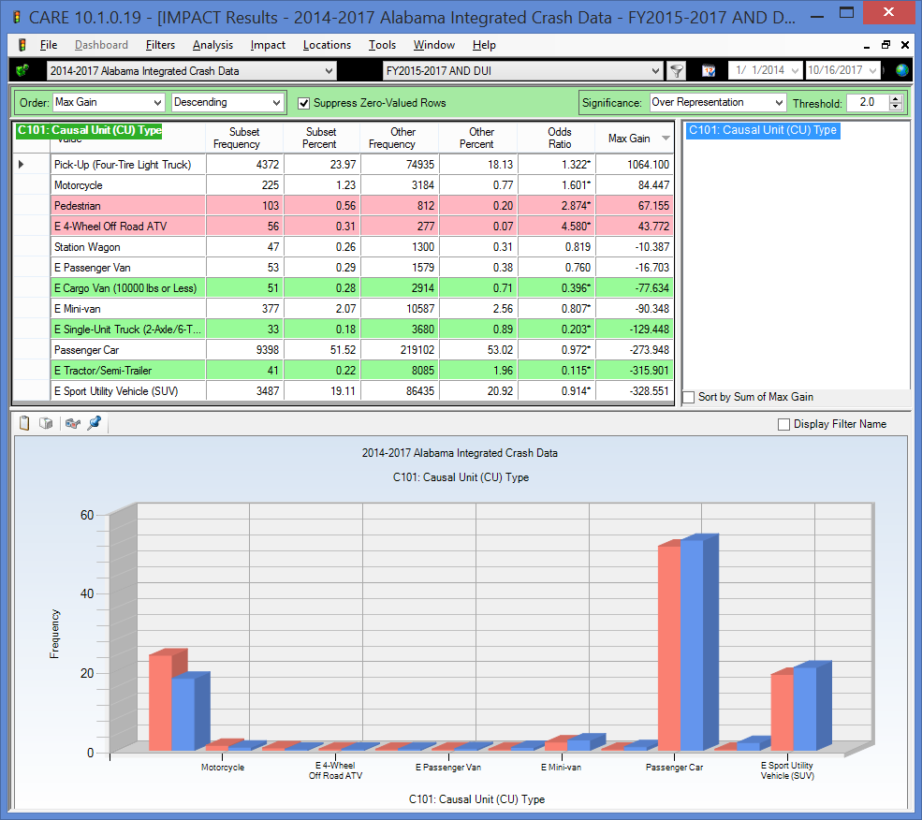

Vehicles types with less than 30 crashes in the ID dataset were removed for the above display, and pedestrians were considered a unit type. While pickups have the highest MaxGain indicting the greatest potential for reduction, Motorcycles, Pedestrian and ATVs all have higher over-representations but their MaxGain is lower because of their lower frequencies. Of interest is the proportion of pedestrians and off road 4-wheelers that involve ID, both of which are over two times their expected proportion. So the major finding of this analysis is that motorcycle, pedestrian and 4-wheeler crashes have far more than their share of ID causation.

Driver License Status

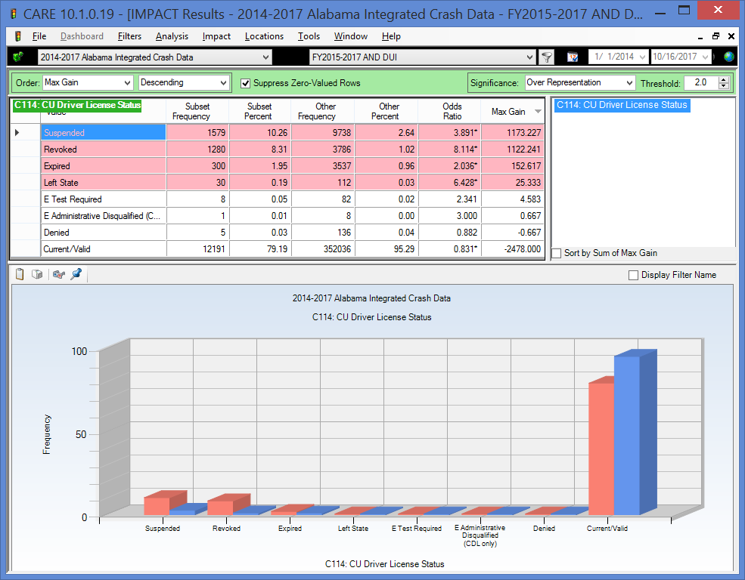

Clearly ID crashes are so over-represented in ID causal drivers without legitimate licenses that the question might be asked: Does suspending or revoking their licenses even make a difference? Some states have gone so far as to make it a mandatory arrest if a driver is found to not have a current license. The results of this analysis need to be given serious consideration by those determining the direction of the legislative process regarding ID. It seems clear that the suspension/revocation of licenses is not bringing about the desired effect.

Driver Employment Status

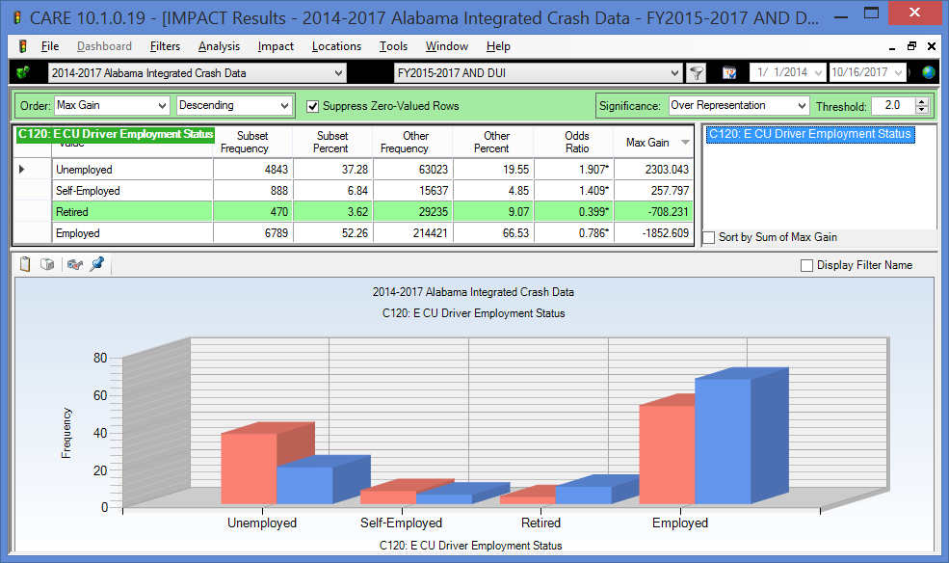

In our current era when the economy is playing such a big role in traffic safety, the quantification and tracking of the employment proportion of drivers involved in ID crashes will be important. This indicates that their unemployment rate is about 90.7% higher than expected. This is probably not unexpected, and the correlation between not having a job and being involved in an ID crash should be watched carefully going forward in that it could affect the type and location for countermeasures.

Summary of Findings

The following summarizes the findings of the problem identification analyses given above:

- General Comparison of FY2017 against FY2015-2016
  - Overall crash frequencies got FY2017 were about 5000 crashes higher than the average of FY2015-2016. Total crashes in FT2017 were only about 1560 fewer than in FY2016. Thus, there is nothing in the overall crash picture that would suggest that FY2017 should not be comparable to FY2015-2016, or even to FY2016 alone.
  - In a comparison of the fiscal years, overall fatal crashes were up by 22.8% in FY2016 over FY2015, and this only came down by 2.1% in FY2017.
  - A similar a comparison of the fiscal years of ID fatal crashes showed an increase of 9.2% in FY2016 over FY2015, and this only came down by 1.7% in FY2017.
  - On the other hand, there was a remarkable decrease in the proportion of fatal crashes caused by ID to the overall number of fatal crashes for each year. Over the three fiscal year periods (FY2015-2017), the proportions were 27.0%, 24.0% and 20.4%, a significant overall reduction of reported ID fatal crashes of 6.6%. The reason for this was given intensive analysis in the Factors Affecting Severity Section.

- Geographical Factors
  - County - Generally, the over-represented counties are those with combined large population centers and large rural areas, as opposed to the highly urbanized counties or the extremely rural counties. One reason that the highly urbanized counties are under-represented is the large number of low severity crashes that occur there separate and apart from ID crashes. See the rural-urban comparison below.
  - Rural Areas with the Greatest Increases in FY2017 – several virtual cities (rural areas of counties) were found to have over twice the proportion of ID crashes compared to their proportions in FY2015-2016. Place in Max Gain order, the ones with the highest potential for reduction were (all rural areas of the following counties): Cullman, Blount, Houston, Coffee, Colbert, and Pike.
  - City Comparisons of ID crashes by Total ID Crash Frequency. There is little surprise in this output, which tracks the areas by population. Traffic safety professionals should look for any locations that fall counter to this trend.
  - City (and area) Comparisons within Crash Frequency Ranges – analyses were performed for those areas that had 100-200 ID crashes as well as those that had 60-100 ID crashes. There are presented separately to present fair comparisons among the various areas.
  - Overall Area Comparisons Conclusions –Generally those rural areas that are adjacent to (or contain) significant urbanized areas are over-represented, since their urban areas generate more traffic even in the rural areas. Possible factors for relatively fewer severe ID crashes within urban areas include:
    - Less need for motor vehicle travel and shorter distances to the drinking establishments;
    - Larger police presence in the metropolitan areas; and
    - Lower speeds in rural areas.
  - The city, county, and area comparisons are, of necessity, a selection of the total outputs that could be generated. They are given to illustrate the capabilities as much as to present the numerical results. Anyone wishing additional studies or outputs, please contact CAPS – see e-mail address above.
  - Severity of Crash by Rural-Urban – While only about 42% of crashes occur in rural areas, nearly 67% of the fatal crashes occur there. Similar results are found for the highest severity non-fatal crashes. This is obviously the result of higher impact speeds in the rural areas. Note that additional causes of increased severity are given in the Factors Affecting Severity Section.
  - Rural or Urban ID Crash Frequency – Not only are impaired driving crashes more severe in rural areas, but their frequency is about the same as in the urban area, despite the much lower population and traffic volumes (about 42% rural as compared to about 58% urban). While only 22.44% of the crashes are expected in the rural areas, the proportion of crashes in the rural areas is over 42.14%, or very close to double its expected value (Odds Ratio = 1.965).
  - Highway Classifications – County roads had well over twice their expected proportion of crashes, while all other roadway classifications were under-represented. County road characteristics no doubt contribute to the crash frequency. County roads are also known to be less “crashworthy” (i.e., they result in more severe crashes at comparable impact speeds).
  - Locale – Reflecting the rural over-representation, open country and residential roadways show a high level of over-representation as compared with the more urbanized area types, especially Shopping or Business, which only has about half of its expected proportion.

- Time Factors
  - Year – a discussion of the overall crash, fatal crash and ID fatal crash frequencies by year were given in the section above entitled IS Update for FY2017 that appears right after the Introduction. The display in the Year attribute section presents and discusses the three fiscal years according to their calendar year occurrences.
  - Month – There only significant over-representations by month was in February and March, indicating that the number of ID crashes correlated well with the other crashes during the rest of the months. None of the months were significantly under-represented.
  - Day of the Week – This analysis is not only useful for the typical work week, but it also reflects the typical “holiday weekend” patterns. The days can be classified as follows:
    - Typical work weekday (Monday through Thursday) – these days are under-represented in ID crashes due to the need for many to go to work the following day.
    - Friday – this pattern is also reflected in the day before a weekend (or holiday), i.e., before a day off. The high ID frequency on this day is due to those who are getting an early start to the weekend, recognizing that they have no work responsibilities the following day.
    - Saturday – the “Saturday” pattern is the worse for ID crashes in that it has both an early morning component (like Sunday) and a late night component (like Friday). So, it could be viewed as a combination of the typical Friday and Sunday.
    - Sunday – since this is the last day of a holiday sequence or weekend, its over-representation comes strictly from those who start on Saturday night and do not complete their use of alcohol/drugs until after midnight.
  - “Holiday Weekends” – these can be viewed as a sequence of the weekend-pattern sequence. For example, the Wednesday before Thanksgiving would follow the Friday pattern assuming that most are at work on Wednesday. The Thursday, Friday and Saturday would follow the Saturday pattern, and the Sunday at the end of the weekend would follow the typical Sunday pattern. This is the reason that long holiday events (i.e., several days off) can be much more prone to ID crashes than the typical weekend. Three-day weekends typically give Monday off, so that Monday would behave like the typical Sunday, and both the Saturday and Sunday would follow the Saturday pattern.
  - Time of Day – The extent to which night-time hours are over-represented is quite striking. Optimal times for ID enforcement would start immediately following any rush hour details, and would continue through at least 3 AM.
  - Time of Day by Day of the Week – This quantifies the extent of the crash concentrations on Friday nights, Saturday mornings and Saturday nights and early Sunday mornings. This is a very useful summary for deploying selective enforcement details.

- Factors Affecting Severity
  - ID Crash Severity -- The rate of injuries and fatalities are consistently higher in ID crashes than that of non-ID crashes. Fatality crashes are over seven times their expected proportion, while the two highest non-fatal injury classifications have over twice their expected values when compared with non-impaired driving crashes The odds ratio is over three (3.204) for the highest non-fatal classification, Incapacitation Injury. The other variables analyzed in this section give the reasons for this disparity.
  - Speed at Impact – All impact speeds above 45 MPH are dramatically over-represented. See the next attribute.
  - Severity by Impact Speed –Past analyses have found the general rule of thumb that for every 10 MPH increase in speeds, the probability of the crash being fatal doubles. This was validated in the discussion of the cross-tabulation.
  - Severity Comparison FY2017 vs FY2016 – There was a reduction from 226 in FY2016 to 188 in FY2017, which was a 16.8% reduction in ID fatal crashes. Both the overall crashes and the fatality crashes were reduced, but the reduction in the fatality crashes were obviously much greater than that of the overall crashes.
  - Restraint Use by Impaired Drivers – The impaired drivers are close to 9 times more likely to be unrestrained than the non-ID causal drivers. Clearly ID drivers lose a good part of their concept of risk when they are willing to drive while being impaired.
  - Fatality Crashes by Restraint Use for Impaired Drivers – A comparison of the probability of a fatal crash indicates that a fatality is almost six (5.82) times more likely if the impaired driver is not using proper restraints. With restraints, one in 61 ID crashes are fatal; but without restraints, the fatal crash ratio is 1 in about 11. So the combined effect of lower restraint use and higher speed is a devastating combination that accounts for much of the high lethality of ID crashes.
  - Number Injured (Including Fatalities) – Not only are ID crashes generally more severe to the driver, but the number of multiple injuries in these ID crashes is over-represented as well. This might have something to do with the preference of those going out to socialize to take some of their friends with them.
  - Police Arrival Delay – ID crashes generally had longer police arrival delays; in this case all arrival delays over 31 minutes were over-represented. There can be little doubt that this has to do with the rural nature of these crashes and the potential that the late night occurrence might not be discovered for some time.
  - EMS Arrival Delay – Higher EMS delays were over-represented for impaired driving injury crashes in all categories above ten minutes, and dramatically for the very longer times of 46 to 60 minutes and above. This obviously contributes to the severity of crashes and the chances that the crash results in one or more fatalities. As for the very long times, these might be due to the delay in discovering the crash as much as their generally over-represented rural locations.

- Driver and Vehicle Demographics

  - Driver Age – Younger (16-20 year old) drivers have a very serious problem in crash causation even in the absence of impairment. However, these crashes are not generally caused by ID up until ages 19 and 20, and even at these ages they are under-represented. At 23, the first age over-representation takes place and continues on to age 55. There is a bi-modal distribution in the 21-54 year olds; 21 through about 35, and a second group from 36 to 55. Generally, the first of these might be classified as largely social drinkers; while it is inescapable that the middle aged caused ID crashes would be largely problem drinkers.
  - Impaired Driver Gender –Males are a far greater issue in ID crashes, and if there are countermeasures that can be directed toward them, doing so would be much more cost-effective than those that are not gender based, all other things being equal.
  - Causal Vehicle Type – Pick-ups, which up had a significant over-representation and came out at the top of the Max Gain order because of their large number of ID involvements. Motorcycles were also highly over-represented. Also of interest is the proportion of pedestrians that involve ID, which is close to three times their expected number. ATVs had the highest over-representation (Odds Ratio = 4.580), perhaps because drivers do not believe that the ID laws apply to them as long as they are not on the public highways.
  - Driver License Status – ID crashes are very highly over-represented in causal drivers without legitimate licenses challenging the effectiveness of license suspension and revocations as a traffic safety countermeasure, at least after the fact. There is no way to estimate its deterrent value.
  - Driver Employment Status –ID driver unemployment rate at 37.38% is about 90% higher than expected. This factor will be watched carefully going forward.

Appendix C. Detailed Legislative Recommendations

These issues are listed and summarized at a very high level in Section 4.1. All of the legislative actions recommended in this appendix have all been formally filed and introduced in the legislature within the last 2 sessions.

C.1 Change the Way DUI is Charged & create a per se DUI/Drug Offense.

Under current law, Ala. Code 32-5A-191 (1975), an officer must elect the method of impairment at the time of a DUI arrest.

If an offender is impaired by a drug or drugs other than alcohol, the officer has no way of knowing if that substance is controlled or not until a toxicology report is issued weeks after the arrest. If the officer guesses incorrectly, the charge is due to be dismissed. The dismissal is solely due to the officer guessing wrong as to the impairing substance not because of the merits of the case. This is a guess the officer is charged under the law to make without having all the facts.

The suggested change to the statute reads as follows:

A person shall not drive or be in actual physical control of any vehicle while:
(1) There is 0.08 percent or more by weight of alcohol in his or her blood;
(2) Under the influence of alcohol; There is such a blood concentration of the following substances that is equal to or greater:
a. 90 ng/mL of Alprazolam.
b. 200 ng/mL of Amphetamine.
c. 10,000 ng/mL of Butalbital.
d. 10,000 ng/mL of Carisoprodol or meprobamate.
e. 70 ng/mL of Clonazepam.
f. 20 ng/mL of Cocaine.
g. 5 ng/mL of Delta-9-tetrahydrocannabinol (THC).
h. 500 ng/mL of Diazepam or nordiazepam.
i. 60 ng/mL of Hydrocodone.
j. 100 ng/mL of Lorazepam.
k. 250 ng/mL of Methadone.
l. 10 ng/mL of Methamphetamine.
m. 100 ng/mL of Morphine.
n. 100 ng/mL of Oxycodone.
o. 800 ng/mL of Tramadol.
p. 50 ng/mL of Zolpidem.
(3) Under the influence of a controlled substance alcohol, a controlled substance, or any other substance, or combination of two or more of those substances, to a degree which renders him or her incapable of safely driving;
(4) Under the combined influence of alcohol and a controlled substance to a degree which renders him or her incapable of safely driving; or There is 0.02 percent or more by weight of alcohol in his or her blood and the person is under the age of 21 years;
(5) Under the influence of any substance which impairs the mental or physical faculties of such person to a degree which renders him or her incapable of safely driving. There is 0.02 percent or more by weight of alcohol in his or her blood and the person is a school bus or day care driver acting in performance of his or her duties; or
"(6) There is 0.04 percent or more by weight of alcohol in his or her blood and the person is driving or in actual physical control of a commercial motor vehicle as defined in 49 CFR Part 383.5 of the Federal Motor Carrier Safety Regulations as adopted pursuant to Section 32-9A-2.

C.2 Increase refusal penalties

Under current law, Ala. Code 32-5-192 (1975), a person who refuses to submit to a chemical test after they have been arrested for DUI is due to having their driver license suspended for a period of 90 days which is the same penalty administered upon being convicted of a first offense DUI where the offenders breath alcohol content (BrAC) was below 0.15 at the time of the offense. If an offender is convicted of a first offense DUI and has a BrAC of 0.15 or greater at the time of the offense, then the offender’s DL is subject to a one-year suspension.

As the law currently reads, the offender not only has no incentive to take a chemical test, but they have incentive to refuse a chemical test. This aspect of the law needs to be changed.

The penalty for refusing a chemical test needs to be the same as that of someone having a BAC of 0.15 or greater. The offender should not be rewarded for refusing a chemical test after they have been arrested for DUI.

The suggested change to the statute reads as follows:

Implied consent; when tests administered; suspension of license or permit to drive, etc., for refusal to submit to test.

(a) Any person who operates a motor vehicle upon the public highways of this state shall be deemed to have given his consent, subject to the provisions of this division, to a chemical test or tests of his blood, breath or urine for the purpose of determining the alcoholic content of his blood if lawfully arrested for any offense arising out of acts alleged to have been committed while the person was driving a motor vehicle on the public highways of this state while under the influence of intoxicating liquor. The test or tests shall be administered at the direction of a law enforcement officer having reasonable grounds to believe the person to have been driving a motor vehicle upon the public highways of this state while under the influence of intoxicating liquor. The law enforcement agency by which such officer is employed shall designate which of the aforesaid tests shall be administered. Such person shall be told that his failure to submit to such a chemical test will result in the suspension of his privilege to operate a motor vehicle for a period of 90 days one year; provided if such person objects to a blood test, the law enforcement agency shall designate that one of the other aforesaid tests be administered.

(b) Any person who is dead, unconscious or who is otherwise in a condition rendering him incapable of refusal, shall be deemed not to have withdrawn the consent provided by subsection (a) of this section and the test or tests may be administered, subject to the provisions of this division.

(c) If a person under arrest refuses upon the request of a law enforcement officer to submit to a chemical test designated by the law enforcement agency as provided in subsection (a) of this section, none shall be given, but the Director of Public Safety, upon the receipt of a sworn report of the law enforcement officer that he had reasonable grounds to believe the arrested person had been driving a motor vehicle upon the public highways of this state while under the influence of intoxicating liquor and that the person had refused to submit to the test upon the request of the law enforcement officer, shall, on the first refusal, suspend his license or permit to drive, or the privilege of driving a motor vehicle on the highways of this state given to a nonresident; or if the person is a resident without a license or permit to operate a motor vehicle in this state, the director shall deny to the person the issuance of a license or permit, for a period of 90 days one year, subject to review as hereinafter provided. For a second or subsequent refusal of such test within a five-year period, the director, upon said receipt of a sworn report, shall suspend his license or permit to drive, or the privilege of driving a motor vehicle on the highways of this state given to a nonresident for a period of one year; or if the person is a resident without a license or permit to operate a motor vehicle in this state, the director shall deny to the person the issuance of a license or permit, for a period of one year subject to review as hereinafter provided. If such person is acquitted on the charge of driving a motor vehicle upon the highways of this state while under the influence of intoxicating liquor, then in that event the Director of Public Safety may, in his discretion, reduce said period of suspension.

C.3 Remove five-year roll off period for prior DUI convictions

Under current law, 32-5A-191(q) (1975), a prior DUI conviction can only be used to enhance a defendant’s sentence if that conviction occurred within five years of the current conviction.

The problem with having only a five-year “look back” period is that it is the habitual repeat offender who is benefitting from this language and is, in essence, allowed to start over every five years. There have been numerous examples of defendants being convicted of DUI with double-digit prior DUI convictions yet the most serious form of punishment they can receive is the same as someone who is convicted of their first DUI offense.

The suggested change to the statute reads as follows:
32-5A-191(p) A prior conviction within a five-year period for driving under the influence of alcohol or drugs from this state, a municipality within this state, or another state or territory or a municipality of another state or territory shall be considered by a court for imposing a sentence pursuant to this section. if the prior conviction occurred within ten years of the date of the current offense, except that if the person has a previous DUI felony conviction all subsequent DUI convictions shall be treated as felonies regardless of the previous DUI conviction dates.

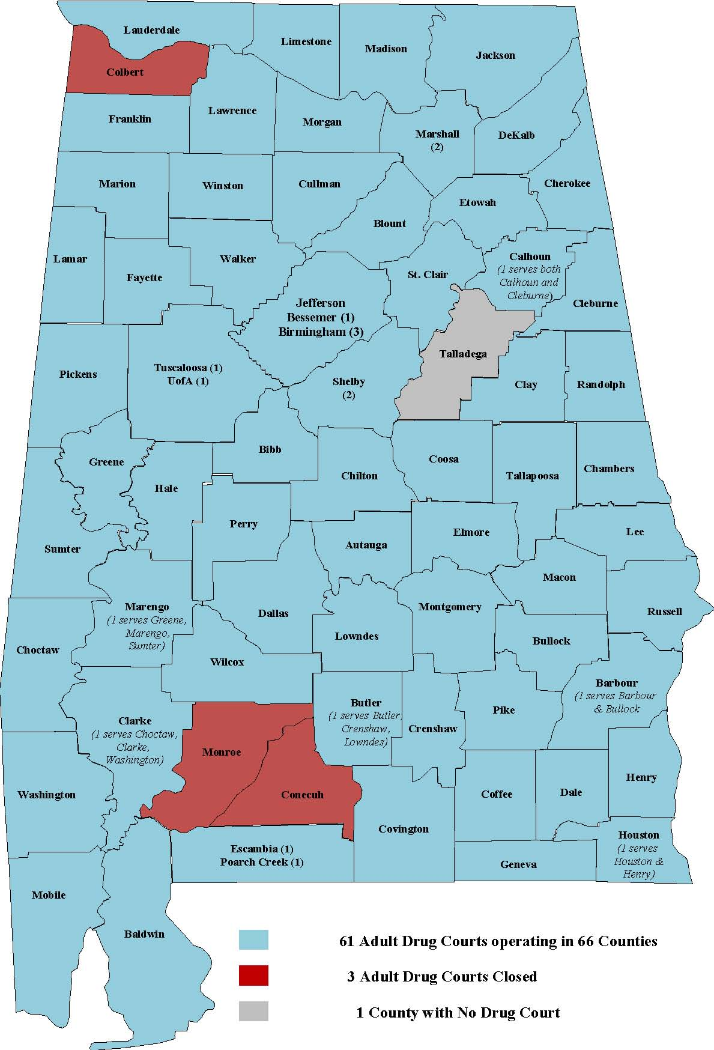
Appendix D. Adult Drug Court Map

